Installing QGIS
Hands-on 2

Learning outcomes
Here, we will be installing QGIS. QGIS is an open-source GIS interface that gives you the ability to work with geospatial data. You will need a stable internet connection to download the executable, but once installed, QGIS can be used at any time on your computer. Follow the steps below to download and install QGIS.

- Download the installation executable by going to: https://qgis.org/en/site/ and click “download now” (note that your version may look different from the one seen here, this is not a problem).

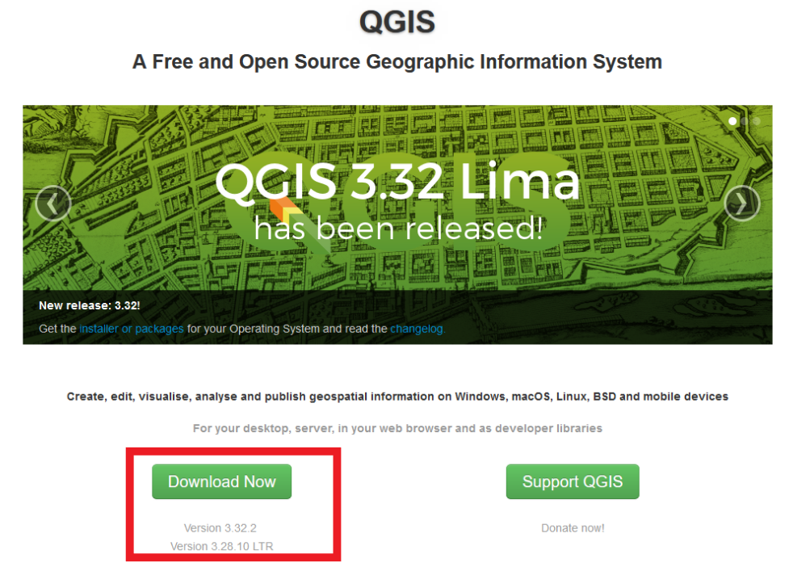

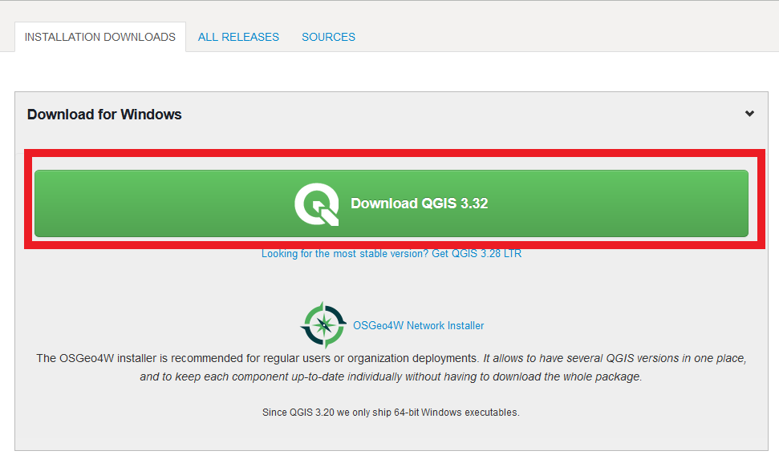
- Double-click on the executable once it has been downloaded to your personal computer.
- The first window will be a welcoming window, click “Next”
- The second window will include all the licenses that you have to agree to in order to get QGIS installed. Check the box which reads “I accept the terms in the License Agreement” and click next.
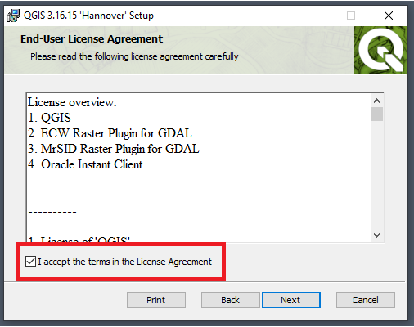

- Next, you will be prompted to select install location. This is where your QGIS version will be installed. It is recommended to go with the default on i.e. C:\Program Files\QGIS 3.32 (or similar). When the installation path is determined click on “Next”.
- When the installation is finished click on Finish. Test to start QGIS (called QGIS Desktop 3.X.X on your computer).

