Geospatial Clean Cooking access modelling using OnStove
Hands-on 1

Resources
BAR-HAP tool
https://www.who.int/tools/benefits-of-action-to-reduce-household-air-pollution-tool
BAR-HAP manual
https://www.who.int/publications/m/item/manual-for-benefits-of-action-to-reduce-household-air-pollution-(bar-hap)-tool
BAR-HAP related literature
Das, I. et al. The benefits of action to reduce household air pollution (BAR-HAP) model: a new decision support tool. PLoS ONE 16, e0245729 (2021).
Jeuland, M., Tan Soo, J.-S. & Shindell, D. The need for policies to reduce the costs of cleaner cooking in low income settings: implications from systematic analysis of costs and benefits. Energy Policy 121, 275–285 (2018).
Jeuland, M. A. & Pattanayak, S. K. Benefits and costs of improved cookstoves: assessing the implications of variability in health, forest and climate impacts. PLoS ONE 7, e30338 (2012).
Jeuland, M. A. & Pattanayak, S. & Bluffstone R. The economics of Household Air Pollution. Annu. Rev. Resour. Econ. 7:81-108 (2015).
CHEST
https://www.who.int/tools/clean-household-energy-solutions-toolkit

Learning outcomes
This exercise focuses on BAR-HAP. BAR-HAP or the Benefits of Action to Reduce Household Air Pollution is the first tool comparing the costs and benefits of specific clean cooking interventions. The tool is developed by researchers at Duke University together with the World Health Organization. As we saw in the previous presentation the use of traditional fuels brings with it negative consequences for health and the environment as well as lost productivity for people (mainly women). BAR-HAP internalizes these benefits of a clean cooking transition in its cost-benefit analysis and relates them to the cost of making the transitions. BAR-HAP is a part of the WHO’s CHEST (Clean Household Energy Solutions Toolkit). CHEST is a collection of 6 modules aiming at helping countries in designing and implementing health policies. BAR-HAP is part of the second module “Identification of technological and policy interventions”. The tool was first published for Nepal in 2019 and then a global version in 2021. The tool is being maintained and updated regularly.
BAR-HAP allows the user to assess different transitions from traditional cooking to cleaner solutions. The traditional stoves included in BAR-HAP are traditional biomass and charcoal as well as kerosene. There are a number of improved cook stoves in the tool, which they define as cleaner solutions and lastly four clean stoves. In total you have 16 transitions to choose from. Each transition is coupled with specific benefits and costs. The analysis can be done on either a national, urban or rural level.
Beyond specifying pure transitions, the user can include specific policy interventions aimed at different stoves. These policy interventions are:
- subsidies (either aimed at the stove or the fuel which they use)
- financing (which assumes to change the willingness to pay for a transition by 40%)
- behavior change communication campaigns (which assumes to change the willingness to pay for a transition by 10%)
- technology and fuel bans
Stove subsidies can be combined with all other subsidies except for technology and fuel bans. This allows the user to determine which policy is the most efficient from a cost-benefit perspective, which policies lead to higher costs than benefits and which policies may be needed to get a desirable transition.
To conduct a cost-benefit analysis a lot of data is needed. BAR-HAP includes default data for all of the information that is needed to model a transition. The default data can be modified by the user if one wishes to do so. We will return to these calculations at a later point when discussing OnStove and here we will just run through the tool for you to gain a greater understanding. A large portion of the tool is password protected to ensure that the wrong edits are not made. The tool is open-source, does not require an internet connection (beyond the initial download) and is purely excel based.
By the end of this exercise, you will learn how to:
1) Basic operation of BAR-HAP
2) The costs and benefits of different cooking transitions

BAR-HAP demo
- Download the tool from the official website: https://www.who.int/tools/benefits-of-action-to-reduce-household-air-pollution-tool
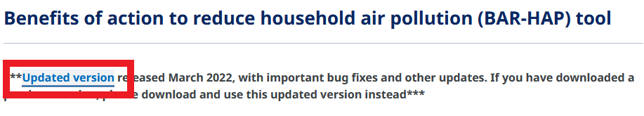
- Step 1 will download an excel file. Once opened you will see that the file includes 64 work sheets. Out of these 23 are the “active” worksheets. These 23 sheets are editable by the user without any specific requirements, while the others are password protected to avoid edits by mistake. The password is available in the manual, but we will not use it for this exercise. We will be working with the tabs shaded in green (the “active” ones).
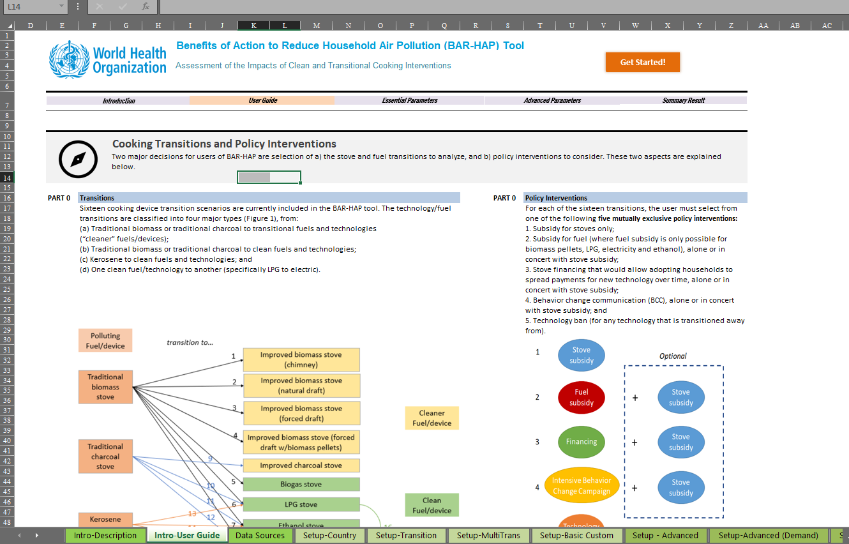
- Go to the “Setup-Country” sheet, this is the sheet number four (see image below). In this sheet we will set general information about your country of choice.
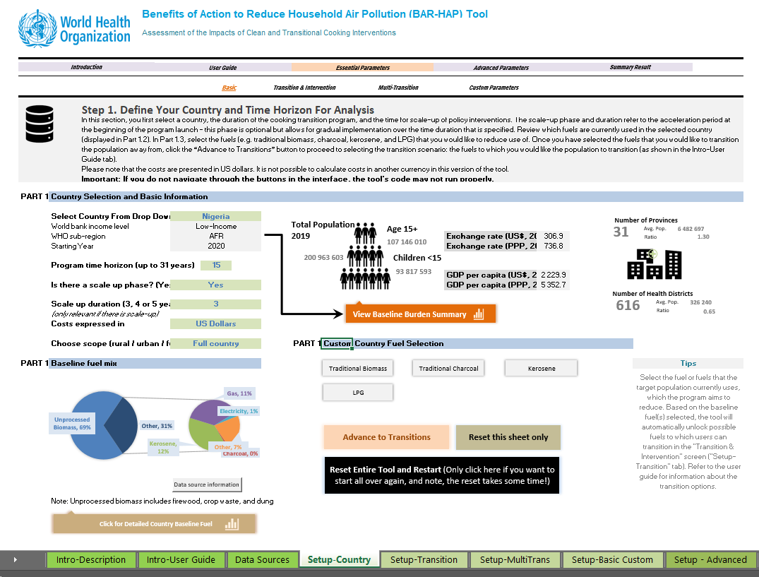
- In the drop down menu which reads “Select Country from Drop Down”, select your country of choice. Notice how the numbers on the sheet change as you select a country. This is because BAR-HAP has a large number of default values for different countries stored within the tool. Most countries have specific data, but if this is not available, regional estimates are used.
- At this point it is important to mention that the tool has different orange clickable buttons in each sheet, make sure to use these as you navigate through the workbook (and not the sheets at the bottom). This is important as orange buttons are the buttons which triggers all necessary calculations.
- Click on “View Baseline Burden Summary” button.
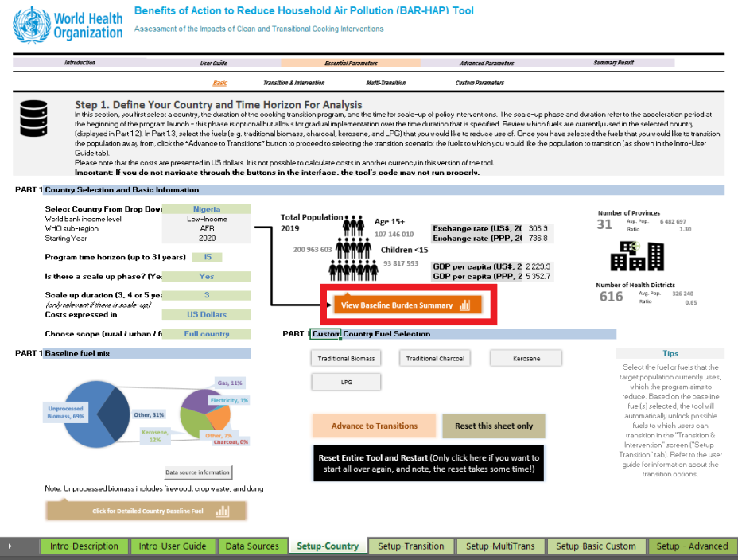
- This will take to a sheet describing the baseline situation of your selected country (before any policies are implemented)
  - First are the health burdens:
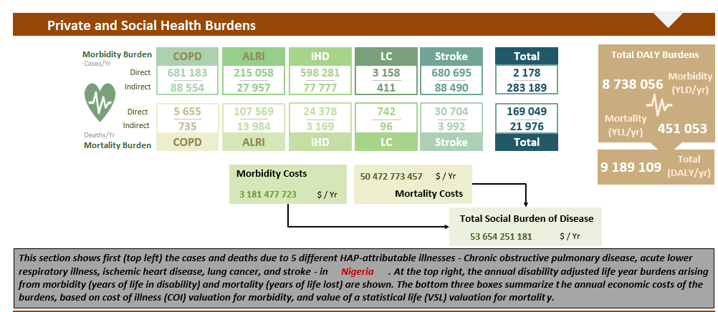
Notice how the diseases reported here are the same as the ones included in OnStove (Chronic Obstructive Pulmonary Disorder, Ischemic Heart Disease, Lung Cancer, Acute Lower Respiratory Infections and stroke). These diseases are strongly linked to the concentration of PM2.5. The first row of numbers show the direct and indirect morbidity burden of each disease in your country currently expected. The second row shows the same thing, but for mortality (deaths) instead. The morbidity and mortality rates are monetized below these rows. The sheet also indicate YLD (One YLD represents the equivalent of one full year of healthy life lost due to disability or ill-health) and YLL (Years of life lost from mortality)
  - Next are the environmental burdens currently expected in your country of choice
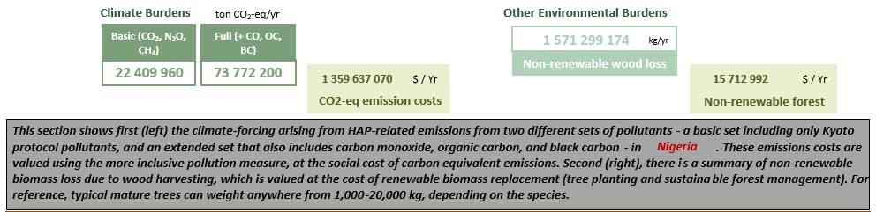
This shows the total environmental due to 1) the gases included in the Kyoto protocol and 2) an extended view including all the Kyoto gases as well as carbon monoxide, organic carbon and black carbon.
  - The last panel is the time lost and opportunity cost seen in your country currently:
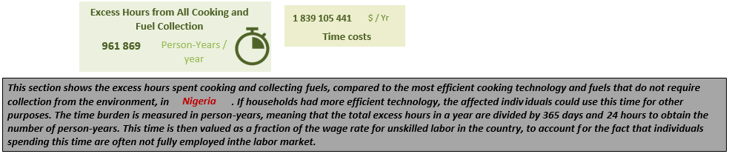
- Once the current burden has been explored click on any of the orange “Go back” buttons, this will take you back to “Setup-country” sheet
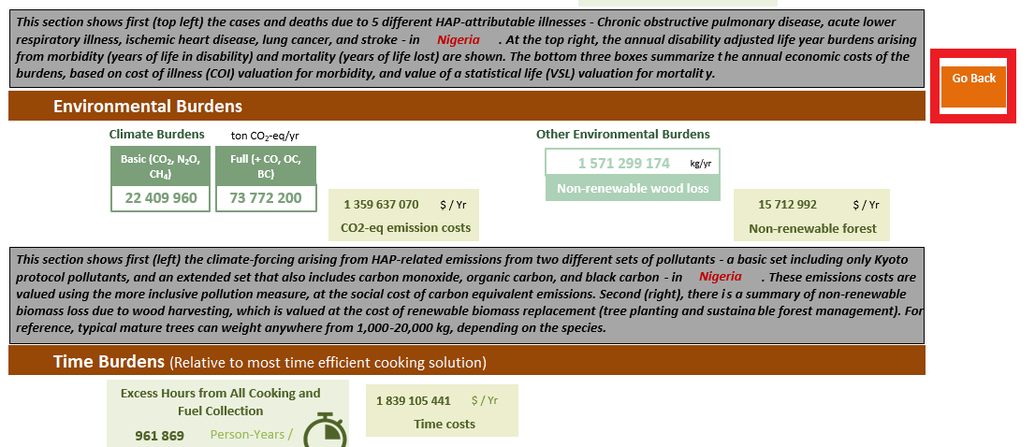
- Once back at the “Setup-country” sheet, set your time-horizon (15 years), scale up (yes), scale-up duration (3 years), monetary value (USD) and select whether you want to do the analysis on a national, urban or rural scale (national)
  - Scale up defines whether the clean cooking transition is gradually scaled up and for how long that goes. We are saying that it is and that it goes on for 3 years.
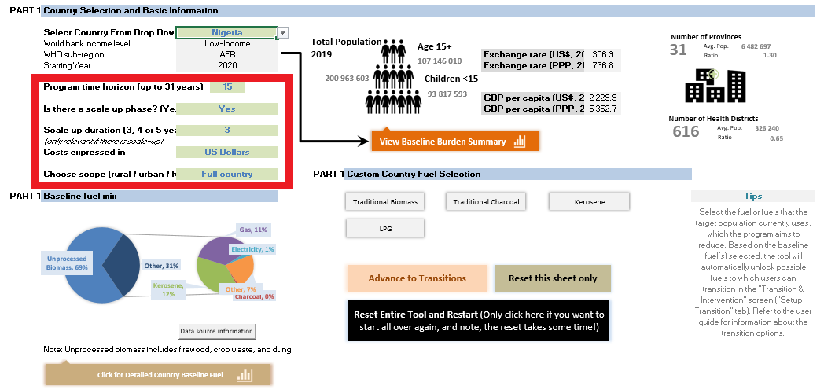
- Below the section called “Country Selection and Basic Information is a section called “Baseline fuel mix” this will show you the fuel mix of your selected country. Click on “Detailed Country Baseline Fuel”
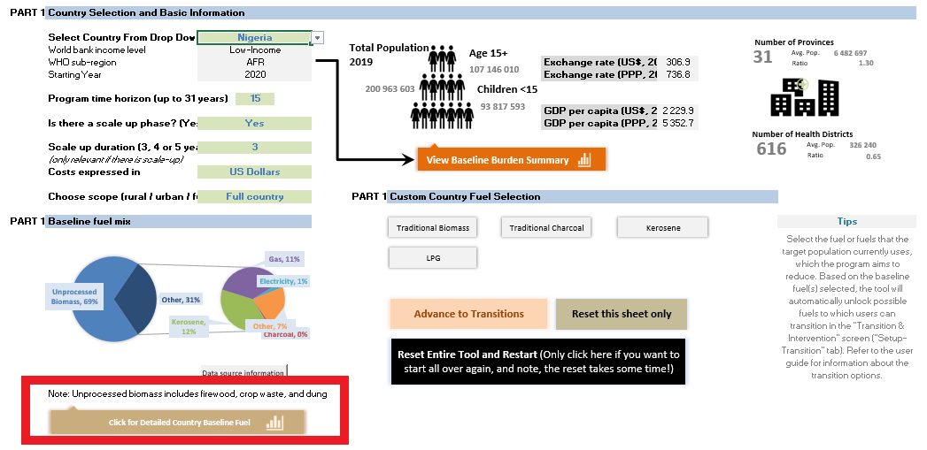
  - On this sheet you see how the share of different cooking fuels has changed in your country during the last 20 years. Once this has been explored click on the orange “Go back” button.
- Next in step 1.3 select the fuels you want to transition away from. For the this example select traditional biomass and traditional charcoal, by clicking on them (this will highlight them, see image below)
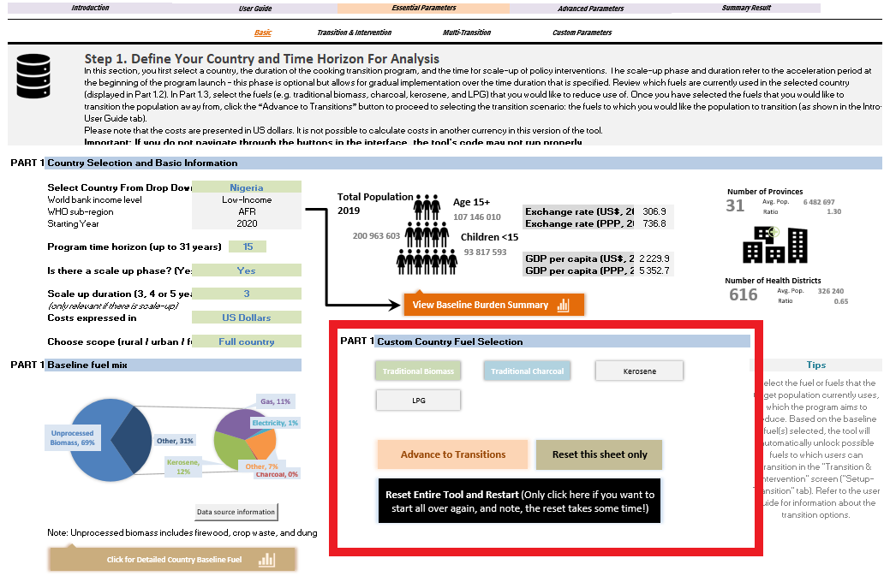

- Click on “Advance to transitions”
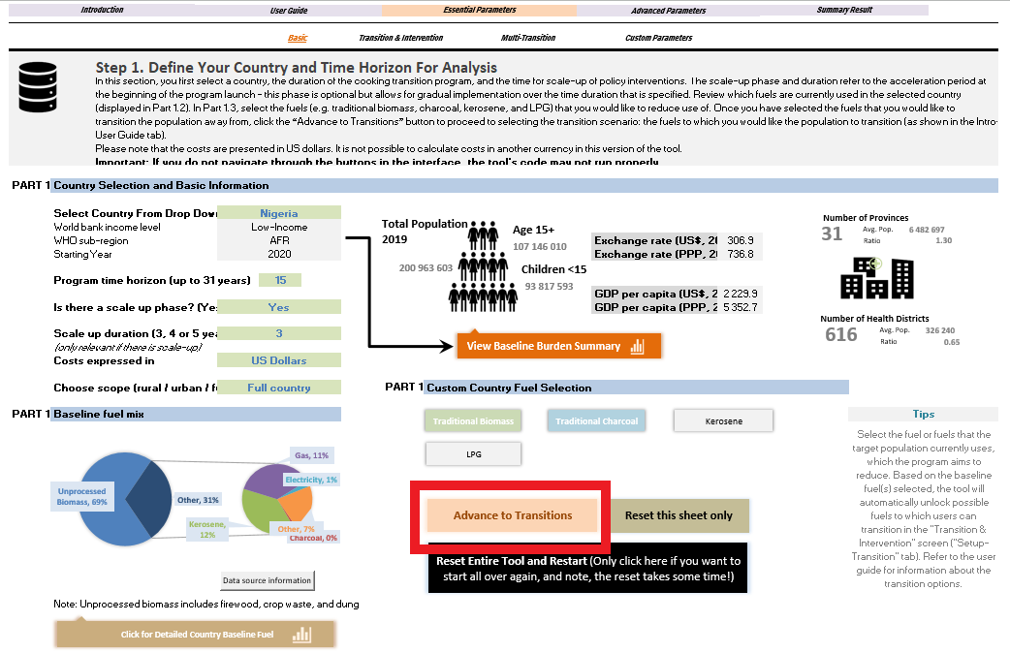
  - Here you decide what transitions you promote and which policy option to use. There are 16 transitions in total:
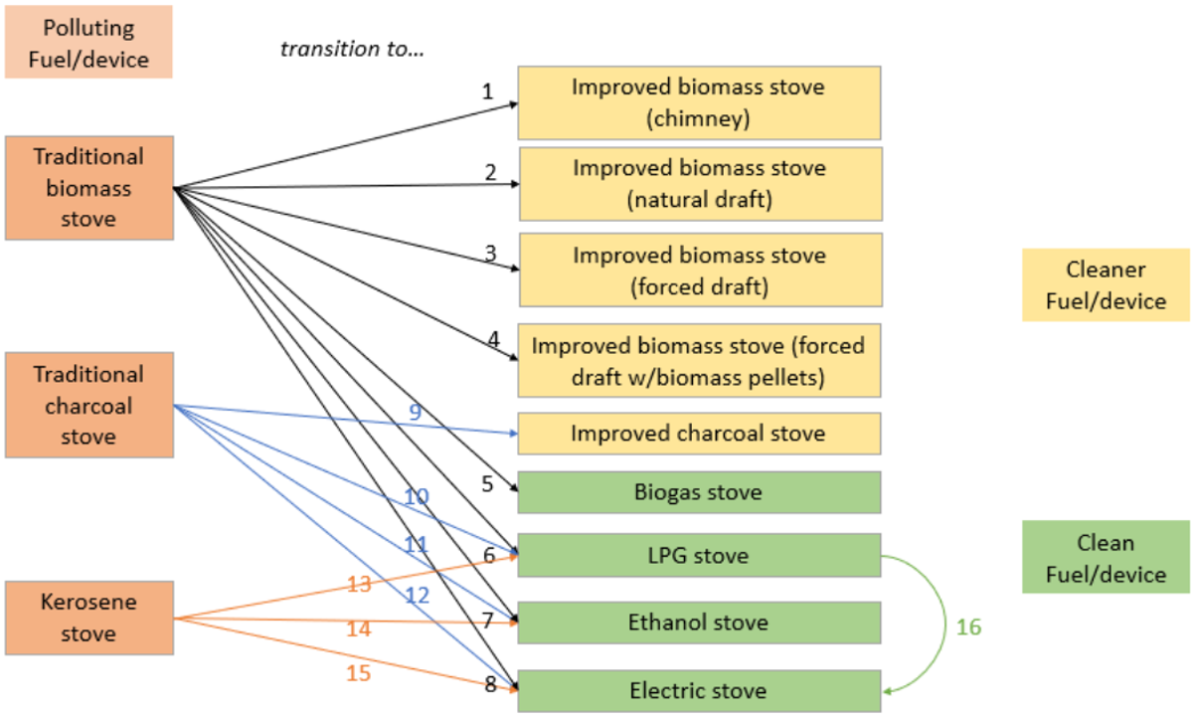
Figure 1. Transitions included in BAR-HAP[1]
  - For each transition, you will have to select a policy option. If you do not select a policy option the transition is not included. There are five policy options
    - Stove subsidies
    - Fuel subsidies
    - financing (which assumes to change the willingness to pay for a transition by 40%)
    - behavior change communication campaigns (which assumes to change the willingness to pay for a transition by 10%)
    - technology and fuel bans
  - For this example select only Biogas, LPG and Electricity (we want to focus on fully clean stoves). Select these transitions for both traditional biomass and traditional charcoal. You are free to select whichever policy you want, but makes sure that you select one policy for each transitions. Your transitions are
    - Traditional biomass -> Biogas
    - Traditional biomass -> LPG
    - Traditional biomass -> Electricity
    - Traditional charcoal -> LPG
    - Traditional charcoal -> Electricity
See example below. Notice that once a transition is selected the gray “Select” changes to a red “Selected”. We want the six transitions above to be selected as in the image below.
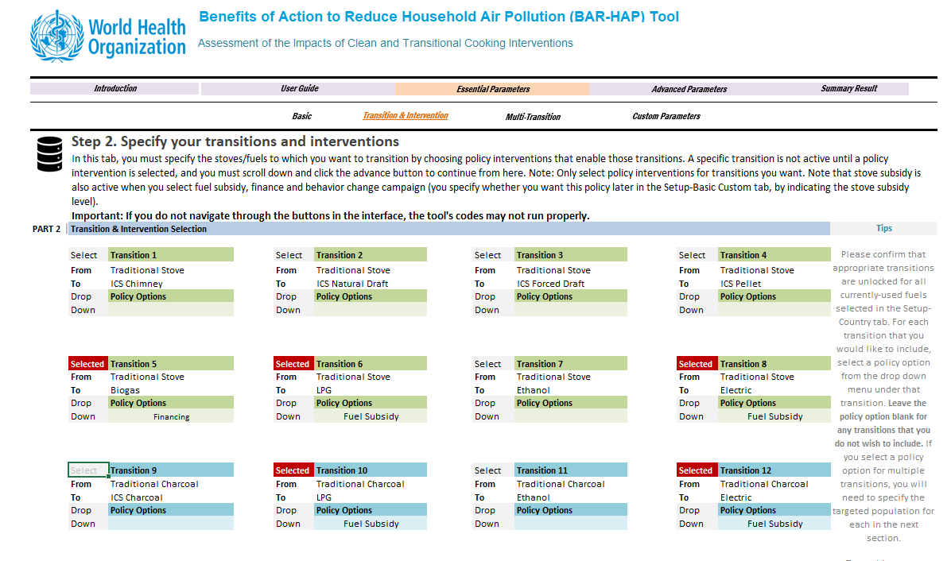
- Once your transitions are selected, click on “Advance to Multi-transitions”
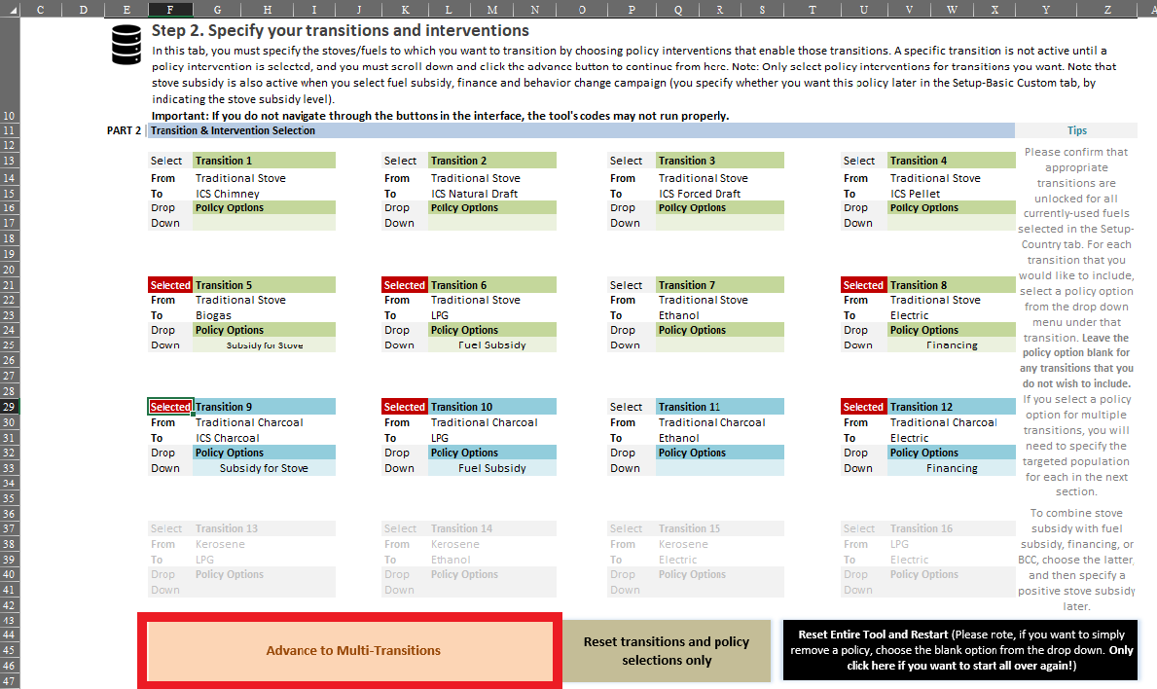
  - If you chose more than one stove to transition to (which we just did), you have to enter the percentage of the population transitioning to each new stove.
  - You do not want the percentage sum to be larger than 100%, but smaller than 100% is OK if you are modelling a scenario where everyone does not switch.
  - For this example, feel free to select the percentages as you wish. See an example below:
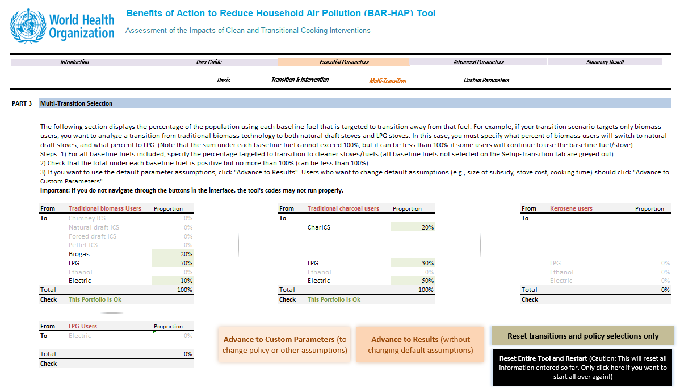
- Click on “Advance to results”. This new sheet will show you all of the results of the transitions that you have modeled.
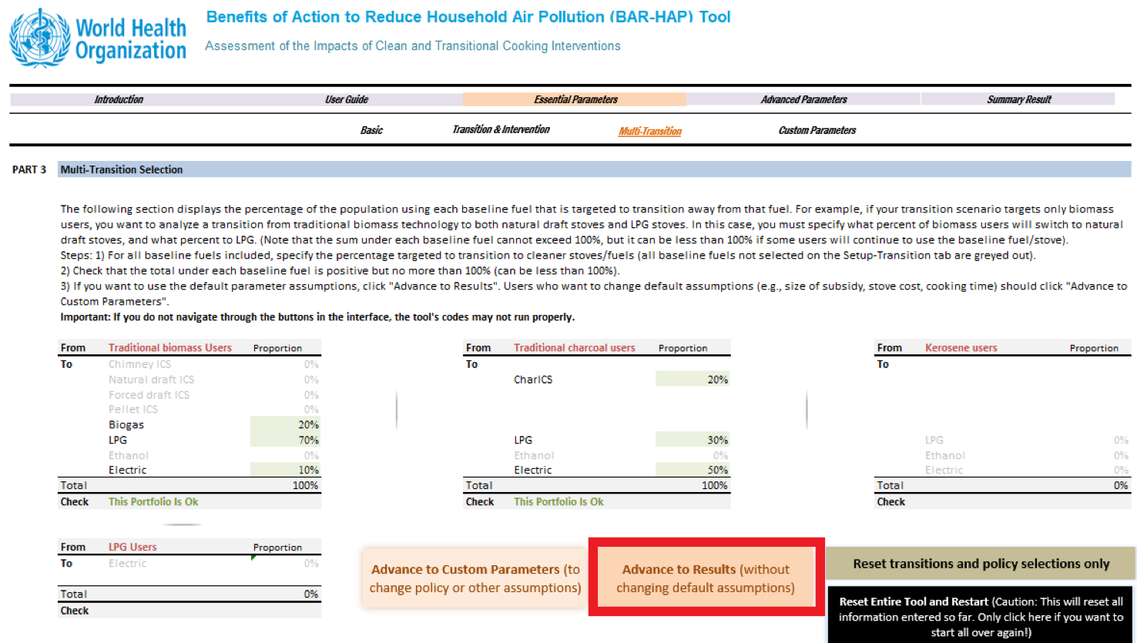
  - Present Value of Social Net Benefits – Shows the net-benefits of the scenario. This is defined as benefit minus costs. One value (the net-present value) includes a social discount rate, while the other one does not. If you have a parenthesis around your value it means that it is negative (the costs outweigh the benefits). If this is the case you might want to change some of your transitions or associated policies.
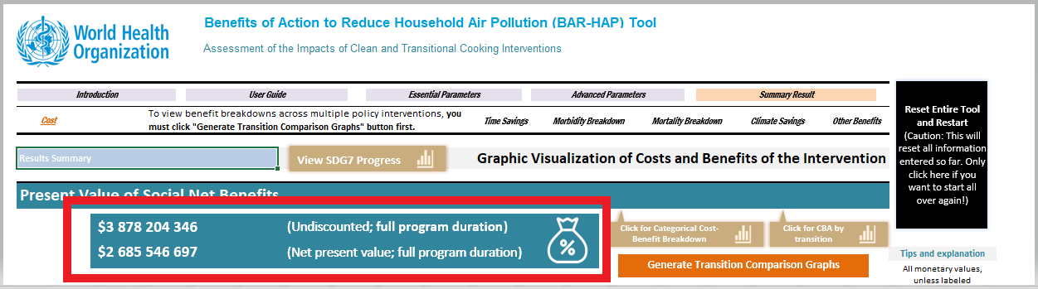
  - If you click on “View SDG 7 progress” you can see the results of your created scenario in comparison the business as usual case.
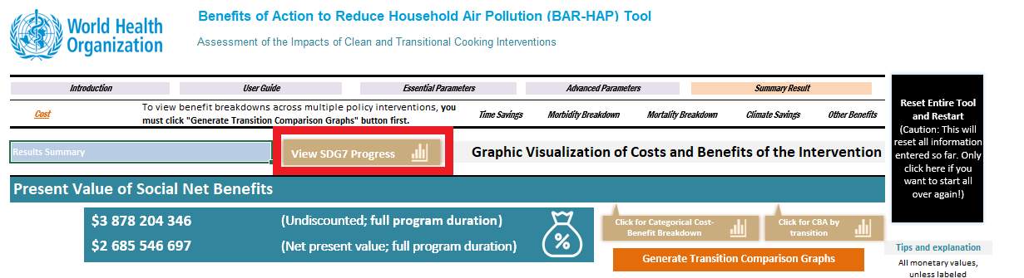
    - The fact that it does not reach 100% for your scenario could be due to the efficiency of your policy assumption. As an example if you do a technology ban (restrict people from using the stove completely) you will see that the share gets much closer to 100%. (click on “Go Back” when you have checked the results).
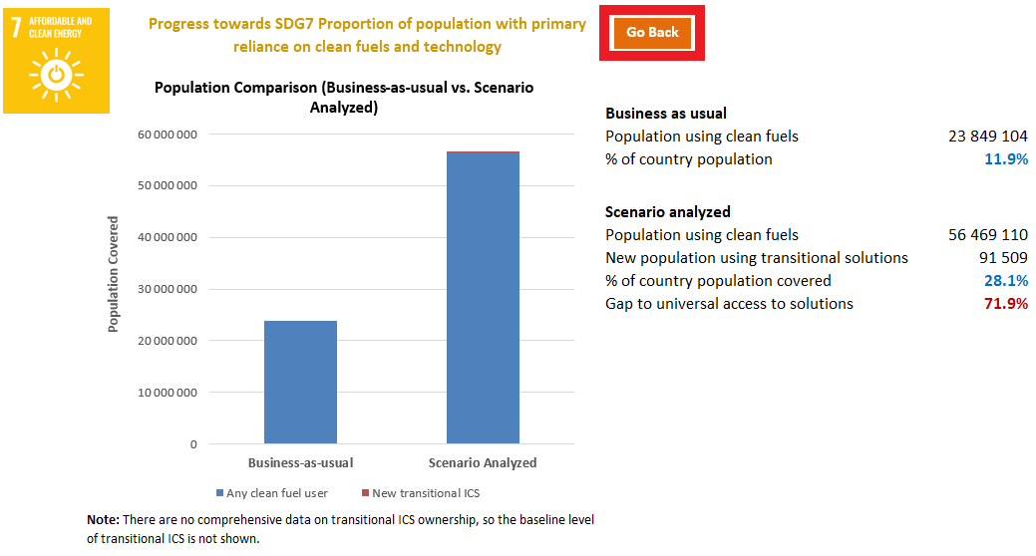
  - Click on categorical cost-benefit breakdown to see each cost and benefit on its own
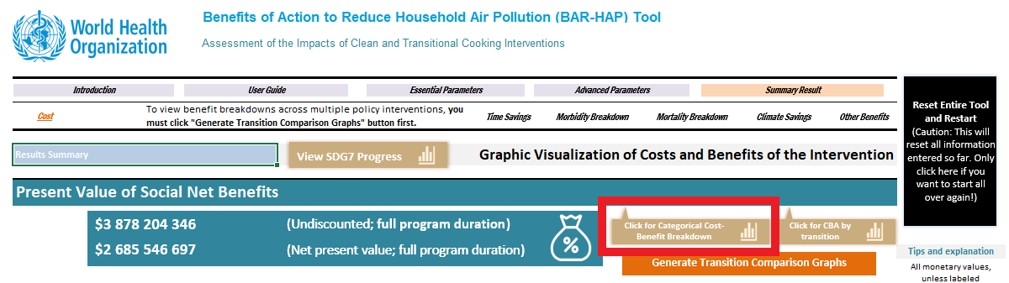
This panel includes:
    - Change in fuel cost – How does fuel cost change
    - Climate change mitigation benefits – reduction of GHG-pollutants
    - Ecosystem benefits – other environmental benefits beyond greenhouse gas emissions. This could for example be a reduction in unsustainable wood collection.
    - Time savings – opportunity cost gained
    - Mortality reductions – reduction in deaths
    - Morbidity reductions –reduction in cases
    - Maintenance and learning cost
    - Private stove costs –cost of buying stoves (to the consumer)
    - Stove subsidy cost (to society) – cost of giving a subsidy on stove
    - Fuel subsidy cost (to society) – cost of giving a subsidy on fuel
    - Program implementation cost - Cost of implementing your proposed program
    - Government costs - personnel/staffing, training, advertising, equipment
    - Net private cost of forcing a ban - Cost of forcing a ban (if you have selected a ban)
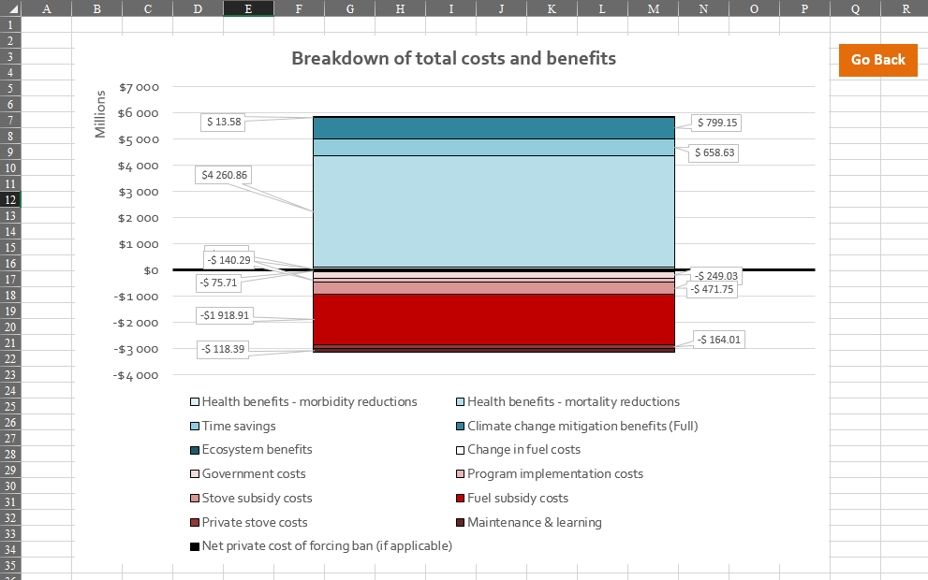
Some questions to look into:
- Are the total benefits in your scenario higher than the total costs?
- Are any of your costs on the positive section? What would this indicate?
- What is the largest category of costs? Do you see any ways of alleviating these?
- What is the largest category of benefits
Click on “Go Back” whenever you are ready
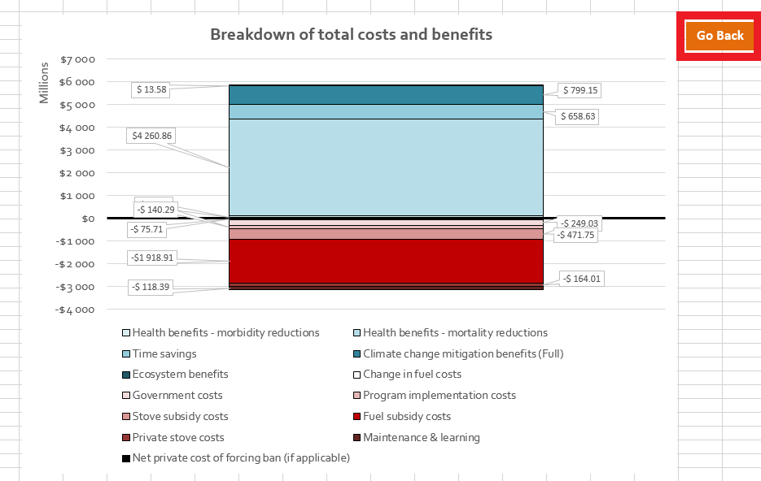
  - Next click on “Click on CBA by transition”
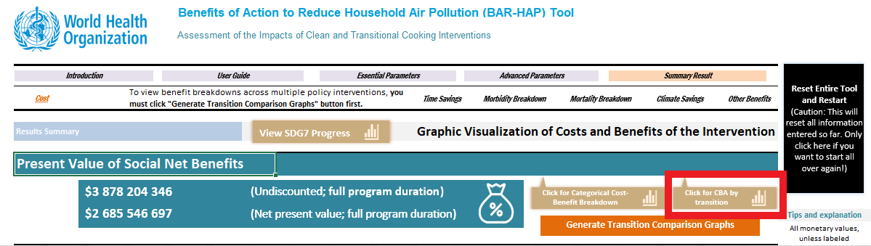
    - Shows you the net-benefits of each transition that you have selected. Are any of the transitions negative? If so, what does that tell you?
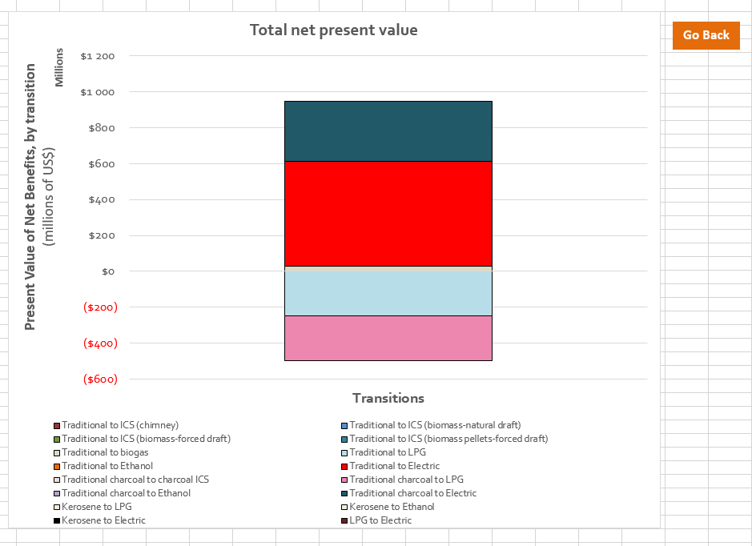

Click on “Go Back” when happy
  - If you scroll down in the sheet that you come back to you will find the costs and the three previously described benefits of your selected transitions. As with the net-benefit values parenthesis indicates negative values. This gives you the ability to compare the results to the current scenario.
Note that there are advanced parameters we have not assessed here. Feel free to do so with the help of the official manual (https://www.who.int/publications/m/item/manual-for-benefits-of-action-to-reduce-household-air-pollution-(bar-hap)-tool)

- This marks the end of this hands-on. The purpose of this exercise has been to introduce to you net-benefit calculations as they relate to clean cooking without the spatial dimension involved. We have here given you a basic run-down on how BAR-HAP works, created some transitions and assessed the results for one case study. We will move on the rest of the course, but feel free to come back to this exercise and run different scenarios at a later stage.

References
[1] I. Das, J. J. Lewis, R. Ludolph, M. Bertram, H. Adair-Rohani, en M. Jeuland, “The benefits of action to reduce household air pollution (BAR-HAP) model: A new decision support tool”, PLOS ONE, vol 16, no 1, bl e0245729, Jan 2021, doi: 10.1371/journal.pone.0245729.

