Geospatial Clean Cooking access modelling using OnStove
Hands-on 7: Data collection

Introduction
OnStove relies on a large number of input data. These data can be categorized into three broad groups:
- Techno-economic data – technical data related to each stove included in the analysis. Given to OnStove in the form of a csv.
- Socio-economic data – socio-economic data related to the study area that is being modelled. Given to OnStove in the form of a csv.
- Geospatial data – used to capture various characteristics across your study area.
When using OnStove you will get experience and information about the different categories of input data. Refer to the manual for more information on the different categories and their requirements.

Learning outcomes
You are required to collect some of data listed in the manual on your own in this exercise. By the end of this exercise, you will be able to:
- Acquire some of the important data that are used in OnStove

GADM
The GADM database contains the administrative boundaries for most countries on both a national and sub-national level. The data are freely available for academic and non-commercial use. Download the Shapefile package for your country.
Source: https://gadm.org/data.html

The Malaria Atlas Project
The Malaria Atlas Project contains geospatial datasets related to Malaria. Some of these datasets are however fairly general and can be used beyond the scope of Malaria. For OnStove, we use friction maps and travel time maps that are available here. A travel time map describes the time it takes to travel across a study area which could in turn be used to estimate costs and time spent. A friction map describes the speed at which you can travel either by foot or motorized transport across different parts of a study area. In OnStove, we often use travel time maps for estimating the cost of LPG and friction maps to estimate the collection times for biomass and biogas. From the Malaria Atlas Project download Global Travel Time to Cities and Global Walking Only Friction Surface. Once downloaded, unzip and explore it in QGIS.
Source: https://data.malariaatlas.org/maps
Hint 1: The datasets are selected form the menu on the left-hand side and are both in the Accessibility category.
Hint 2: Once you have selected the dataset you can then download it from the right hand side of the screen.

The Global Burden of Disease database
Lastly we will determine the mortality rates in the five diseases that we have discussed in the lectures for your country.
- Chronic Obstructive Pulmonary Disorder
- Ischemic Heart Disease
- Lower Respiratory Infections
- Ischemic Stroke
- Lower Respiratory Infections
This is done using the global burden of disease database. These data are not spatial but instead numbers which are entered in the socio-economic specification file.
Source: https://vizhub.healthdata.org/gbd-compare/
Hint 1: Select the map on the left-hand side of the screen:
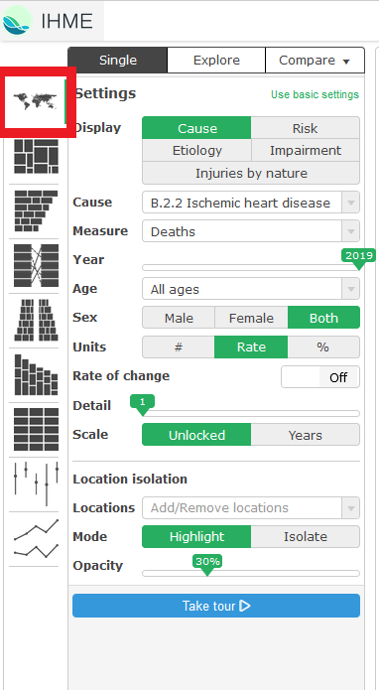
Hint 2: Select Deaths the box saying Measure and each disease listed above in the box saying Cause. See example of how to select deaths for • Chronic Obstructive Pulmonary Disorder
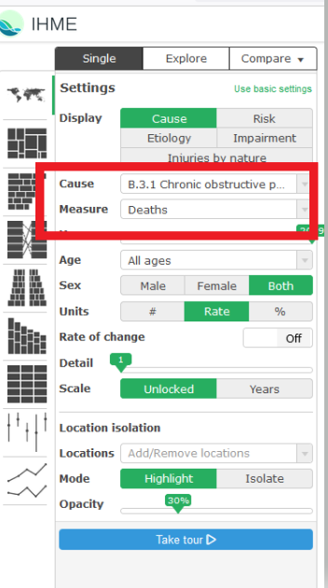
Hint 3: Hover the mouse above your country of choice to see the statistics for your country.

