Energy Access Explorer
Hands-on 5: Using the EAE back-end system
License:
This work is licensed under the Creative Commons Attribution 4.0 International License (CC BY 4.0). To view a copy of this license, visit https://creativecommons.org/licenses/by/4.0/.
Attribution:
Please cite as: Woldeamanuel, A. A., Khalid, A., Anand, S., Sahar, T., Saklani, A., Sinclair-Lecaros, S., Mentis, D., Ronoh, D., & Stockman, J., 2026. Data Driven, Integrated and Inclusive Energy Planning with Energy Access Explorer. Version 1. Climate Compatible Growth Teaching Kit Website, Climate Compatible Growth.

Learning outcomes
By the end of this exercise, you will learn how to:
1) Learn how to navigate the Content Management System interface
2) Integrate and Configure Vector, Raster and Tabular datasets in the back end of EAE

Contents
I. Navigating the CMS: Categories
II. Navigating the CMS: Geographies
III. Navigating the CMS: Datasets
IV. Create a Vector Dataset
V. Prepare Dataset & Run Paver
VI. Update Dataset Configuration
VII. Create a Raster Dataset
VII. Prepare .CSV File
IX. Setting up .CSV Dataset in EAE

I. Navigating the CMS: Categories
1. Access the CMS at: https://admin.energyaccessexplorer.org/?login
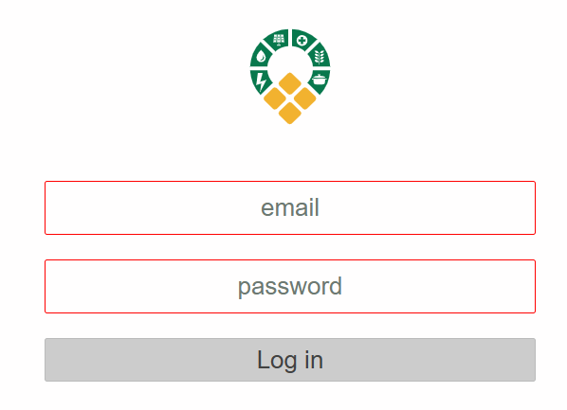
2. Use your credentials to login (same as the registered email and password for My EAE)
3. Navigate to Categories
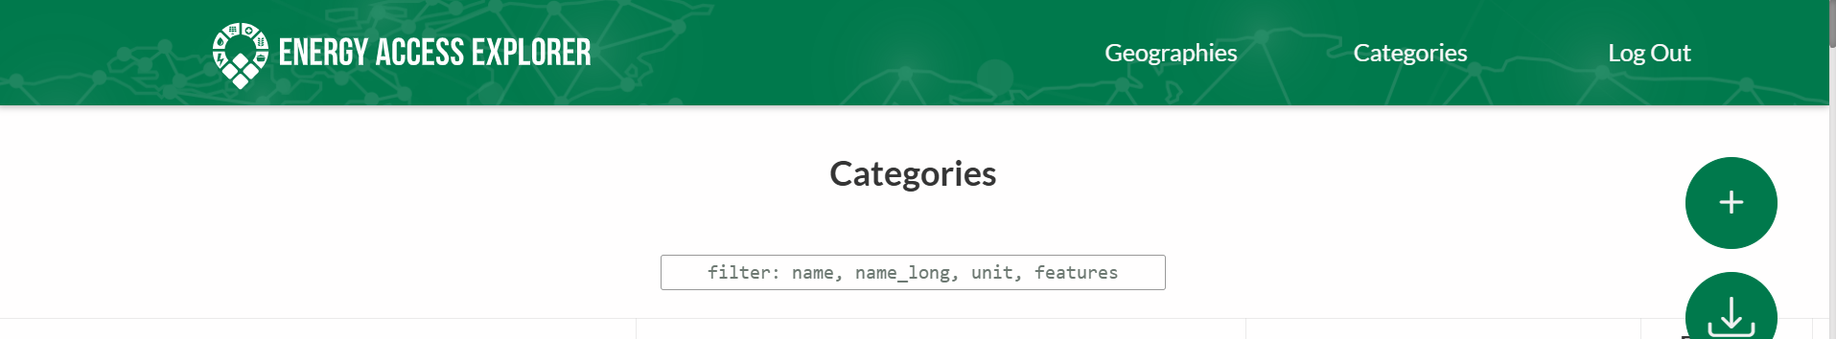
4. Use the Search feature to find Healthcare Facilities
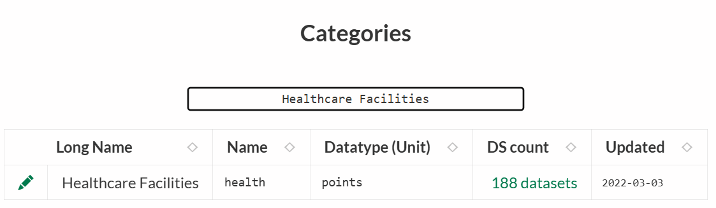
  - What is the Healthcare Facilities’ Category datatype?
  - Click on this category’s settings icon 
  - Find the description of this category
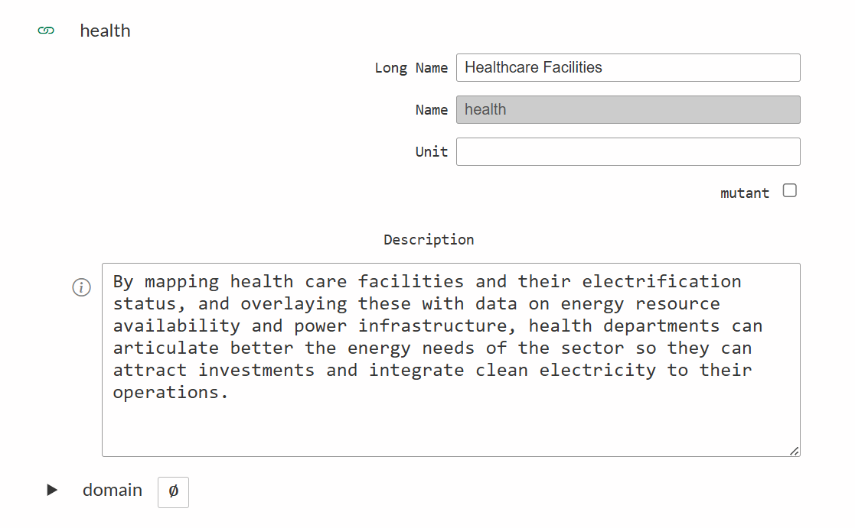
  - Click cancel or anywhere outside the pop up to exit
5. Use the Search feature to find the category Population density
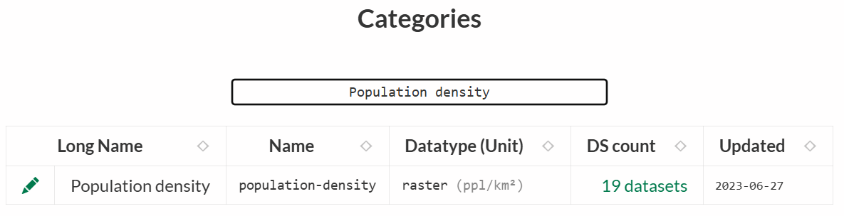
- What is the Category datatype?
- Click on category’s settings icon
- How many color stops does the category have?
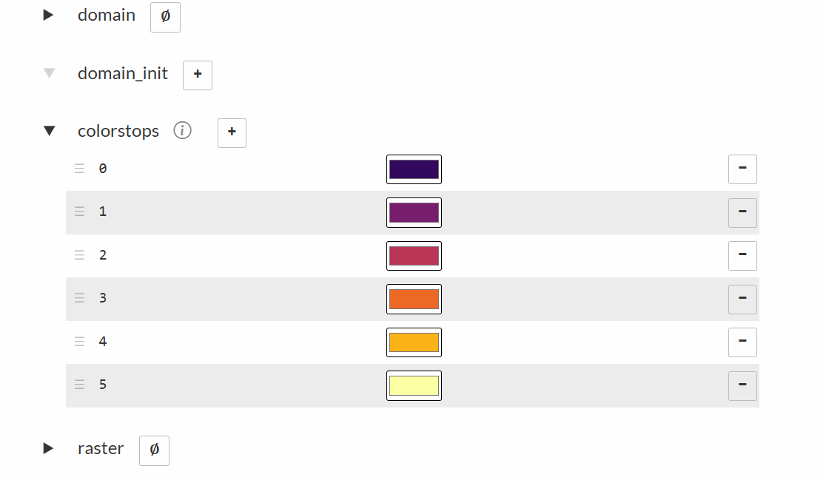

II. Navigating the CMS: Geographies
1. Navigate to Geographies
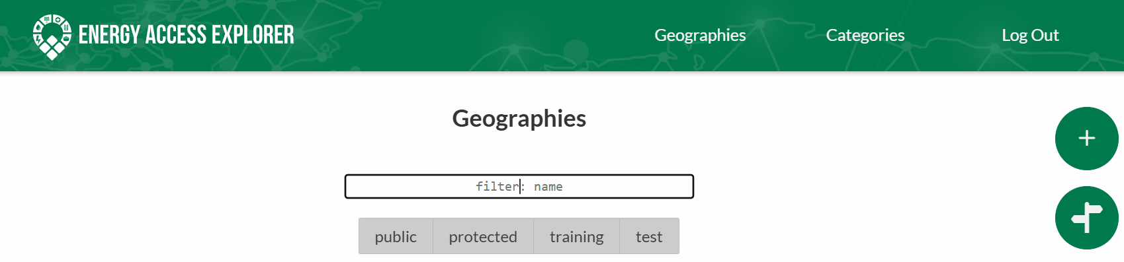
2. Find the following geography properties for Uganda Training
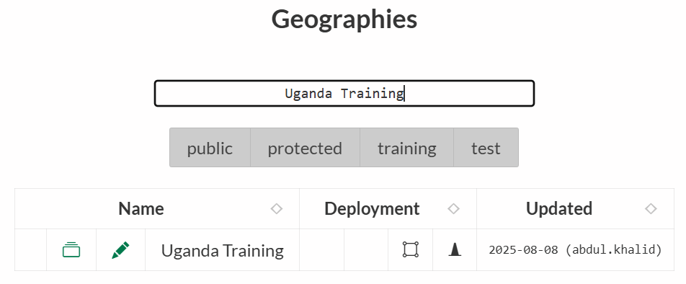
- What environment is the geography deployed in?
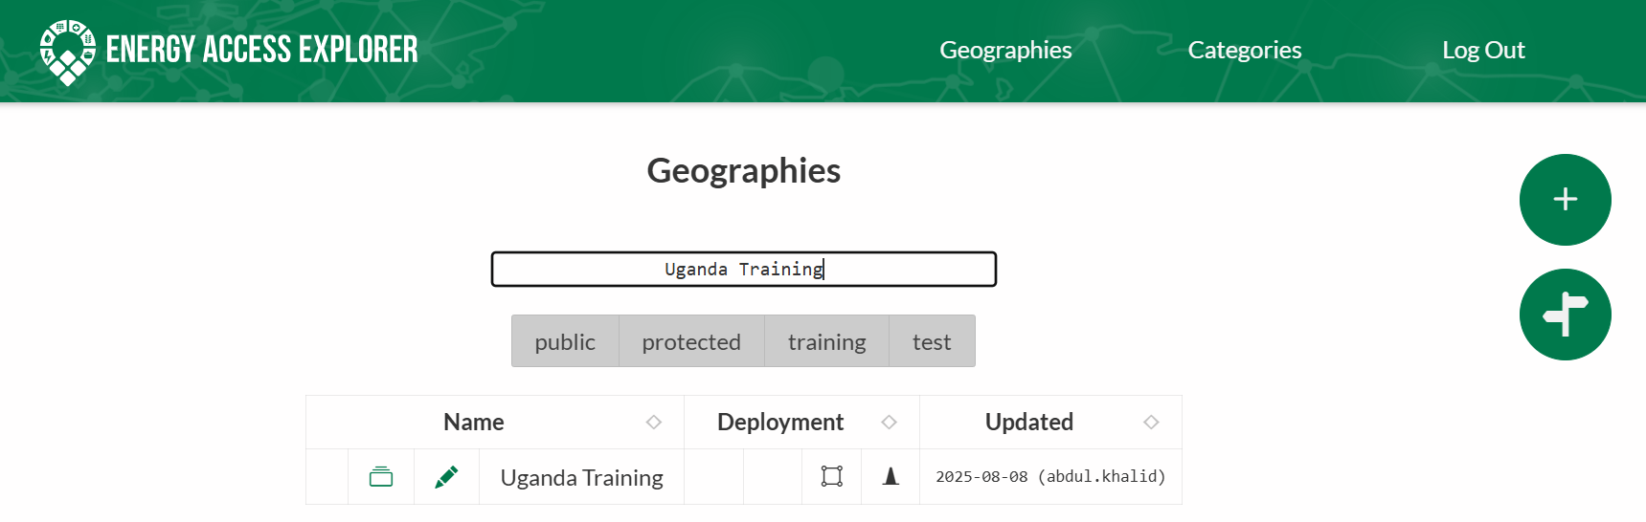
Geography History
Available Environments
Geography Name
Environment View

- Click the datasets button How many datasets are recorded in the geography
- Click the Geographies to go back to the previous window.
3. Click on geography’s settings icon
- How many divisions does the geography have?
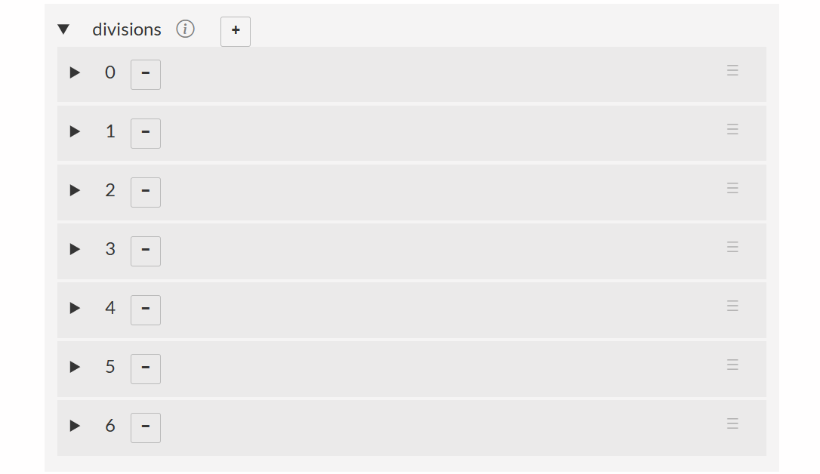
- List the different divisions

III. Navigating the CMS: Datasets
1. Navigate to Geographies
2. Find Uganda Training geography and click the datasets button
- What datasets are stored in the geography?
- What dataset type can you find?
NOTE: It is critical to consider data accuracy, reliability and timeliness when you start working on a geography specific dataset.
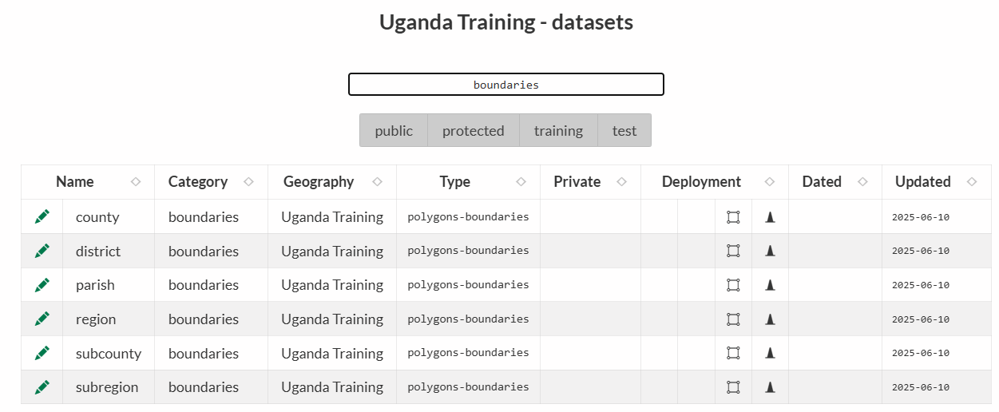
Dataset History
Environments
Dataset Geography
Dataset Type
Dataset Category
Dataset Name
Environment view
Search for Dataset

3. Click on one dataset’s settings (edit icon
- Find the dataset category.
- Check under deployment to see the environment the dataset is deployed on
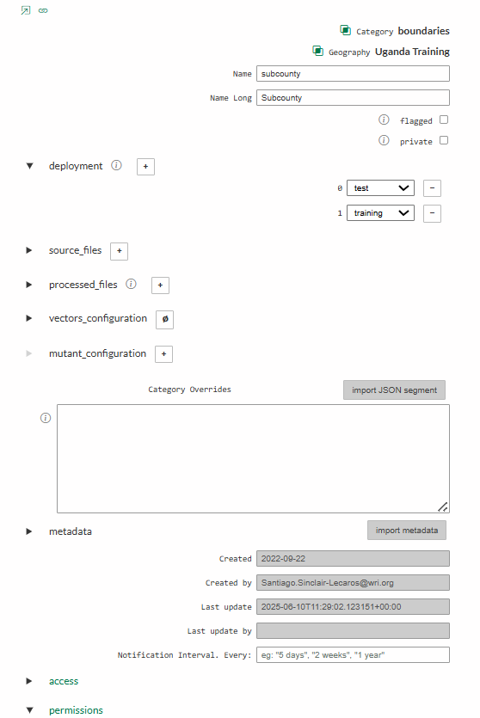
Dataset Governance
Dataset History
Add metadata
Advanced Configurations
Configurations
Input data files
Environments
Dataset Name
Dataset Category & Geography

IV. Create a Vector Dataset
1. You will work with the vector dataset provided below.
Dataset | Type | EAE category | Filepath URL | Attribute Headers [EAE labels]
Distribution Lines | Vector (Lines) | distribution | Link | voltage [Voltage]
2. Log into the EAE Content Management System (CMS) at https://admin.energyaccessexplorer.org/?login using your login credentials
3. Click the datasets button to navigate to ‘Datasets’ for the Uganda Training geography.
4. Click the green ‘plus sign’ button to create a new dataset in EAE.

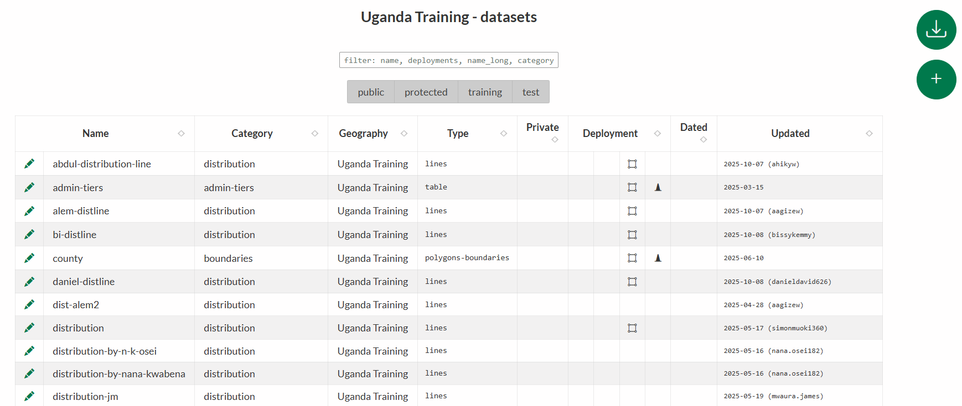
5. Click the search feature in the pop-up window, left side of Category.
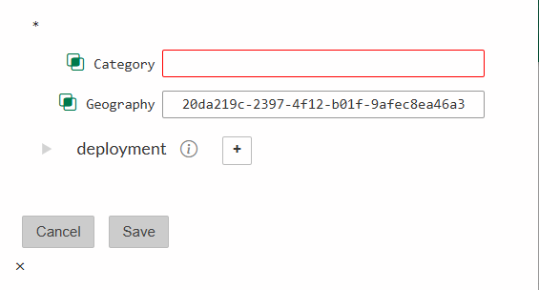
6. Find the ‘distribution’ category record (type and press enter) and then click on the button. You can also deploy at this stage, if you don’t do it now there is also an opportunity to deploy it later (next step). Then click 'Save’ to create the dataset.
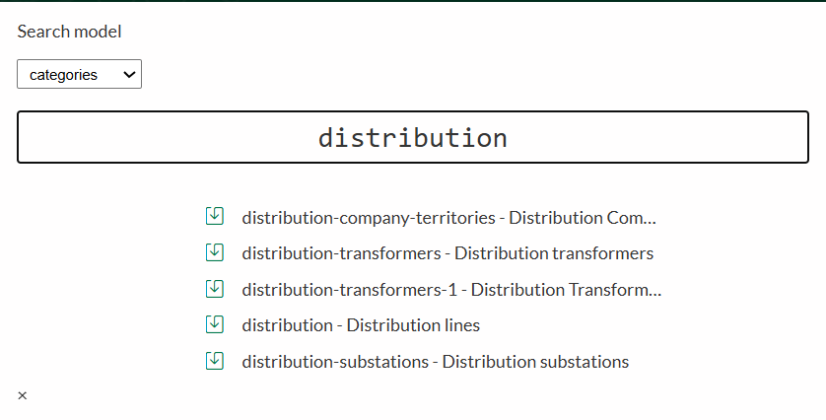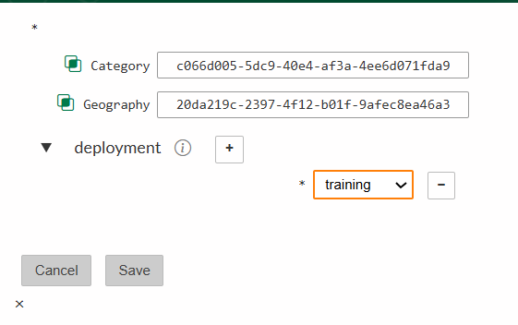
7. Name your dataset (use lower case for ‘Name’ with dashes for spaces, for ‘Name Long’ you can use upper cases, lowercase and spaces). Include your name or initials in the dataset name so that you can differentiate your files from other trainees. Navigate to the ‘Source Files’ section of the record and paste the URL below for the distribution line dataset in the ‘endpoint’ field.
URL: https://wri-public-data.s3.amazonaws.com/EnergyAccess/UGA/UG_DistributionLines_MV_2022.geojson
Remember to define the data type as ‘vector’
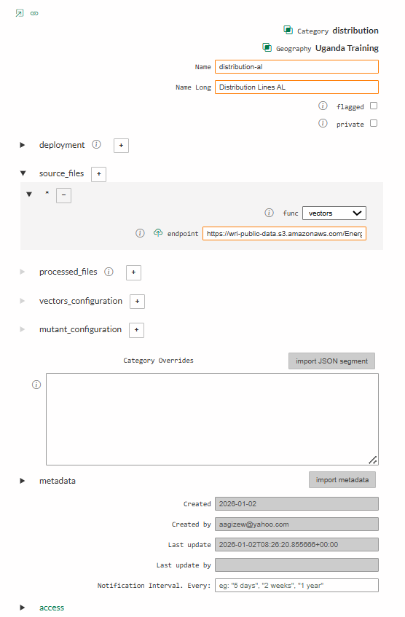

7. Save and exit the dataset record using the tool in the right-hand corner. We will return to this dataset in the next exercise.

V. Prepare Dataset and Run Paver
1. Find the vector dataset that you created in the previous exercise. Click on the edit icon to open the dataset record.

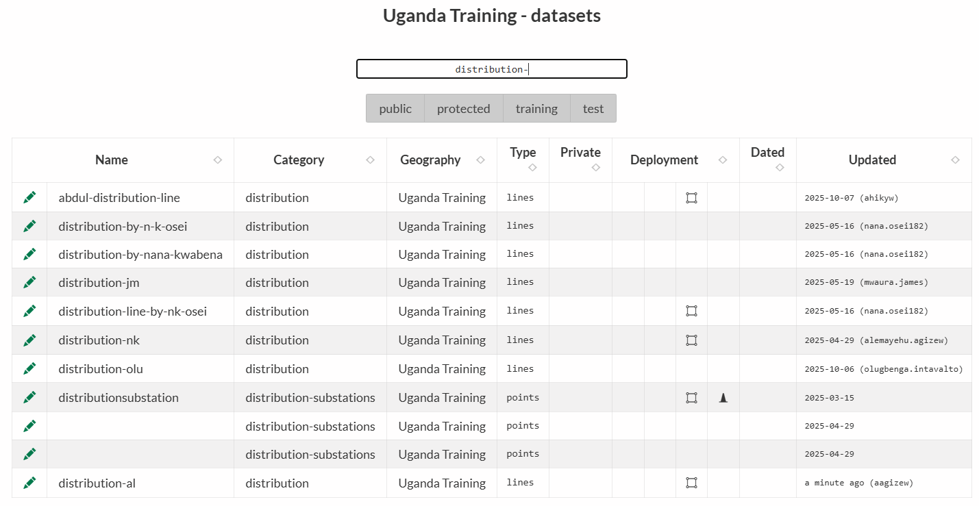
2. Click on the Paver icon to begin Paver processing.
3. We will need to select any data attributes that we wish to preserve in EAE:
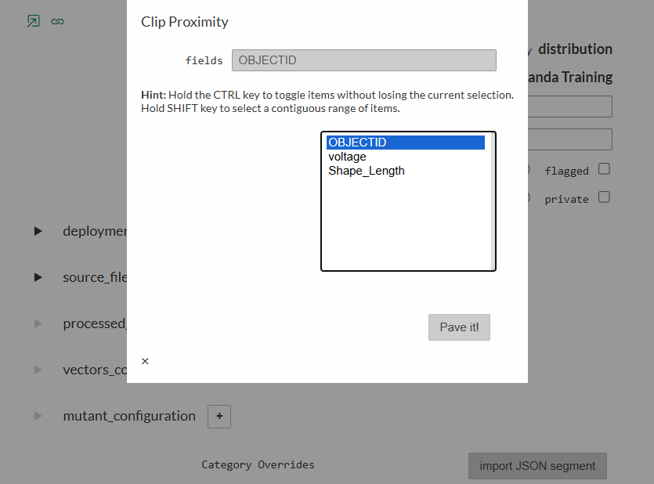
4. Once you’ve selected the desired attributes, click ‘Pave It’ from the pop-up Paver window. The system will begin automatically processing your dataset to match EAE specifications. You will be notified when this process is complete: ‘DONE’
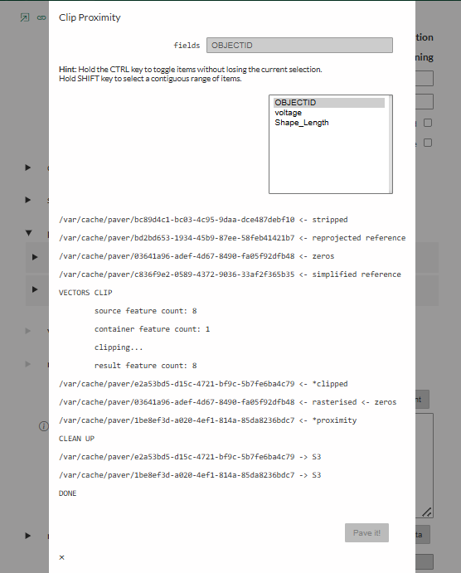
5. You have now processed your dataset and it is ready for deployment in the training environment. You can close the edit window.

VI. Update Dataset configuration
1. Click ‘edit’ to open your dataset’s configuration settings. Open the ‘vectors_configuration’ settings and click the ‘plus-sign’ box beside the ‘attributes_map’ section to add a new data attribute. In the ‘target’ field, enter the name of the attribute as you would like it to appear in EAE (see the text in parenthesis [ ] in the training data spreadsheet). In the ‘dataset’ field, enter the GeoJSON attribute header exactly as it appears on the training data spreadsheet (outside the parenthesis), including all capitalization and special characters. If there are multiple attributes associated with your dataset, repeat this step until they are all listed in the dataset record.
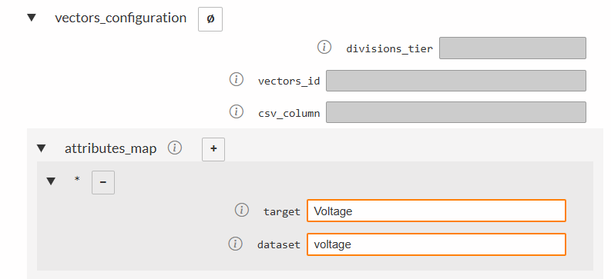
2. Next, we will make lines searchable by voltage level. In the ‘properties_search’ subsection, add the column header ‘voltage’
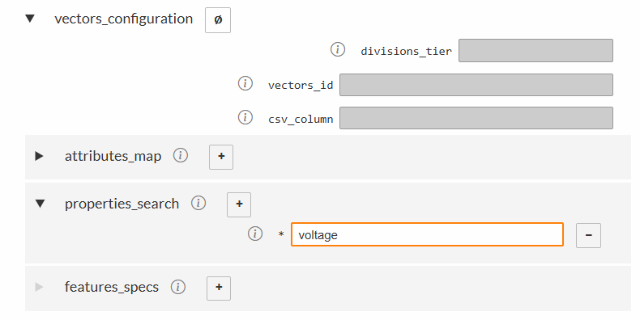
3. Navigate to the ‘Features_specs’ subsection and click the ‘plus-sign’ to view the available fields. This is where you can customize display options for the dataset. The ‘key’ field refers to the attribute column you’d like to modify the appearance of, and ‘value’ refers to the specific value for which you’d like to set display options (example: key = ‘voltage’ , target = ‘33’). For today’s exercise, we will not be customizing the display options, so click the ‘minus-sign’ button next to ‘new’ to cancel. This will revert to the default settings defined in the attached category record.
4. You can now deploy your dataset in the training environment (if not you haven’t done it earlier). Navigate up to the ‘Deployments’ section of the dataset record and select/type ‘training’ from the drop-down menu. Save and exit the record.
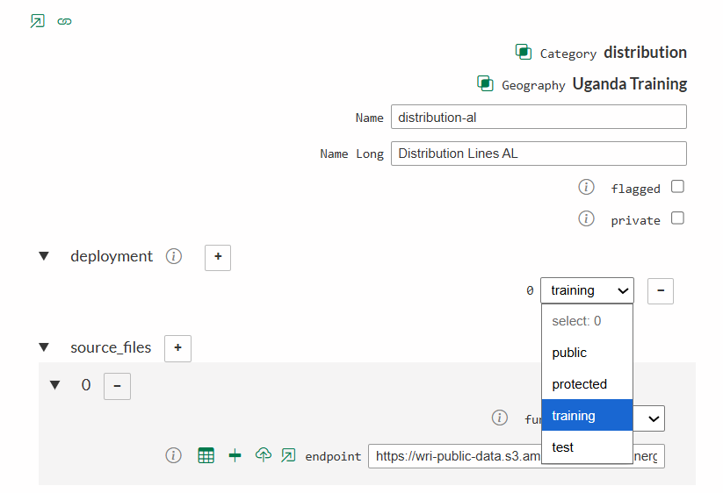
5. Log into the training environment https://training.energyaccessexplorer.org/login/ using your login credentials to test your changes, refreshing your browser if necessary.
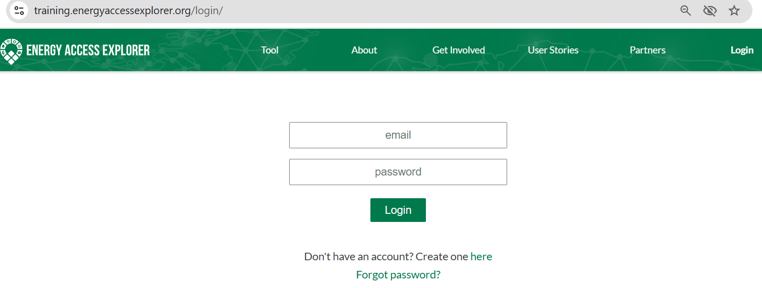
Add the dataset that you’ve created, and make sure you can view and query the data, and that the analysis appears in the middle of the EAE screen. Then go to the Active Layers and unselect Show analysis on the map from the Generate Analysis section and select Show layer for the Distribution line from the Active Data Layers.
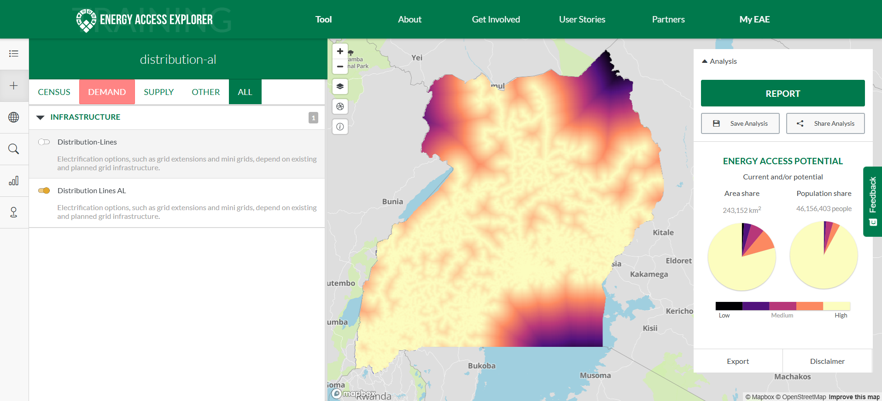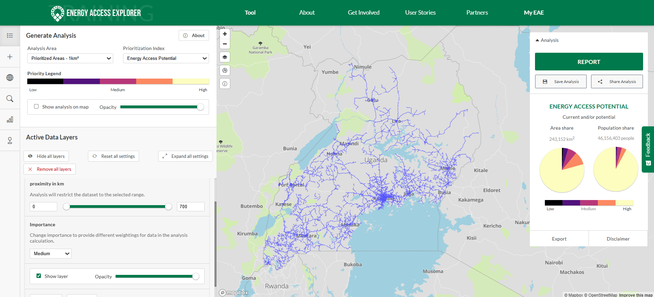
Then, select the search feature (magnifying glass icon) from the menu on the left of the screen. Your data layer should appear in the search feature. Try typing “33” to see a list of potential 33 kV distribution lines.
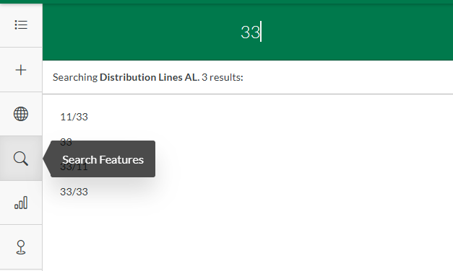
6. You can repeat these steps to process any of the other vector datasets provided below.
Dataset | Type | EAE category | Filepath URL | Attribute Headers [EAE labels]
Distribution Lines | Vector (Lines) | distribution | Link | voltage [Voltage]
Health Facilities | Vector (Points) | health | Link | FACILITY_N [Name]; LEVEL [Level]; ELECTRIFIC [Electrification Status];
Protected Areas | Vector (Polygons) | protected-areas | Link | NAME [Name]; DESIG_ENG [Type]
Minigrids | Vector (Points) | minigrids | Link | Name [Name]; Capacity [Capacity (MW)]; Status [Status]

VII. Create a Raster Dataset
1. You will work with the raster dataset from the table below.
Dataset | Type | EAE category | Filepath URL
Nighttime Lights | Raster | nighttime-lights | Link
2. Log into the EAE Content Management System (CMS) using your login credentials
3. Navigate to ‘Datasets’ for the Uganda Training geography. Click the green ‘plus sign’ button to create a new dataset in EAE
4. Click the search feature in the pop-up window.
5. Find the ‘nighttime’ category record and then click on the button. Then click 'Save’ to create the dataset.

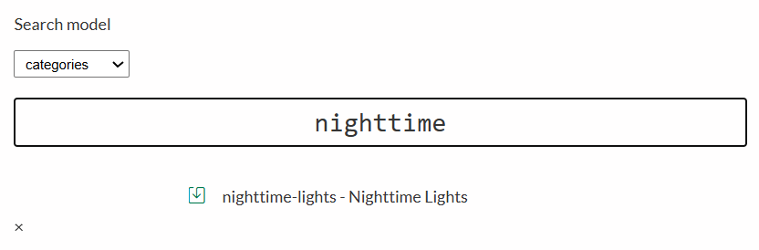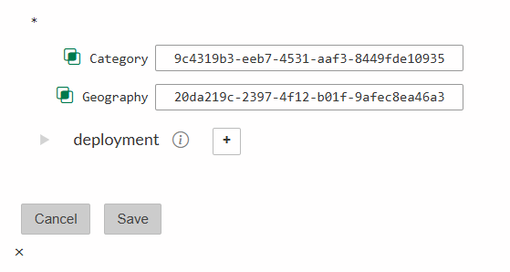
6. Name your dataset (use lower case for ‘Name’ with dashes for spaces, for ‘Name Long’ you can use uppercaser, lowercase and spaces). Navigate to the ‘Source Files’ section of the record and paste the URL below for the distribution line dataset in the ‘endpoint’ field.
URL: https://wri-public-data.s3.amazonaws.com/EnergyAccess/UGA/nighttime-lights.tif
Remember to define the data type as ‘raster’
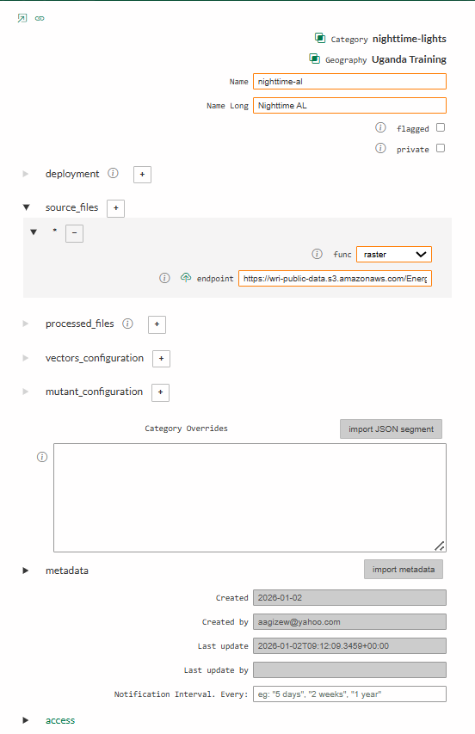
7. Save and exit the dataset record using the tool in the right-hand corner. Click the edit icon on your dataset again and then click on the Paver icon to begin automated data processing then close the dataset’s settings window once done.
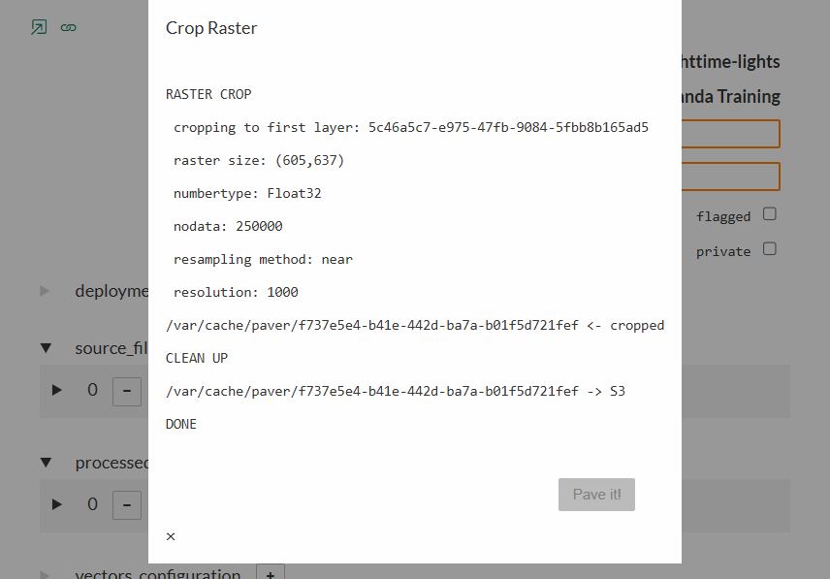
8. When Paver processing is complete, use the ‘edit’ icon to return to the dataset record. Click on the plus-sign in ‘deployments’ section and select/type ‘training’ from the drop-down menu. Save and exit the record. It is now active in the training environment.
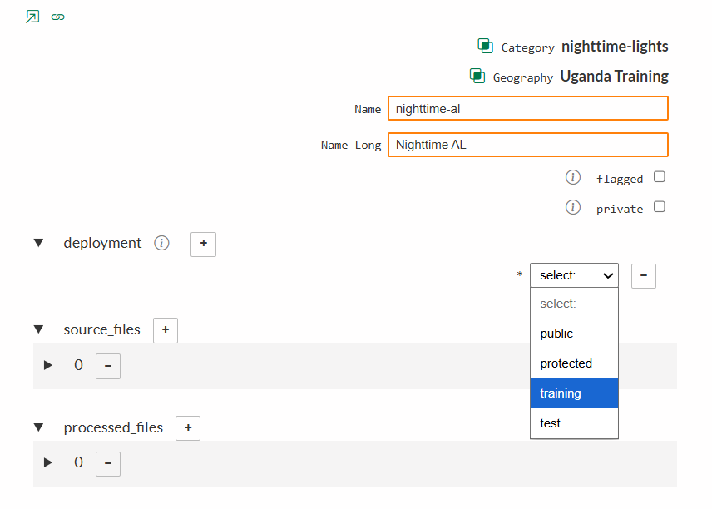
9. Log into the training environment https://training.energyaccessexplorer.org to test your changes, refreshing your browser if necessary. Select the dataset to view it in the EAE Data View. Confirm that it loads properly, and that it generates an analysis preview in the bottom right corner of the EAE window. You may also try querying any point within the dataset in the map view to see the value for that cell.
If EAE is already open in your browser, you will have to refresh to see any changes.
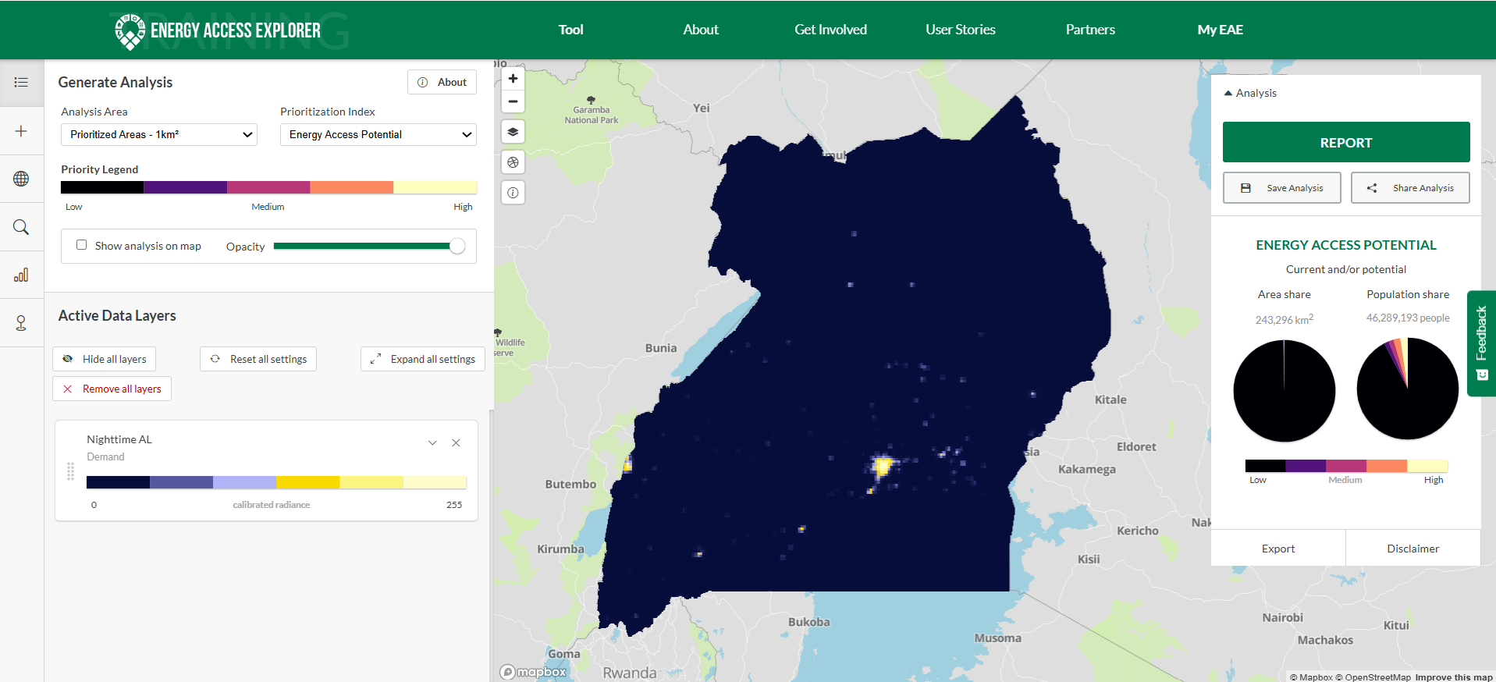

VIII. Prepare CSV File
1. For this exercise, you will be referring to the table below which contains an extract of household grid electricity access data at the sub-regional level from the 2019/2020 Uganda National Household Survey (2019/20 UNHS) undertaken by the Uganda Bureau of Statistics.
Sub-Region | Grid Electricity
GREATER KAMPALA | 92.5
CENTRAL II | 42.8
CENTRAL I | 23.3
BUSOGA | 13.3
BUKEDI | 5.2
BUGISU_SEBEI | 9.6
TESO | 3.6
KARAMOJA | 1
LANGO | 8.4
ACHOLI | 2.3
WEST NILE | 1.60
BUNYORO | 6.20
TOORO | 10.10
ANKOLE | 8.10
KIGEZI | 7.70
- Open excel and copy the table above to the excel workbook.
3. The table below provides a reference for Uganda Subregions’ OBJECTID. In your excel worksheet, carefully update/replace the values in the Subregion column to match the numerical OBJECTID for each Subregion as per the table below.
FID | F15Regions
0 | ACHOLI
1 | ANKOLE
2 | BUGISU_SEBEI
3 | BUKEDI
4 | BUNYORO
5 | BUSOGA
6 | CENTRAL I
7 | CENTRAL II
8 | GREATER KAMPALA
9 | KARAMOJA
10 | KIGEZI
11 | LANGO
12 | TESO
13 | TOORO
14 | WEST NILE
4. In your worksheet, update the first column header from ‘Subregion’ to ‘OBJECTID’ to match the reference file. Your updated copy of the census table should now contain Subregion OBJECTID in the first column and data values in the second as shown below.
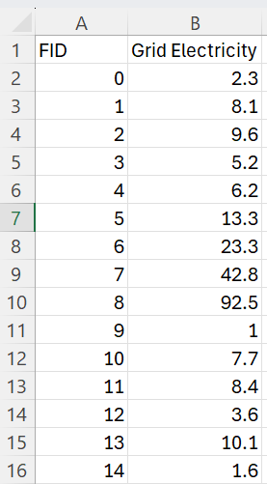
Go to File > Save As and save the file as a .csv to your local computer. Be sure to give the file a descriptive name including the lighting source.
Example: UGA_region_lighting_electricity.csv
5. Your .csv file is now ready to display region-level data for the lighting source.

IX. Setting up CSV Dataset in EAE
1. Open the datasets table for Uganda Training and create a new dataset (same as previous exercises) with a category of ‘indicator – Administrative Boundary Indicator’ Save it.
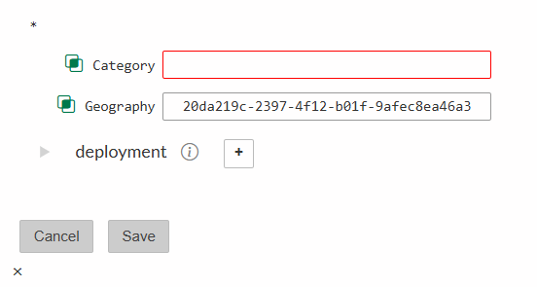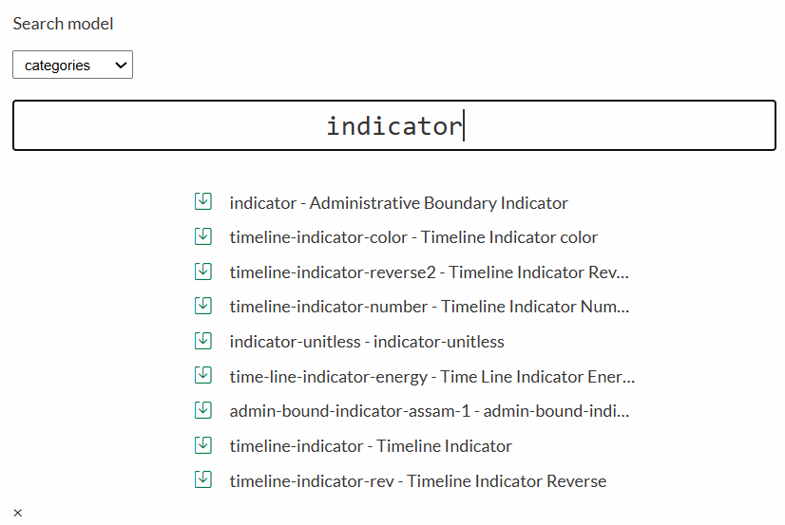
2. Name your dataset and then go to the ‘Source Files’ section of the record. Indicate that the data type is ‘csv’ and then upload the file to the ‘endpoint’ field from your local computer where you have the file saved. Save after inserting the source file.
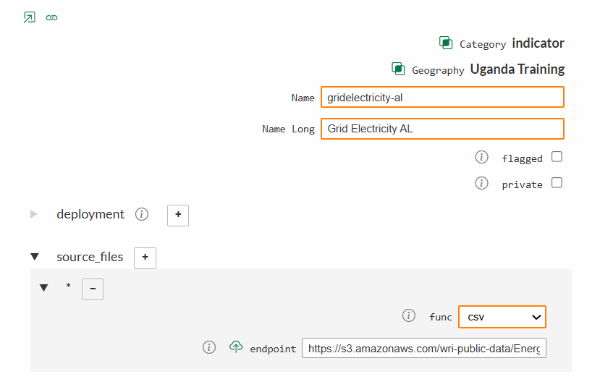
3. Click the edit icon for this dataset and navigate to the vectors_configuration section of the record. In the ‘divisions_tier’ field, type ‘2’ to indicate that this data is linked to 2nd-level administrative divisions (Subregions) and in the ‘csv_column’ enter the column header corresponding to the data indicator ‘Grid Electricity’.
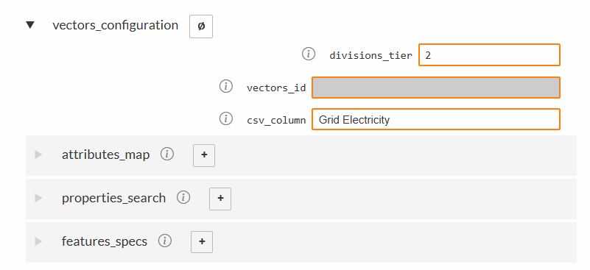
5. Deploy your record in the training environment. You may now save and exit the dataset record.
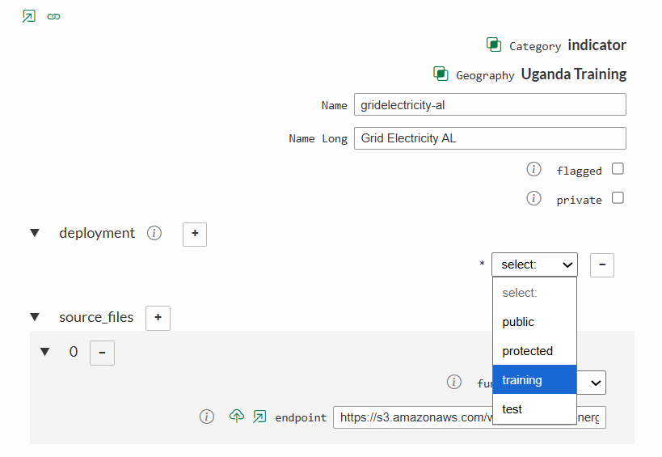
6. Test the record in the EAE training environment, refreshing your browser if necessary. You should be able to view, query, and filter on the census indicator you’ve uploaded.
