Energy Access Explorer
Hands-on 4: Using the EAE front-end interface
License:
This work is licensed under the Creative Commons Attribution 4.0 International License (CC BY 4.0). To view a copy of this license, visit https://creativecommons.org/licenses/by/4.0/.
Attribution:
Please cite as: Woldeamanuel, A. A., Khalid, A., Anand, S., Sahar, T., Saklani, A., Sinclair-Lecaros, S., Mentis, D., Ronoh, D., & Stockman, J., 2026. Data Driven, Integrated and Inclusive Energy Planning with Energy Access Explorer. Version 1. Climate Compatible Growth Teaching Kit Website, Climate Compatible Growth.

Learning outcomes
By the end of this exercise, you will learn how to:
1) Learn to navigate EAE’s front end interface
2) Visualize various combinations of datasets on energy demand and supply
3) Conduct multi-criteria decision analysis to identify high-priority areas

Contents
I. Introductory Exercises
- Census data. Locate the following data for Kasese District.
- Lighting: Subcounty Lighting Electricity % in Kyondo Subcounty.
- Lighting: Subcounty Lighting Electricity % in Muhokya Subcounty.
- Add the following layers and identify:
  - Population density
  - Add Health Facilities
  - Add Satellite base map and Global Horizontal Irradiation
  - Add Hydropower potential - small scale
- Multi-criteria Decision Analysis
II. Multi-criteria Analysis
    - Analysis 1
    - Analysis 2
    - Analysis 3

I. Introductory Exercises
1. Census data. Locate the following data for Kasese County
a) Lighting: Subcounty Lighting Electricity % in Kyondo Subcounty.
On a browser, open Energy Access Explorer using this link: https://www.energyaccessexplorer.org/tool/s/
Select Tool then select Uganda from the geographies listed.
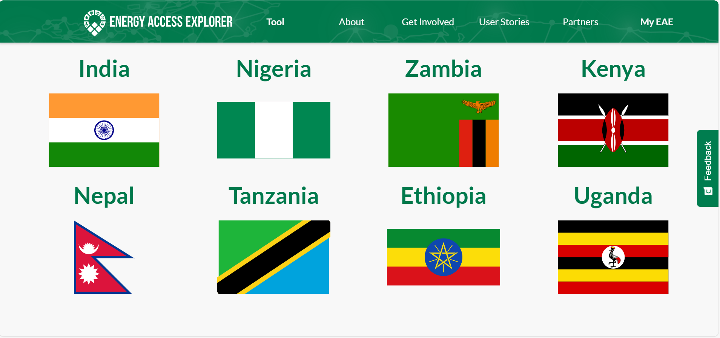
In the pop up that appears of ‘Choose your area of interest’, select ‘Generate custom analysis based on your own criteria’ (select OK if another pop-up message about display settings appears on your screen)
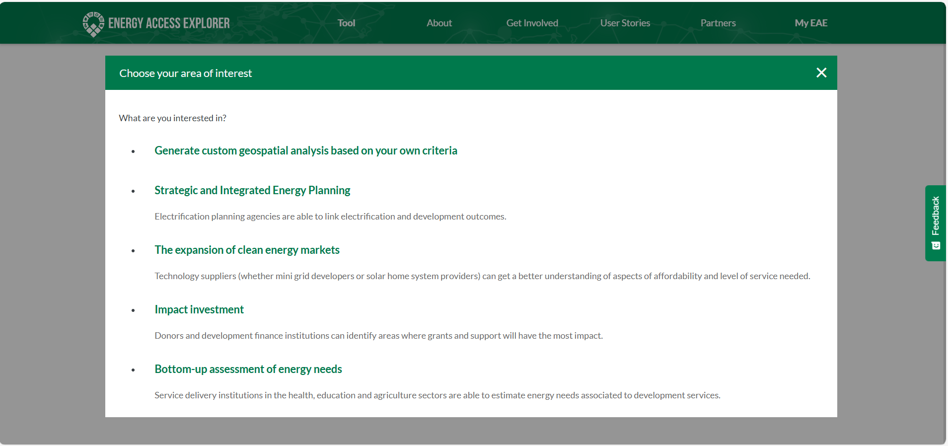
You can see the EAE interface for Uganda where the panel on the left shows the various functions to see active layers, add layers, change geography, search features, find top locations and search POIs. The Generate Analysis section shows the Analysis Area and Prioritization Index as well as the Active Data Layers. When data are selected and loaded to the map window it displays in the middle for visualizations and analysis. The Analysis section in the right panel shows areas for report generation, saving and sharing analysis, area and population share and analysis export.
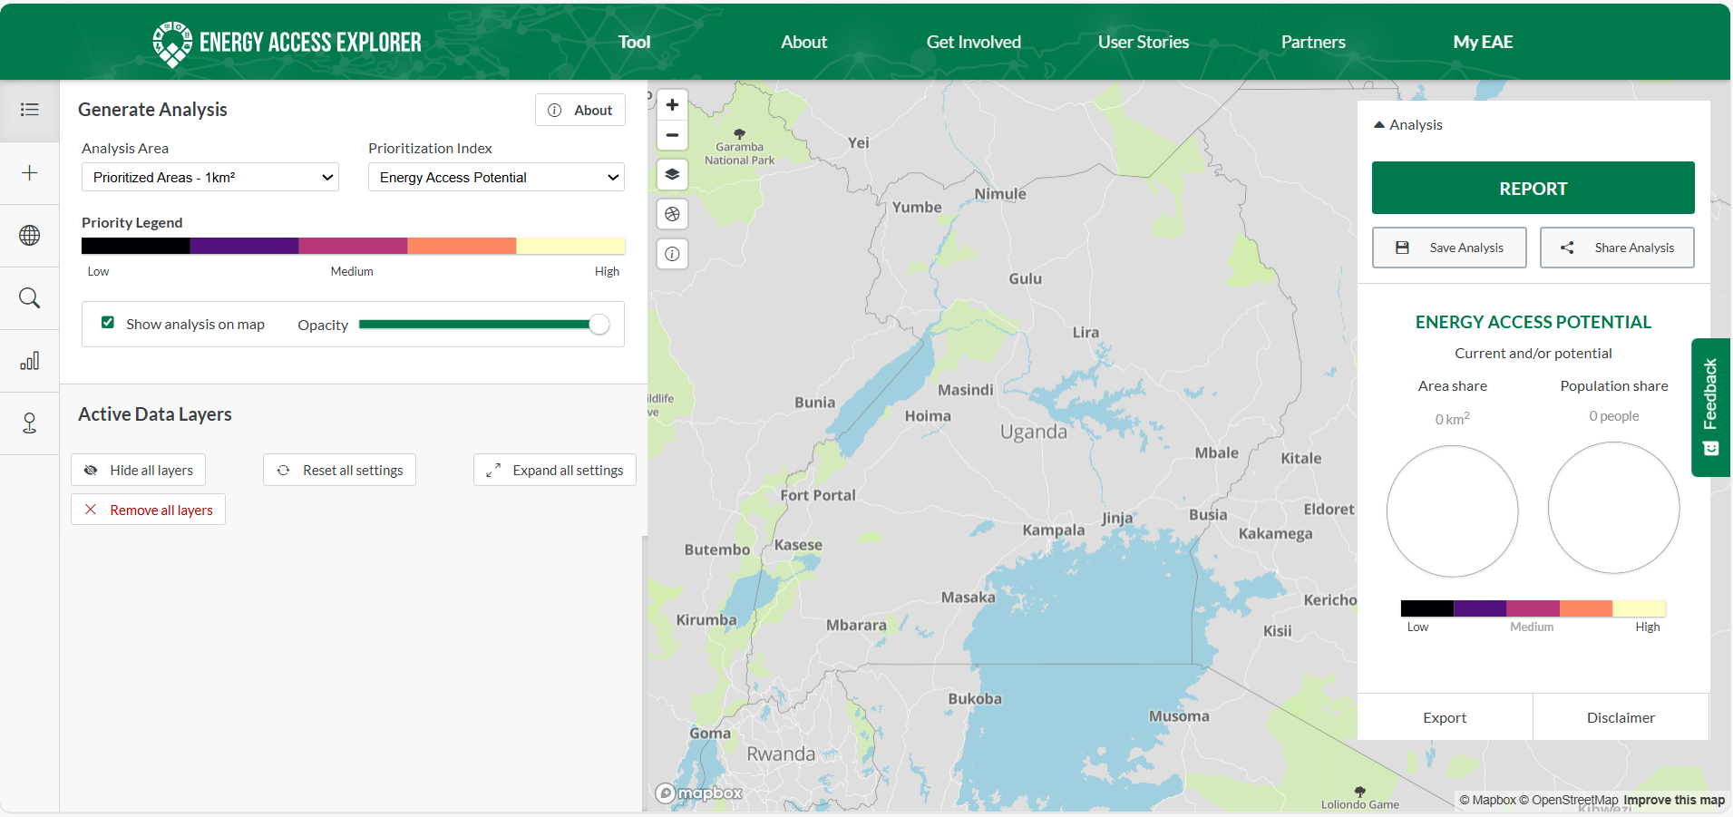
To orient yourself with where Kasese & flag out Kyondo, select Other category in the data panel, then select District under Administrative Boundaries group to load it to the map.
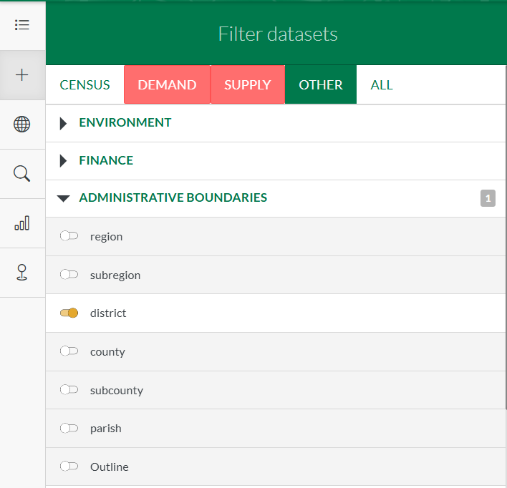
You can zoom and pan on the map till you spot Kasese County. Reduce the opacity of the layer to see the basemap. Use the query tool on the top left side of the middle screen and click on the districts in the southwest of Uganda until you find Kasese district.
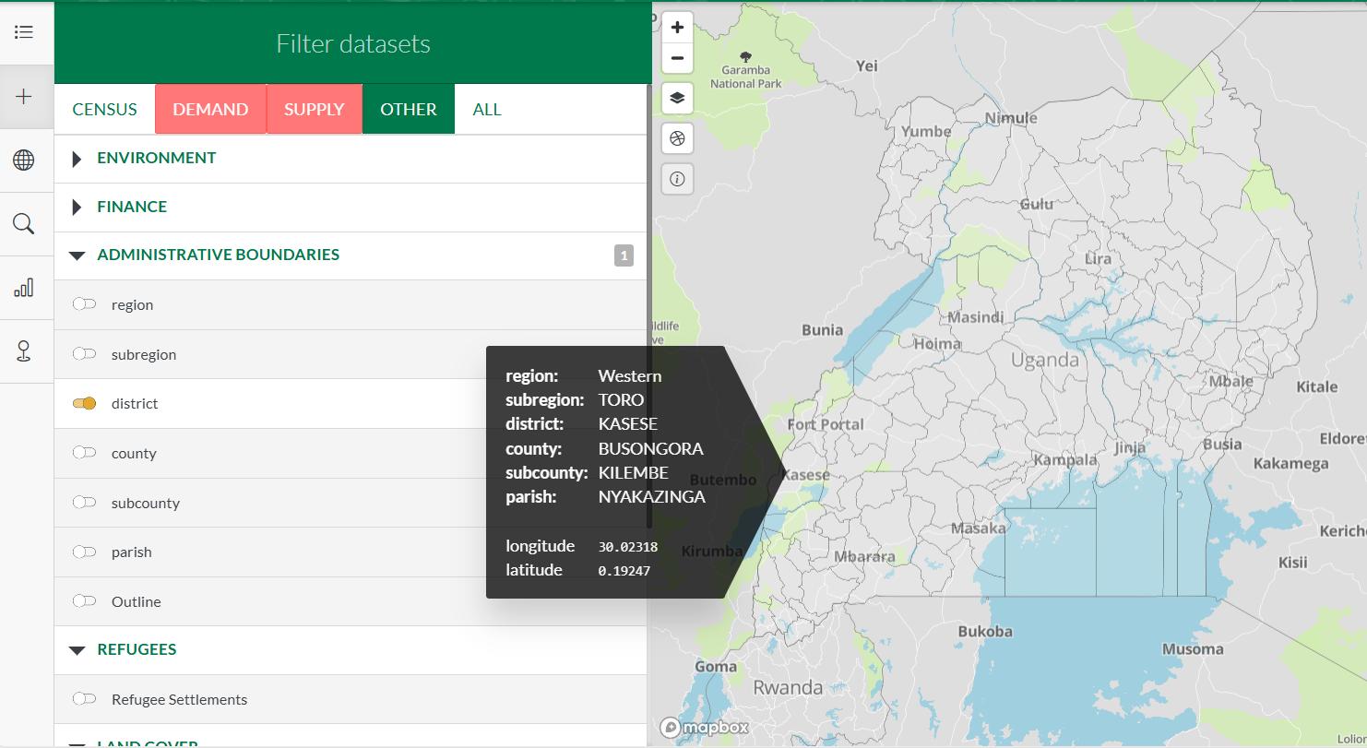
Note: You can also use the search icon 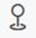in the tools panel on the left to search for Kasese.
In the data panel, select Census category, then scroll down to Lighting District group and select Subcounty Lighting Electricity to load it on the map.
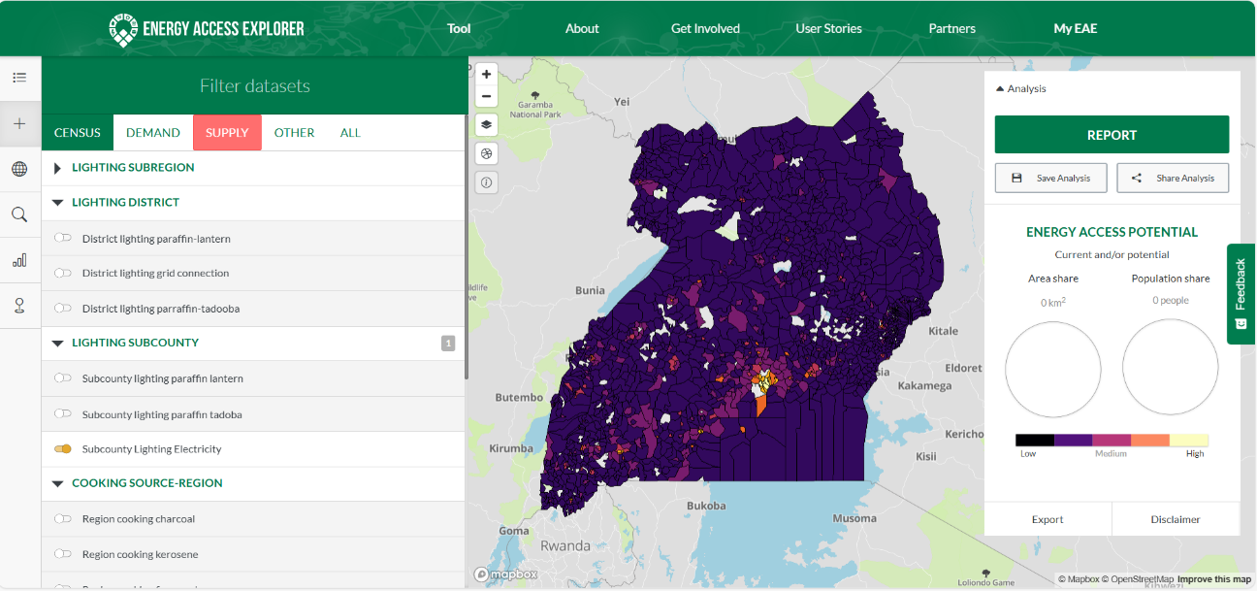
The map window now displays a map comparing household electricity access rate for lighting at the sub-county level in Uganda as per the census data.
Zoom on the map till Kasese County is the center focus on the display.
Use the ‘Active ‘Layers’ tool on the top left panel to see which layers are active on the map.
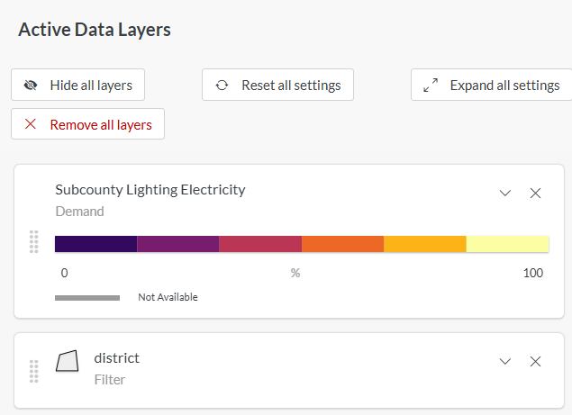
Now expand the Subcounty Lighting Electricity layer and use the Opacity slider button to adjust opacity to about 30% (at least a third). Also increase the transparency of the district layer to 100% in the same way.
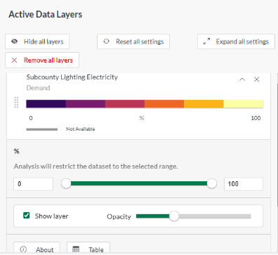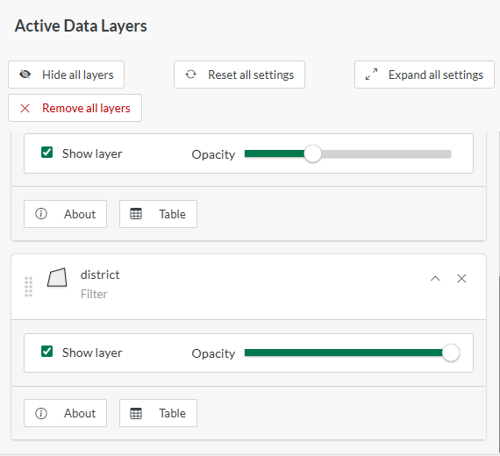
Make sure you can see Kasese county outline from the counties layer as well as the distinct sub-counties boundaries within Kasese from the Subcounty Lighting Electricity layer.
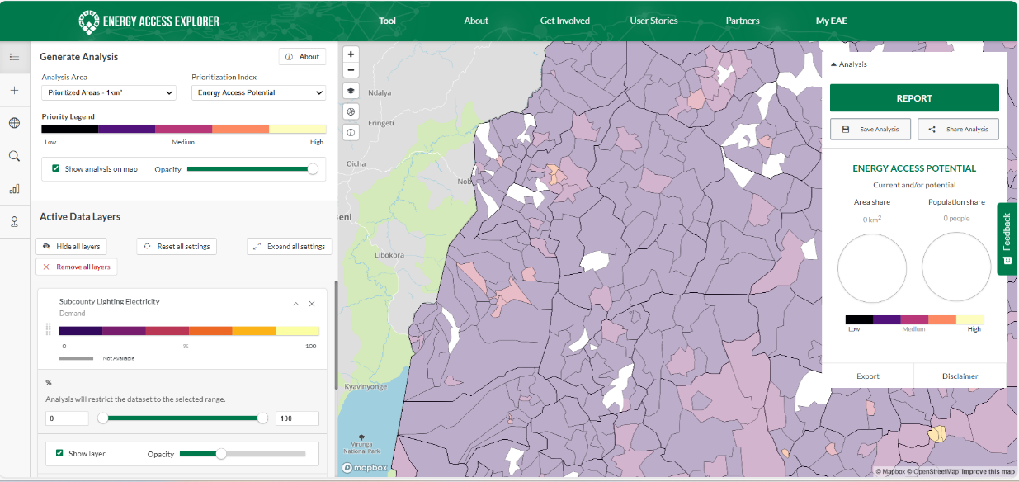
On the map window, use the query tool on the top right side of the screen and click randomly on the sub-counties in the Kasese district on the map till you identify Kyondo subcounty. (As shown below, a pop-up should appear showing the name of the sub-county and the Subcounty Lighting Electricity percentage.
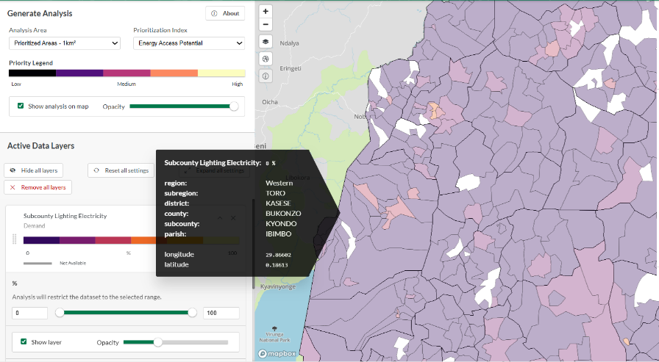
You can also use the Search POI’s tool to locate Kyondo.
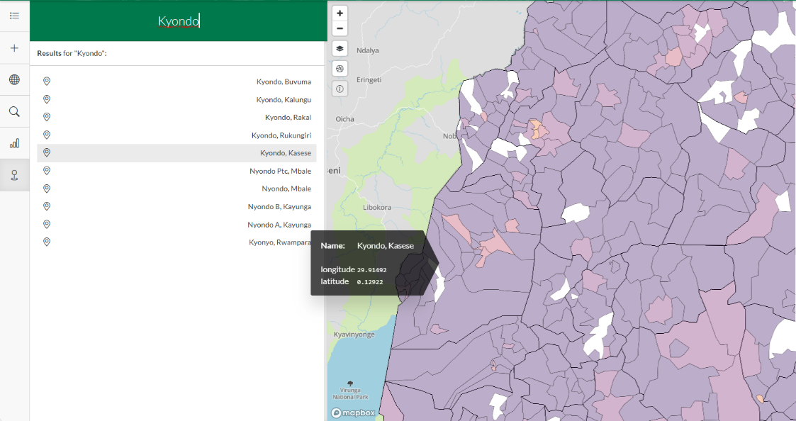
Q: What is the Subcounty Lighting Electricity percentage in Kyondo from the pop-up information?
b. Lighting: Subcounty Lighting Electricity % in Muhokya Subcounty.
Using the same procedure as in (a) above, obtain the percentage of households using electricity for lighting in Muhokya subcounty in Kasese district.
Once done Remove all layers from the Active Data Layers and proceed to the next step.
2. Add the following layers and identify:
a. Population Density
On the data panel, select Demand category, then under Demographics, select Population density to load this data. In the Active layer, unselect the box show Analysis on map
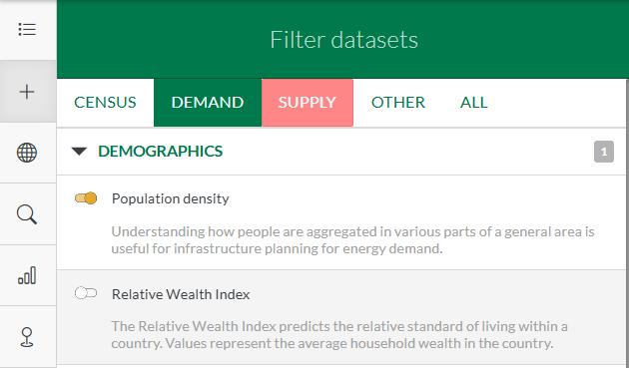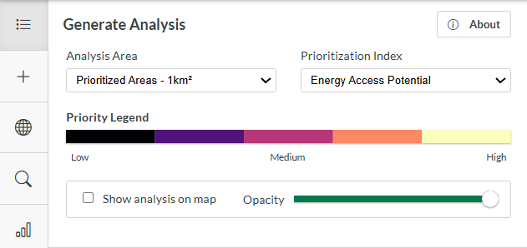
- Locate areas with the highest population density.
On the map window, try to spot the areas with the highest population densities (light-yellow in color).
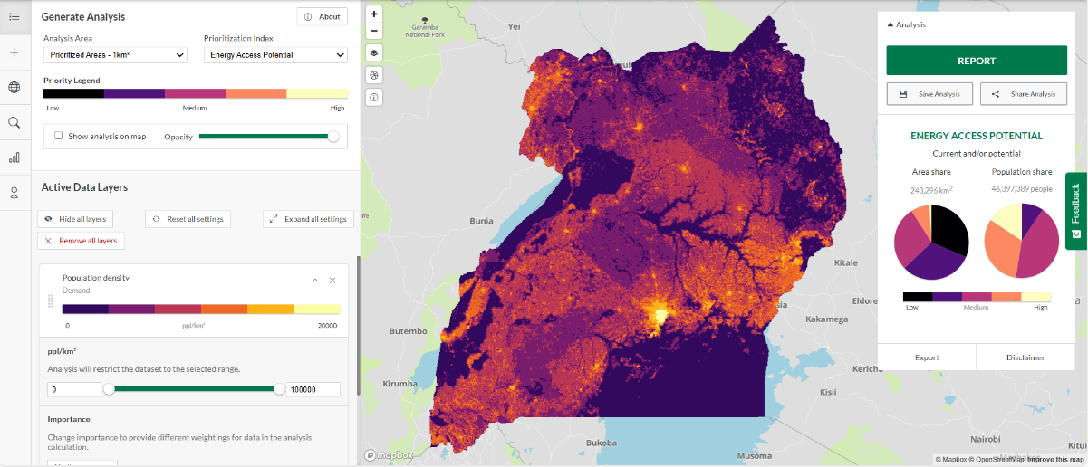
- Locate the town of Mbale.
To orient yourself with where Mbale town is, select Other category in the data panel, then select County under Administrative Boundaries group to load it to the map and reduce the opacity of both the Population density and County in the Active Data Layers.
Note: You can also use the search POIs in the tools panel on the left to search for Mbale.
Zoom in to Mbale County (Eastern part of Uganda) and notice as you zoom in the names of towns appear.
Once you spot the name ‘Mbale’ you can drag the population density layer above the counties layer in the legend (top right).
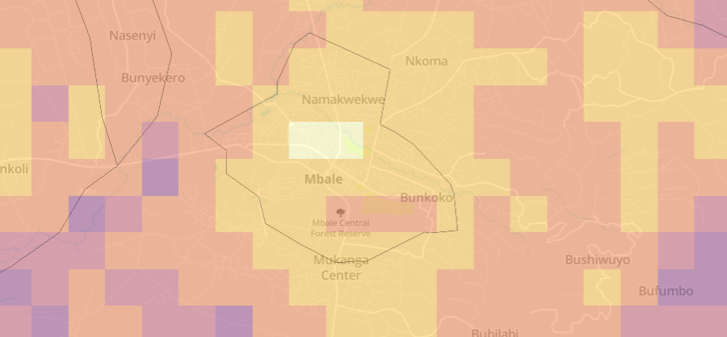
- Locate other major urban centers within Mbale County
Zoom in a bit closer to see other major towns labels appear on the map.
You can adjust the opacity of population density layer till you can see the boundary of Mbale County (about 60% will do).
Q: Pan the map and identify and list at least 5 towns you can spot within the boundary of Mbale County then list them here:
- Town 1:
- Town 2:
- Town 3:
- Town 4:
- Town 5:
b. Add Health Facilities
- Locate Health facilities in Mbale County. Indicate attributes under Health Facilities.
Leave the map still on the same display scale where you can see the Mbale County boundary.
On the data panel on the left, select Demand category then Health Facilities under Productive Uses.
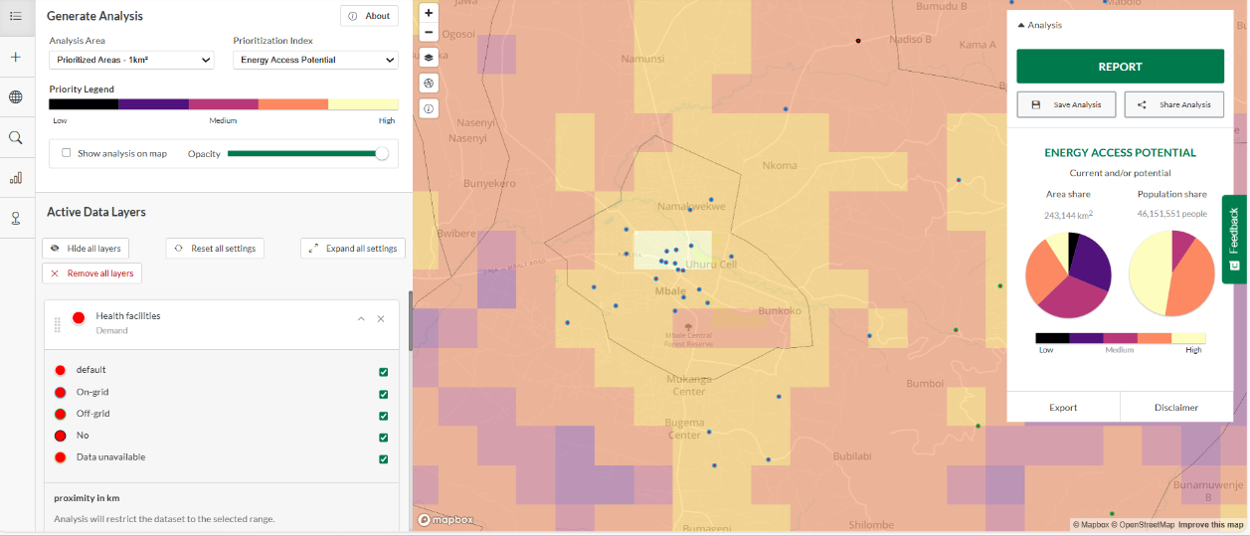
Once the health facilities load on the map, use the identify button to click on a health facility in the map within Mbale county. You can zoom in a bit closer to identify and click one health facility at a time. The health facilities are colored differently based on their electrification status. See the left panel.
Q: You should see a pop up with attributes of the health facility. List them here:

On the Active Data Layers, click Remove all layers from the map display. (You can also switch them off from the data panel).

c. Add Satellite base map and Global Horizontal Irradiation

Use the basemap switcher button on the map window to switch on the Satellite basemap.
On the data panel, select Supply then Global Horizontal Irradiation under the Resources group.
You can use the opacity slider on the GHI layer to compare with the satellite basemap below it. Once done put it back to 100% opacity.
- What is the solar irradiance range (max-min) found in Moroto district?
Select the identify button on the map window and click on the darkest orange section of the GHI layer within Moroto County boundary to see the maximum solar irradiance value from the pop up that appears.
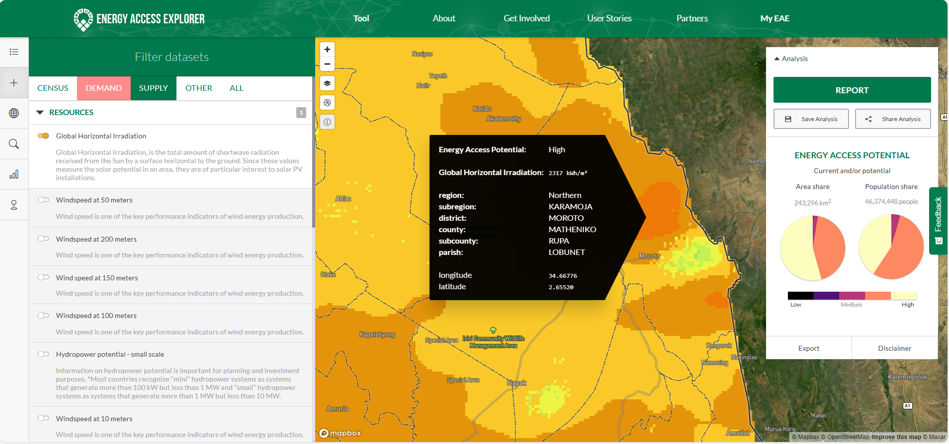
Q: Now click on the light blue section of the GHI to get the value of the minimum solar irradiance and list it here:
- What is the solar irradiance in Nakapelo?
Zoom in closer on the map till you can see the town names appear.
Q: Locate ‘Nakapelo’ town on the map (should be around where the highest GHI value in Moroto is) and click on it to see the solar irradiance value and note it here:
Remove all layers before proceeding to the next activity.
3. Multi-criteria Decision Analysis
Here you will do an analysis to identify areas in Napak County that are not within the range of the grid and estimate the population (nationally) also far from the grid.
Add Population density layer (Demand category).
Now under Supply/Infrastructure, add Distribution lines layer to the map.
Make sure you are centered around Napak County (Search using POIs to locate it)
In the active layer, under the Distribution lines layer, you will see the proximity in km slider and boxes on both sides that show the minimum and maximum values of the filter you set. You will set values manually to filter the areas on the map at custom defined distances away from the distribution lines.
Type 2 for on the left box and leave the one on the right with its default value of 700. See below.
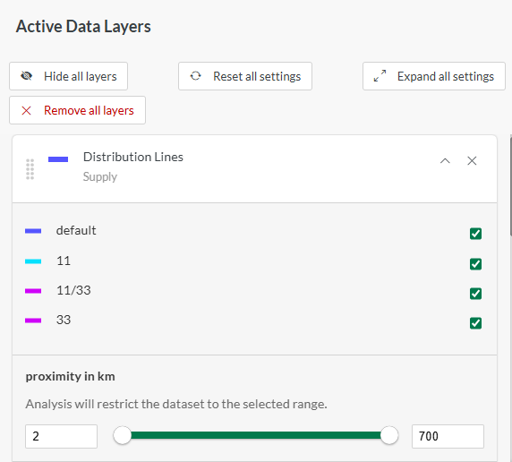
On the Active Layers, select Show analysis on map under Generate Analysis and unselect Show layer under both the Population density and Distribution lines layer to locate areas within Napak county that are at a distance of 2km and above away from the distribution lines.
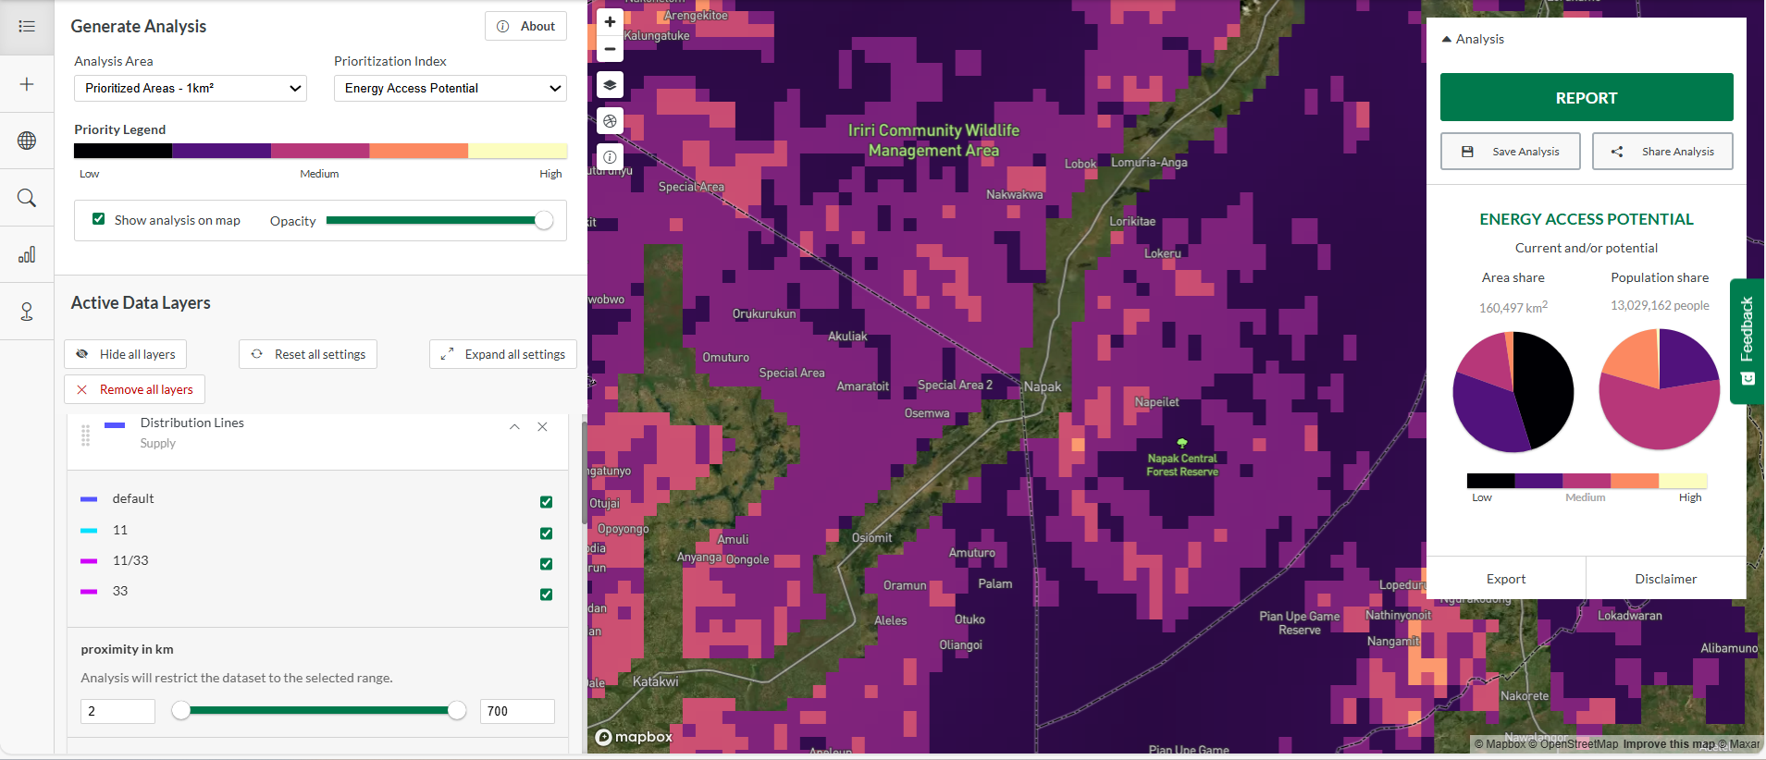
Select the Change geographies button & under Geographies Search, type ‘Napak’ to filter it out from the list & select it to only visualize results from Napak Town Council on the map.
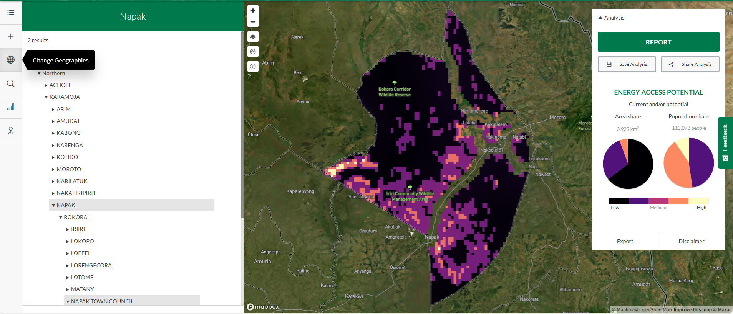
Q: Which areas seem to have high population density and are far from the distribution lines?
In the Change geographies window, click on Uganda to zoom out the map and see analysis results of the whole of Uganda.
On the right panel, you can see the Energy Access Potential indicated as either Low, Medium and High as well as additional statistics on Area and Population share.
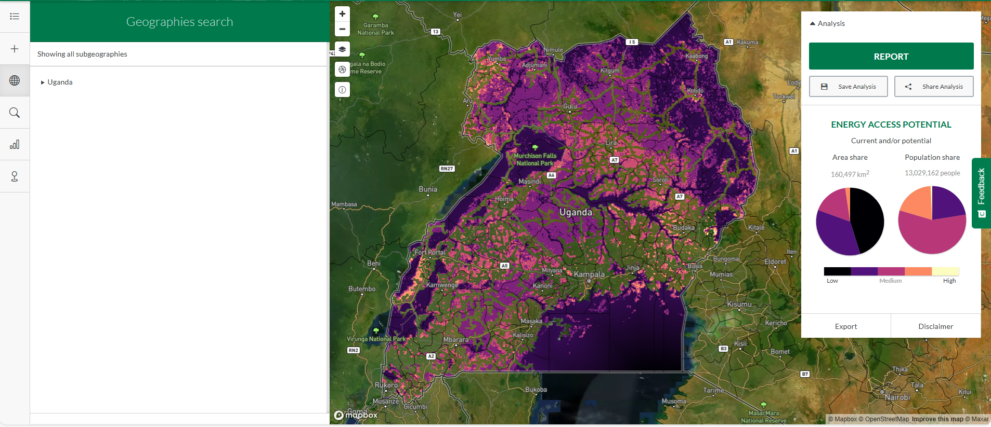
Q: Locate some areas where the energy access potential is high i.e., where population is high (demand) and not too far from the distribution lines (supply).
You can use the top locations button to see the top 20 locations that the system identifies with highest energy access potential and click some of them to zoom in the map to view their locations. Use the identify button to click and get more info on these top locations.
Q: What is the total population and area listed for Uganda which is located above 2km away from the distribution lines? (See panel on the right).
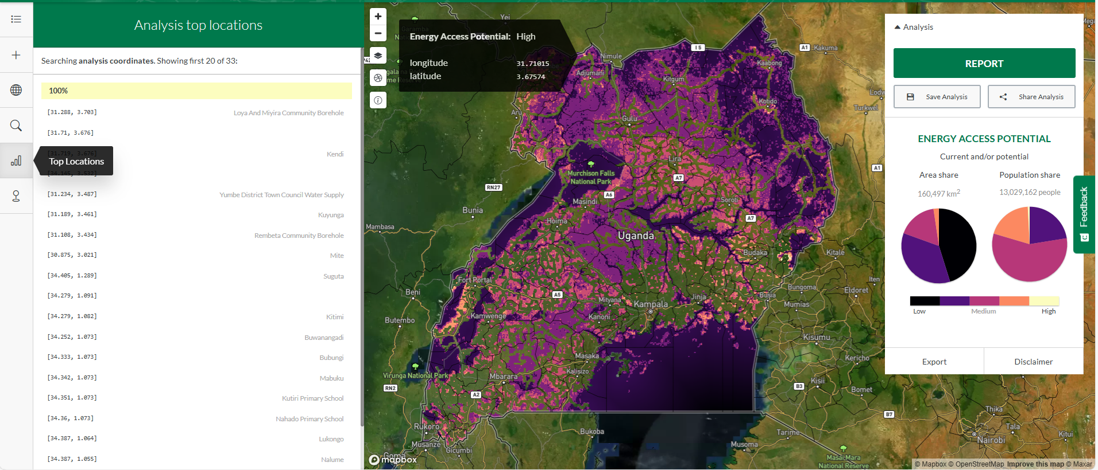
Add Relative Wealth Index data under Demand-Demographics
The Relative Wealth Index predicts the relative standard of living within a country. It is built using digital connectivity, satellite data, and other indicators. Values range from -2 to 2, with 0 representing the average household wealth in the country.
Below the Relative Wealth Index data in the Active Layers, type 0 on the left box and leave the one on the right with its default value of 2.
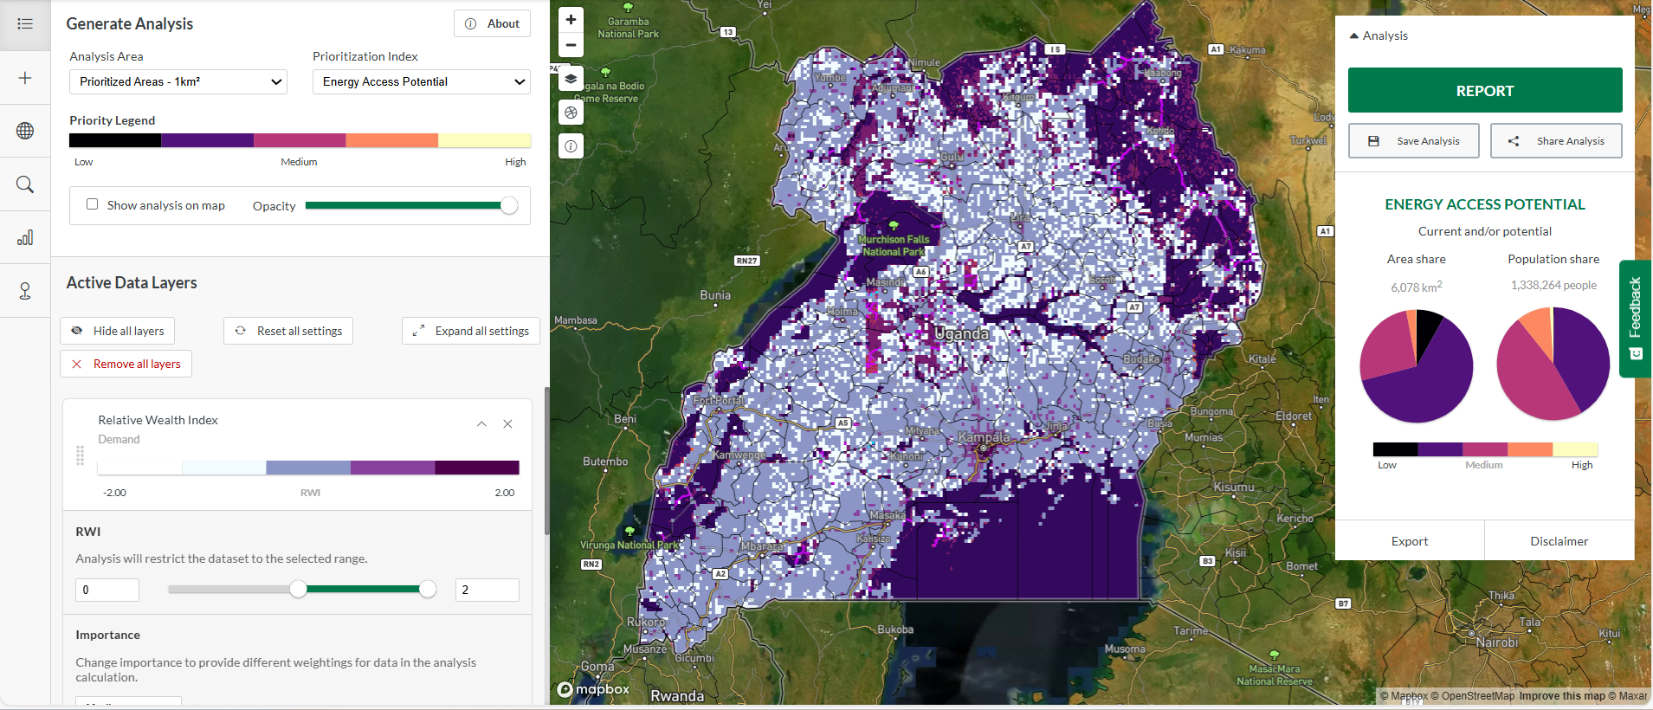
The map now displays areas in Uganda with populations living 2km away from the distribution lines and are living above the average household wealth in the country, thus have potentially ability to pay for energy services supplied to them.
Hide all layers from the Active Data Layers and change the basemap to Basic (default
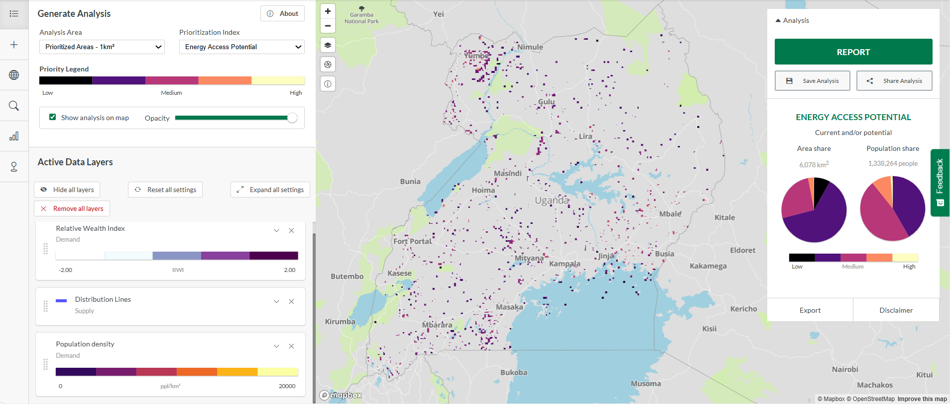
Q: What is the total population living 2km away from the distribution lines and are living above the average household wealth in Uganda?

You can change the values of the Relative Wealth Index filters to a maximum of 0 and minimum of -2 to see the populations living below the average household wealth. These populations would likely require assistance to acquire energy services.
Click on Report to get a snapshot of the summary table and graphs as well as export the presentation.
Then, close the snapshot and Remove all layers from the Active Data Layers.

II. Multi-criteria Analysis
Analysis 1
- Add Population density and Healthcare Facilities
On the dataset panel on the left (Add Layers), and under Demand category, add Population density and Healthcare Facilities
Questions
- Are there any areas that appear with a high energy access potential (lightest color)? Choose one of these areas and explain why this could be high. (Hint: Show analysis on map should be selected in the Generate Analysis section and Hide all layers from the Active Data Layers)
- Estimate the total population near one of the areas with high energy access potential. (Hint: use identify tool).
- Locate the areas near healthcare facilities but not within range of the grid. (Hint: Add distribution lines and set filters of your choice for distance away from grid e.g., min:2km away, but close to the healthcare facilities e.g., max:5km nearby, make sure to Hide all layers from the Active Data Layers)
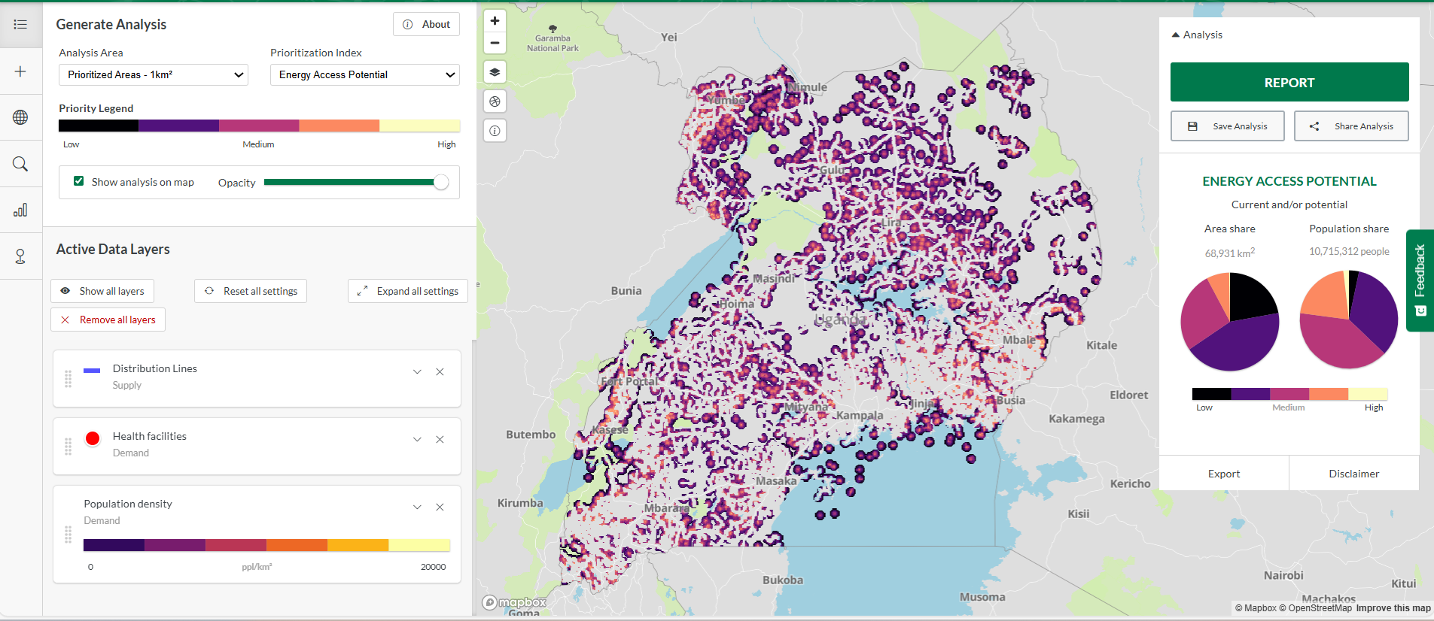
- Get the top 20 locations that meet these criteria and select the first location to view where it is located on the map (Hint: use top locations tool on the left panel)
- Unselect Show analysis on map from Generate Analysis section and Show all layers from the Active Data Layers. Then, select the health facility that falls within the top location and indicate its name, electrification status and current electricity source from its attributes. Remove all layers after completing this exercise

Analysis 2
- Add Population density and GHI. Locate areas with high global horizontal solar irradiance.
Using Add Layers and under Demand category, add Population density layer to the map. Then select Supply category and add Global Horizontal Irradiation.
Questions
- What is the total area in Uganda with high solar irradiation? (Above 2,000 kWh/m²)
(Hint: Use the filters on the GHI layer and check the Energy Access Potential panel in Analysis view, select Show analysis on map and Hide all layers)
- What is the total population in Uganda within this area of high solar irradiation? (Above 2,000 kWh/m²)
- Add a healthcare facilities dataset to the map. What is the solar irradiance potential in the areas where these healthcare facilities are located? Do you think solar can be a viable electrification option for them?
- Arute HC II:
- Nakiloro HC II:
- Kateta HC III:
(Hint: On the tools panel in the left, open the search POI window and search for the above healthcare facilities then use identify tool to click on the healthcare facility when zoomed in).
- Zoom out to see the entire extent of Uganda. On the panel to the left, see the symbology of all the layers loaded in the map.
- Under the Health Facilities data, uncheck all the other points to see only the ones that are Off-grid and see their locations on the map.
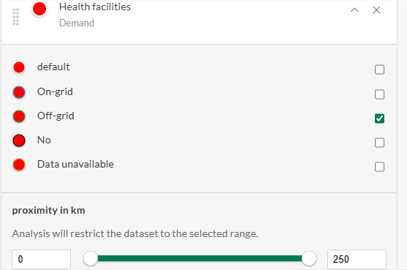
- Click the ‘Change geographies’ tool and select one of the options there. When the map zooms in to your selected extent, click on one of the health facilities and indicate its name, required power capacity (kW), daily elect. Requirement range (kWh), and annual electricity requirement (kWh). (You will notice only off-grid health facilities are displayed since we selected that in the previous step).

Analysis 3
- Add population density & Nighttime Lights.
Using Add Layers and under Demand category, add Population density layer to the map. Still under Demand category add Nighttime Lights under Productive Uses group.
Questions
- What is the population with nighttime calibrated radiance of below 20? (Hint: Use filters calibrated radiance. Min=0, Max=20)
- What is the area occupied by the population above?

- Add distribution lines.
Hint: From Supply category.

Questions
- What is the population distant from the grid? (Hint: Use filters, Distribution lines > 2km)
- What is the population in proximity to the grid? (Hint: Use filters, Distribution lines < 2km)

- Add Health Facilities data.

Hint: From Demand category.
Switch to Data tab and and use the ‘Search Features’ tool to search for ‘Nadangira HC III’. When the map zooms to its location, select it and list its load factor, catchment population and allocated number of beds.

