Energy Access Explorer
Hands-on 3: Working with vector, rater & tabular data
License:
This work is licensed under the Creative Commons Attribution 4.0 International License (CC BY 4.0). To view a copy of this license, visit https://creativecommons.org/licenses/by/4.0/.
Attribution:
Please cite as: Woldeamanuel, A. A., Khalid, A., Anand, S., Sahar, T., Saklani, A., Sinclair-Lecaros, S., Mentis, D., Ronoh, D., & Stockman, J., 2026. Data Driven, Integrated and Inclusive Energy Planning with Energy Access Explorer. Version 1. Climate Compatible Growth Teaching Kit Website, Climate Compatible Growth.

Learning outcomes
By the end of this exercise, you will be able to:
1) Adjust vector datasets to make them suitable for EAE backend uploading
2) Perform pre-processing with raster datasets for easy uploading into EAE
3) Prepare tabular datasets associated with administrative units for EAE uploading

Contents
I. Working with Vector Data
- Gathering data
- Opening files in QGIS
- Exploring layer properties
- Editing data attributes
- Simplifying lines
II. Working with Raster Data
- Gathering data
- Opening files in QGIS
- Clipping images
- Resampling raster data
- Rasterizing vectors
III. Working with Tabular Data
- Gathering data
- Preparing the table

I. Working with Vector Data
- Gathering data
Download the following datasets from the links provided, extract if they are in zipped folder, and save them in a folder that you can easily recognize on your computer.
- Admin boundaries for Uganda https://data.humdata.org/dataset/cod-ab-uga (Shapefile)
- Uganda – Distribution Lines https://energydata.info/dataset/distribution-lines-2023 (Geojson)
- Uganda Health facilities https://data.humdata.org/dataset/uganda-healthsites (Shapefile)
- Opening files in QGIS
This exercise uses QGIS 3.40.X, you can download and install the latest version from https://qgis.org/
For more GIS tutorials, refer https://www.qgistutorials.com/en/
There are many ways to open a file in QGIS
- First, you can easily open a file by drag and drop or double click on the file from your ‘Browser’ (not a web browser but a function in QGIS). To activate it, go to ViewàPanelsàBrowser (see image below). You can also select Layers from the list so that you can see both the Browser and selected Layers in the left panel of your window. Using this method go to the folder where you save the above files and drag and drop or double click on each to open them (for the boundary data open the national boundary or outline of Uganda with file name: uga_admin0).
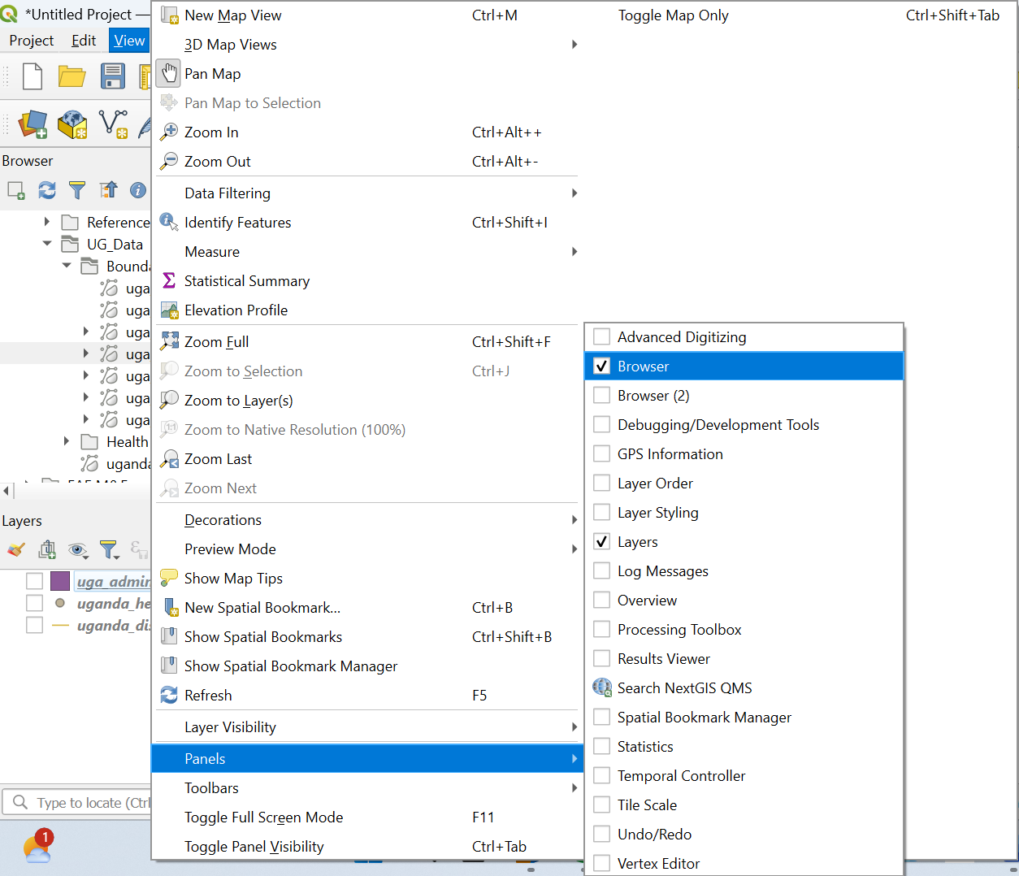
- Second, you can open a file by LayeràAdd LayeràAdd Vector Layer, which opens another dialogue box to bring the file from the source (folder). See images below
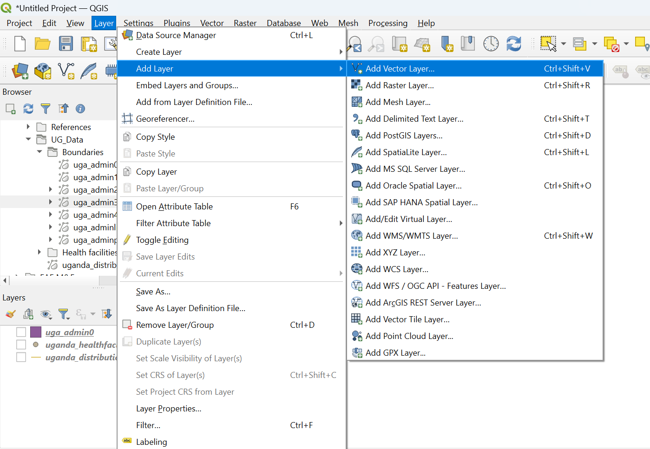
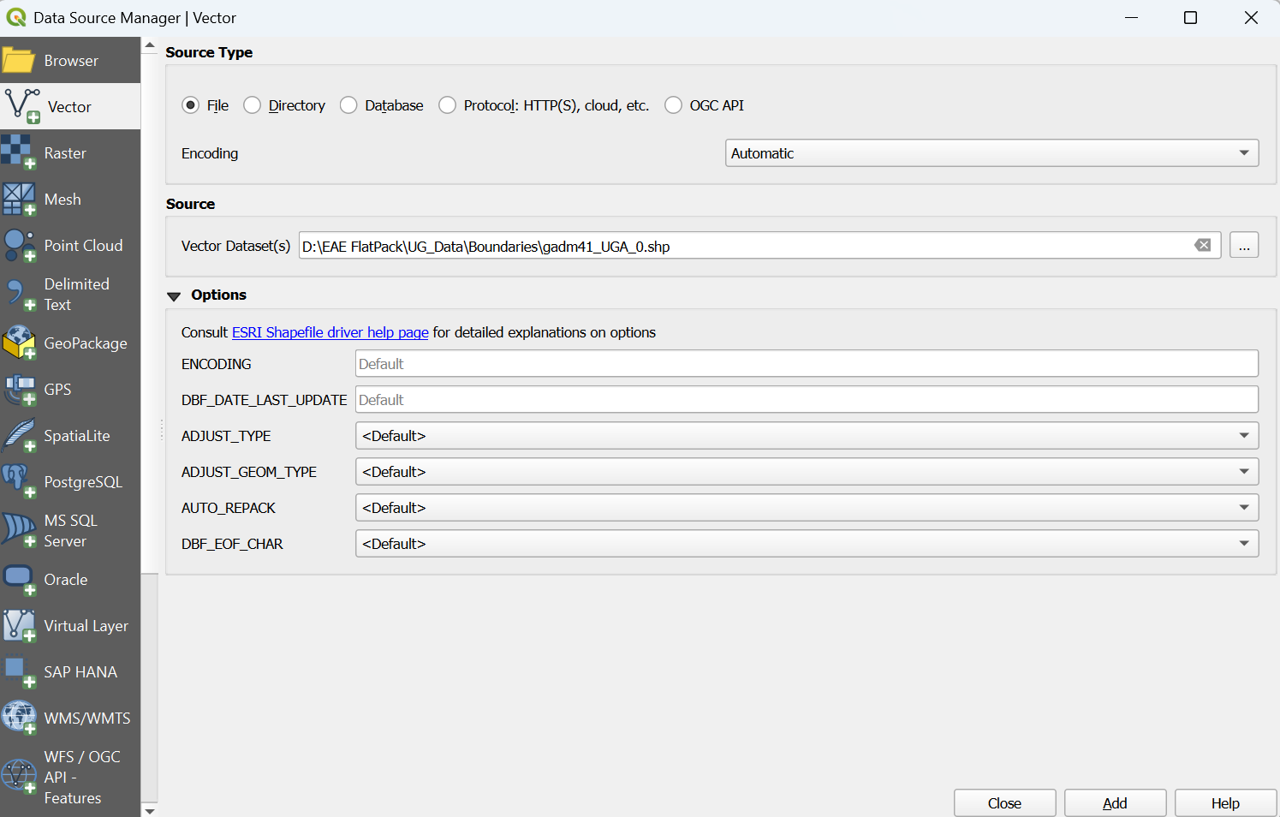
- Exploring layer properties
Right click on the uga_admin0 layer and go to Properties, a layer properties box opens. You can first see the information about the layer. It’s important to check total size, storage type and the coordinate reference system before uploading the file to the EAE content management system later. To directly upload files into EAE, the vector file should be in geojson storage type, total size of not more than 15MB and CRS of EPSG:4326: WGS84. We will see how to convert vector layers into geojson, minimize their size and reproject their CRS in this section. Before that let’s see how to change their symbology and modify fields.
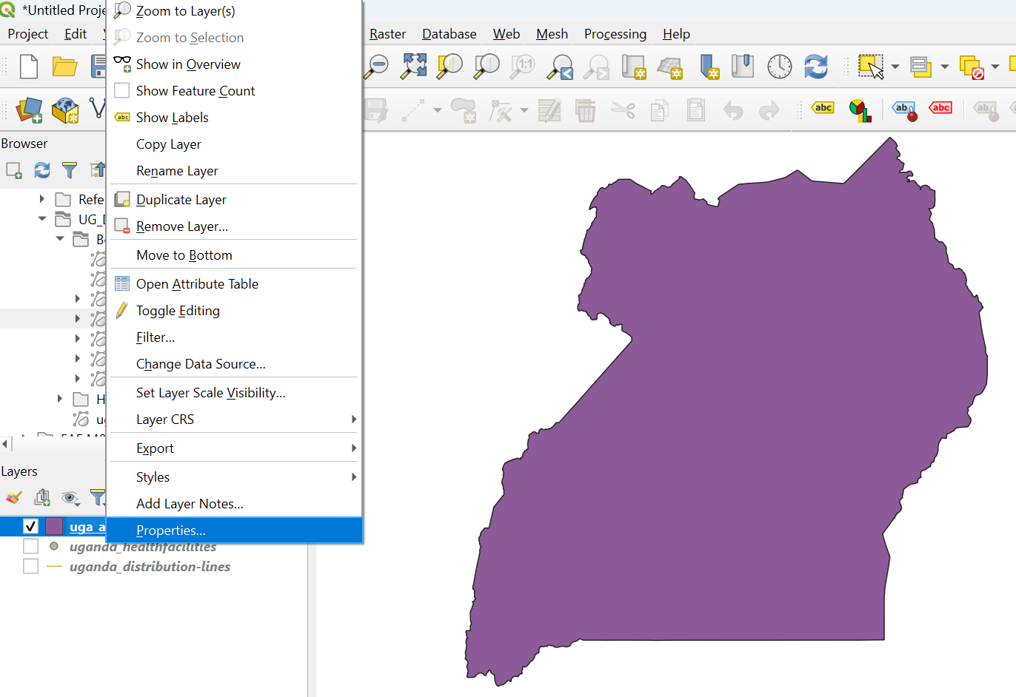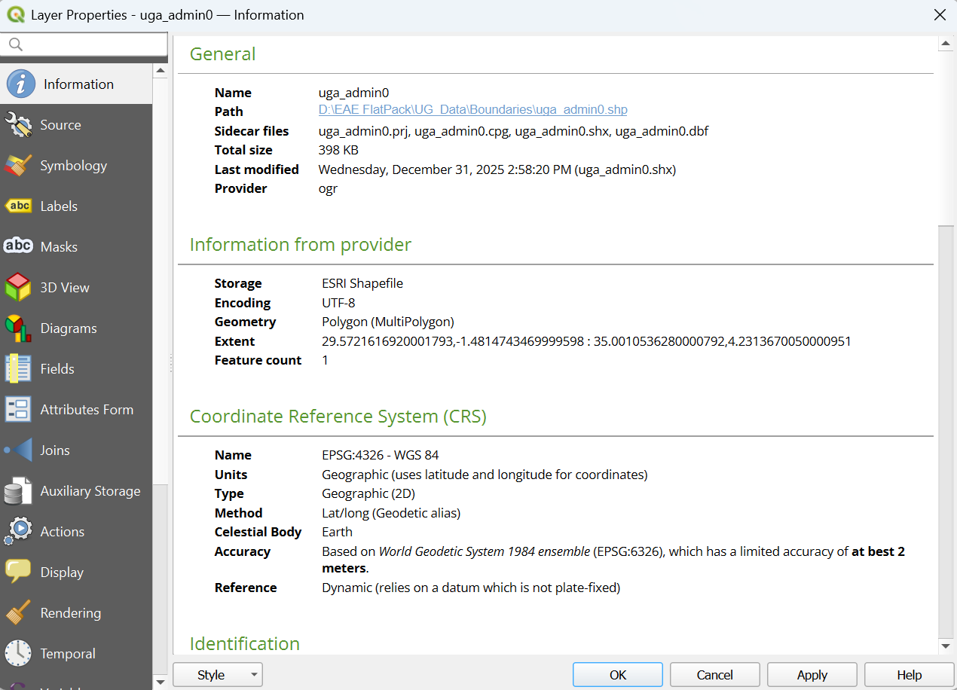
Go to symbology and change the simple fill color to transparent for the boundary layer
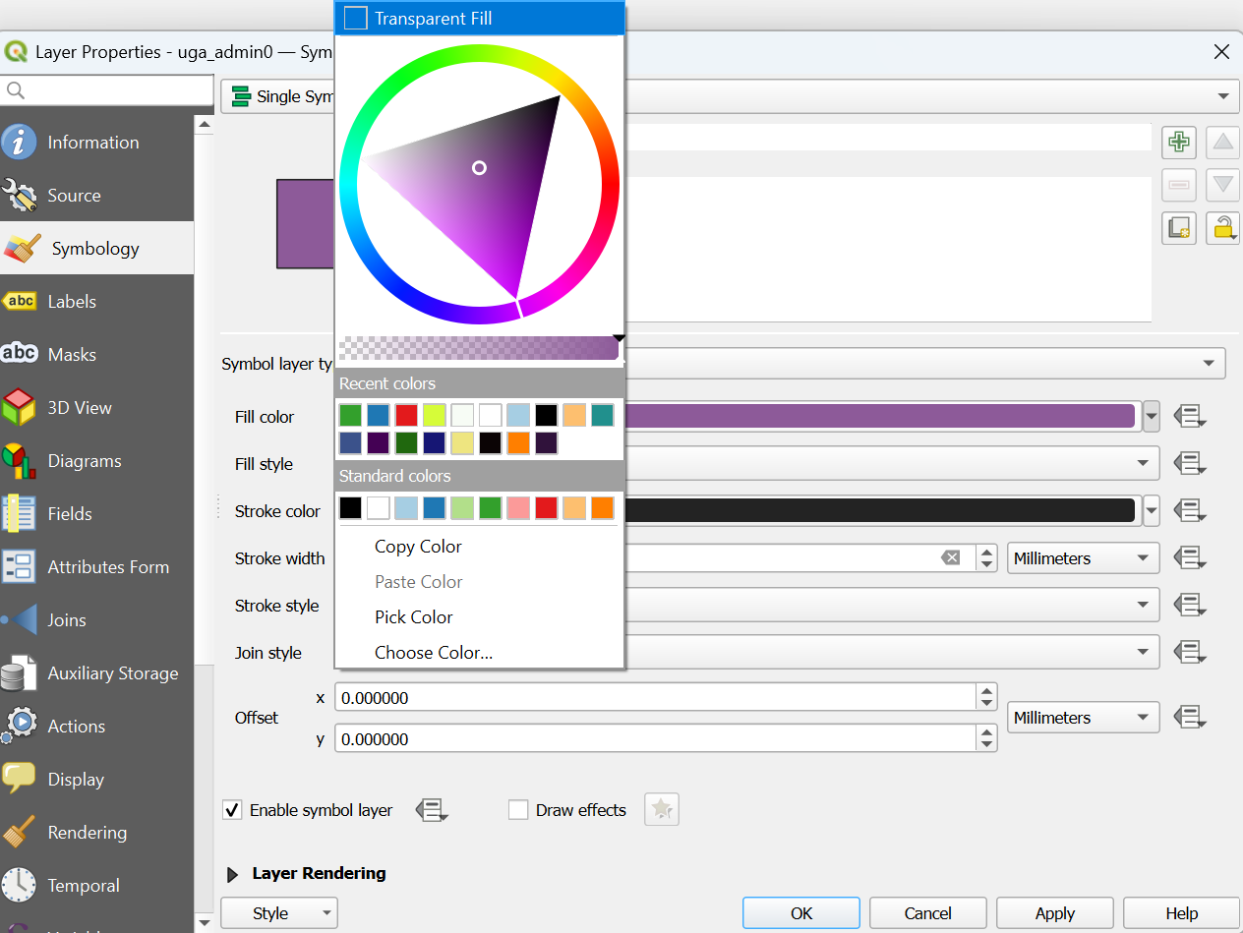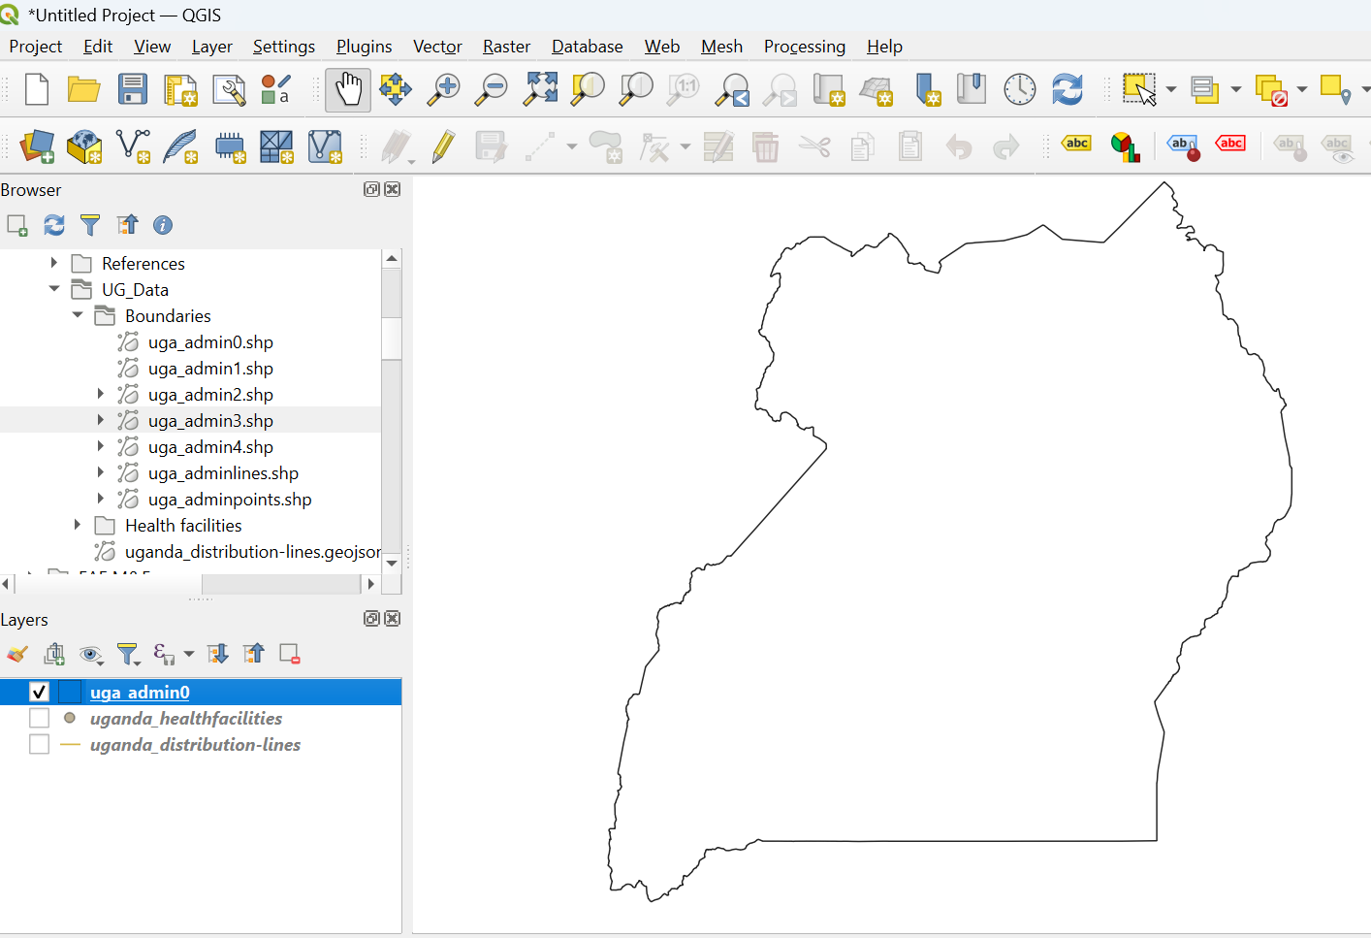

- Editing data attributes
Next, the filed section allows you to examine the attributes and edit them by activating the Toggle editing mode
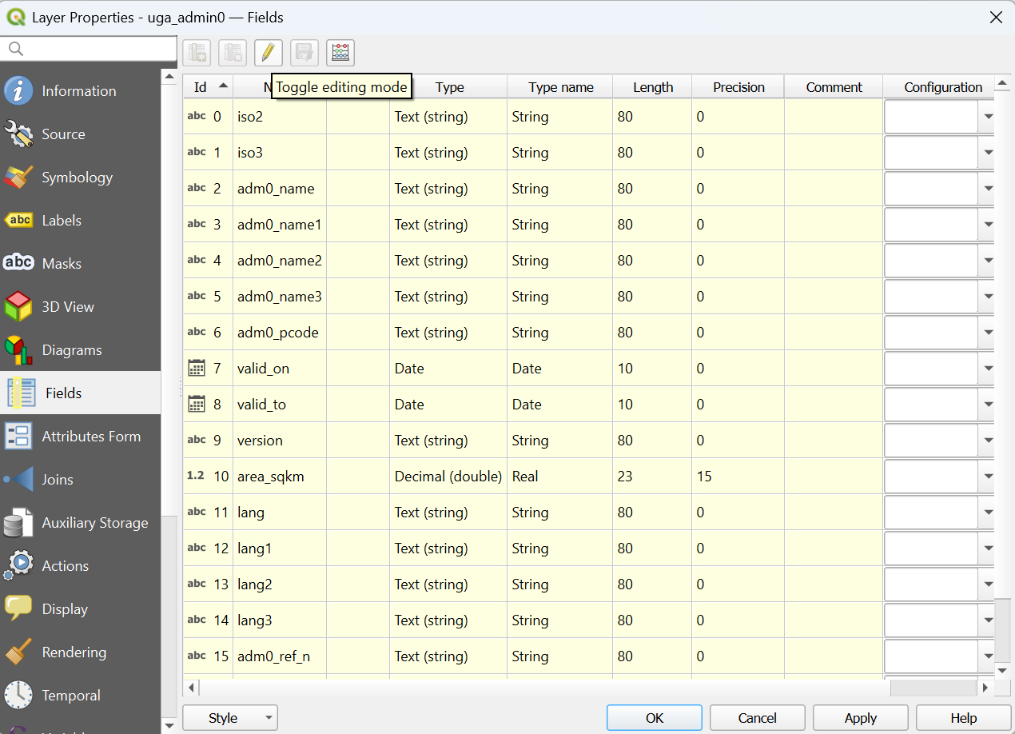
The other way to examine and modify the fields is by opening the attribute table:
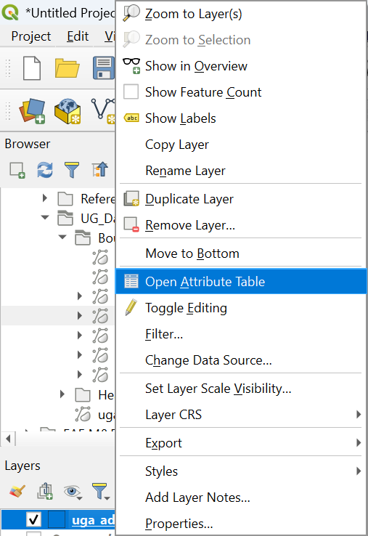
You can also edit the fields here by toggling editing mode so that you can add or delete fields and make calculations using field calculator. Make sure to save your edits and deactivate toggle editing mode once you finished editing to see the changes in the layer.
Let’s see how we can edit the attributes of the health facilities data in Uganda. Select the uganda_healthfacilities layer and check the properties. It has a file size of 17.74MB and it needs to be reduced. One way to do this is by removing some of the fields from the attribute table. Open the attribute table and toggle editing
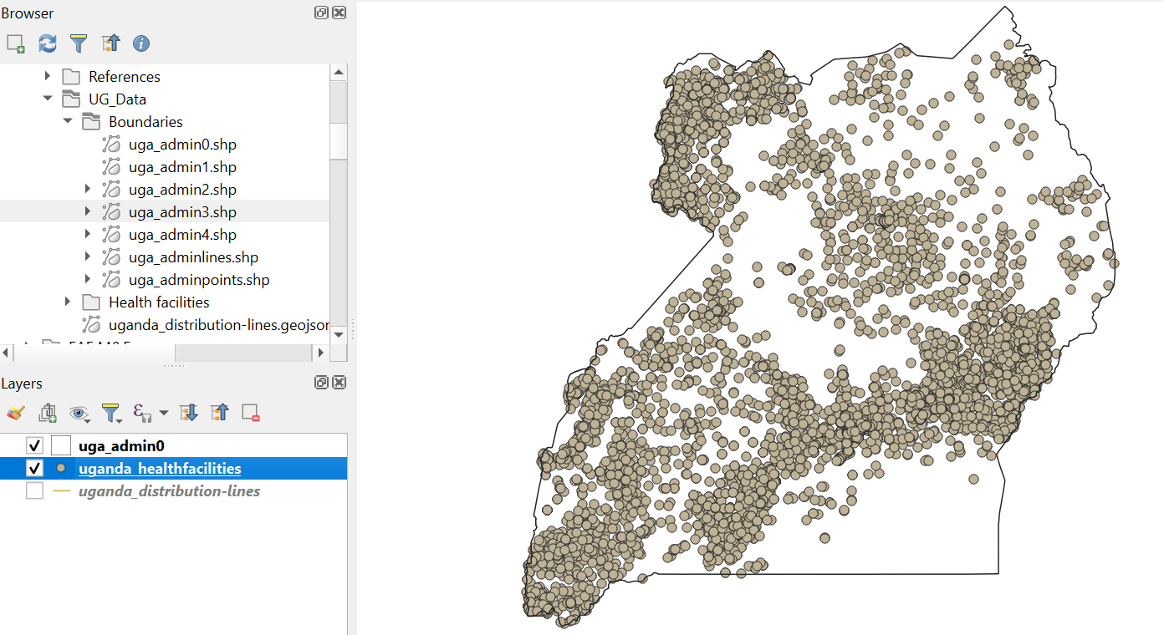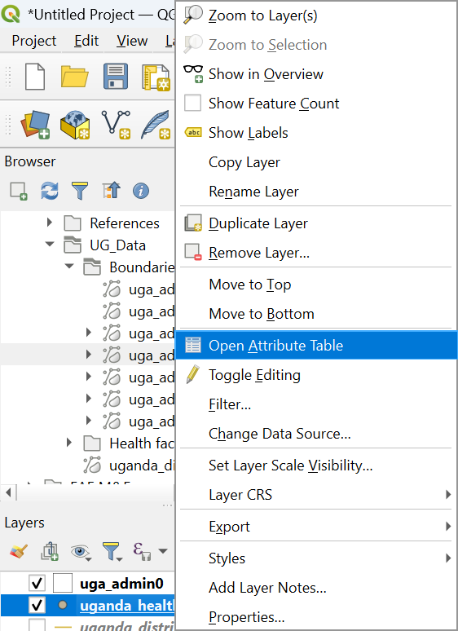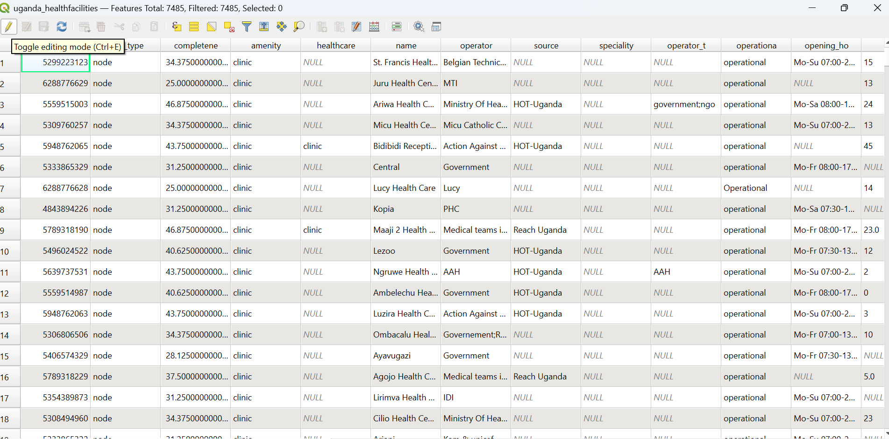
Then click on delete field, select the fields to remove except ‘osm_id, amenity, name, operator and operationa’ and click ok. Make sure to save and unselect the toggle editing mode.
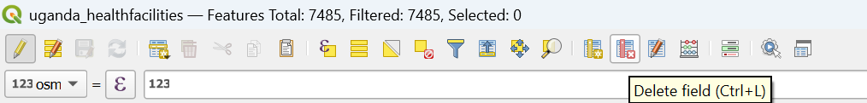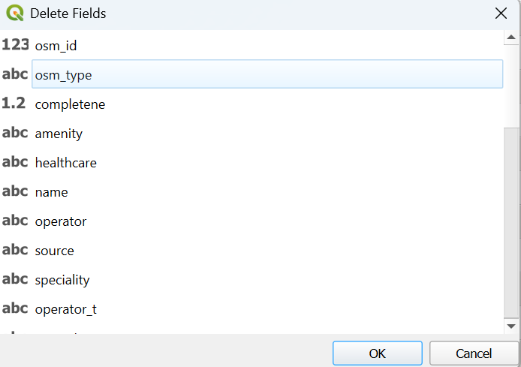
Q1. After removing the fields, what is the layer’s file size? Does the file size satisfy the requirements of EAE (i.e. <15MB) (Hint: check the properties again)
You can also see that the storage type is Shapefile and it should be converted to geojson. To convert the storage type to geojson, right click on the health facilities layer à Export à Save Feature As… Then, in the opening box, make sure Format is GeoJSON and CRS is EPSG:4326: WGS84. Use File name to select the folder for saving the file, name it and save your file.
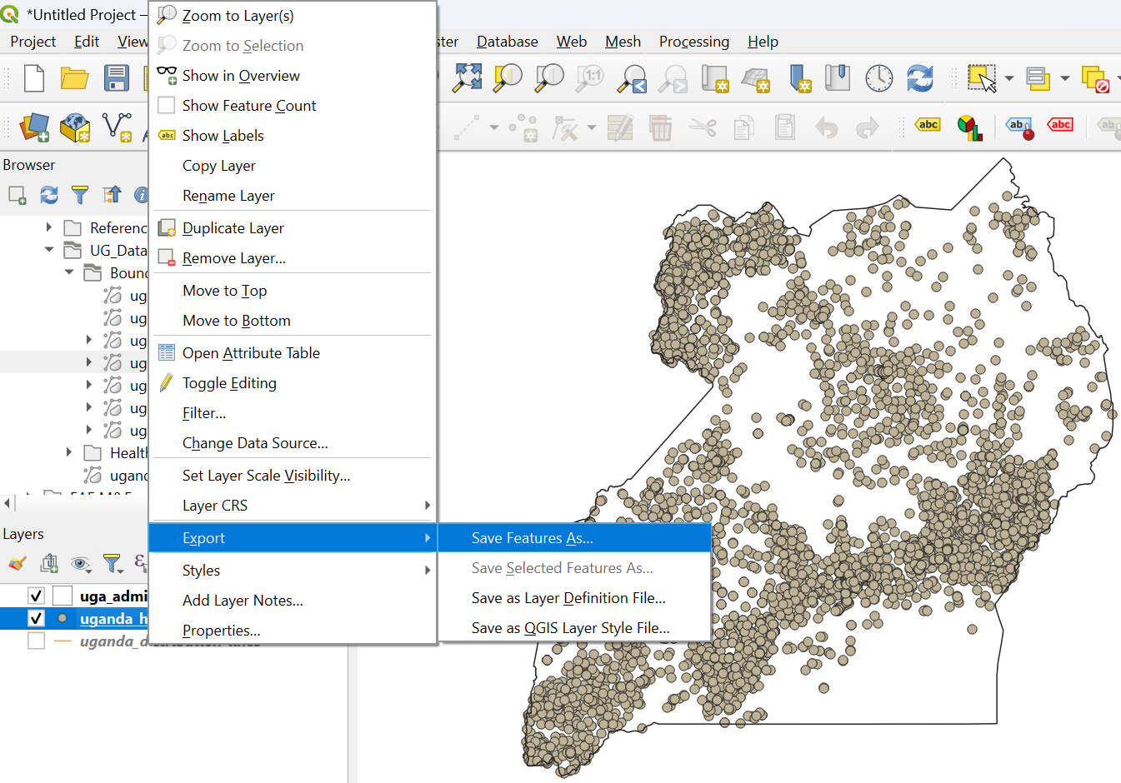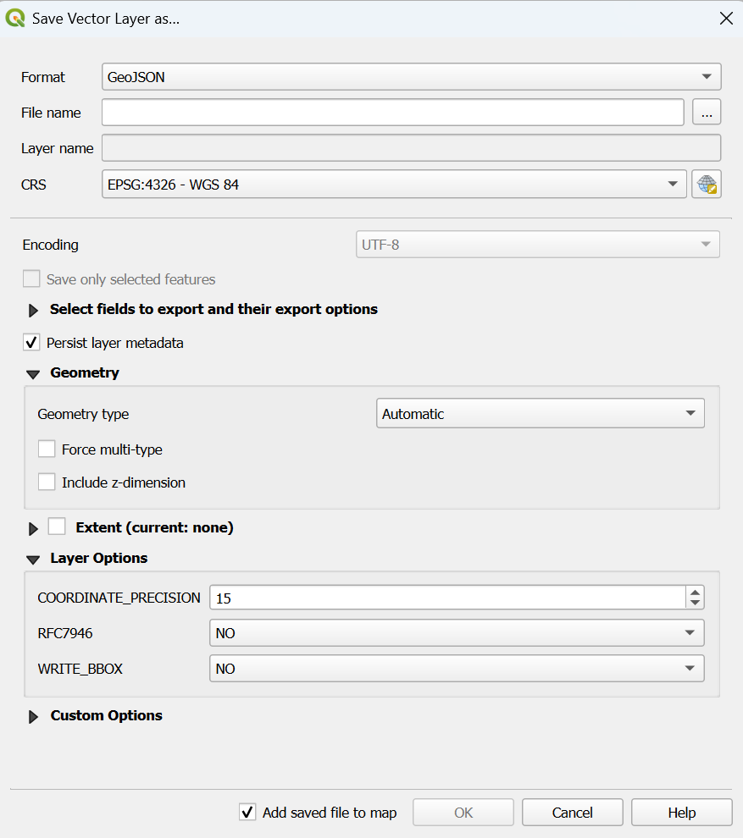
- Simplifying lines
Select uganda_distribution-lines layer and check for its properties. You can see that the file size is 81.56MB and it needs to be reduced before uploading to EAE. Only three important fields exist, and we don’t make changes here. Instead, we will use the geometry tool Simplify.
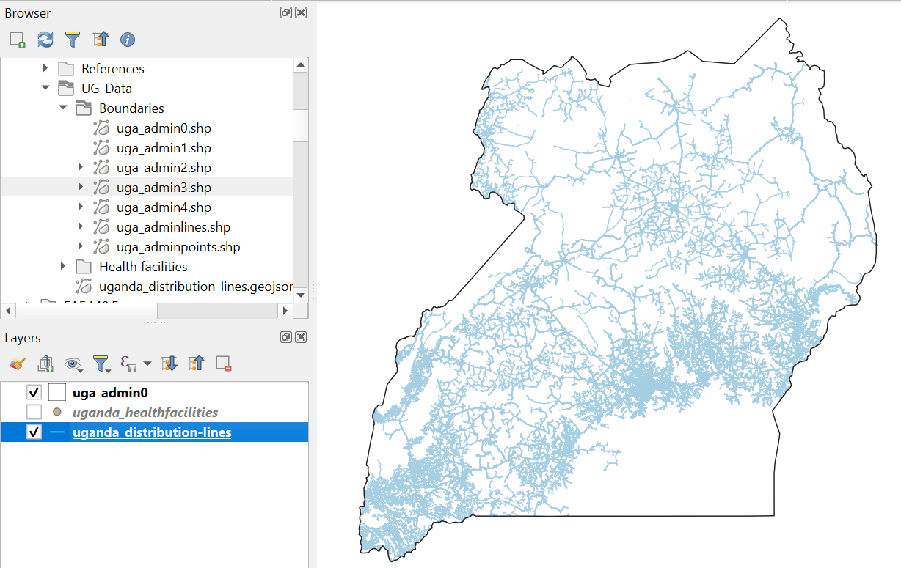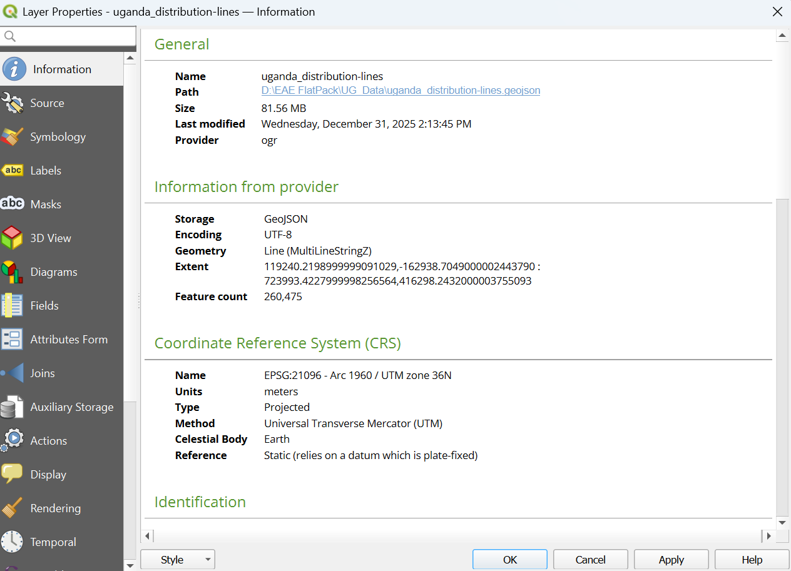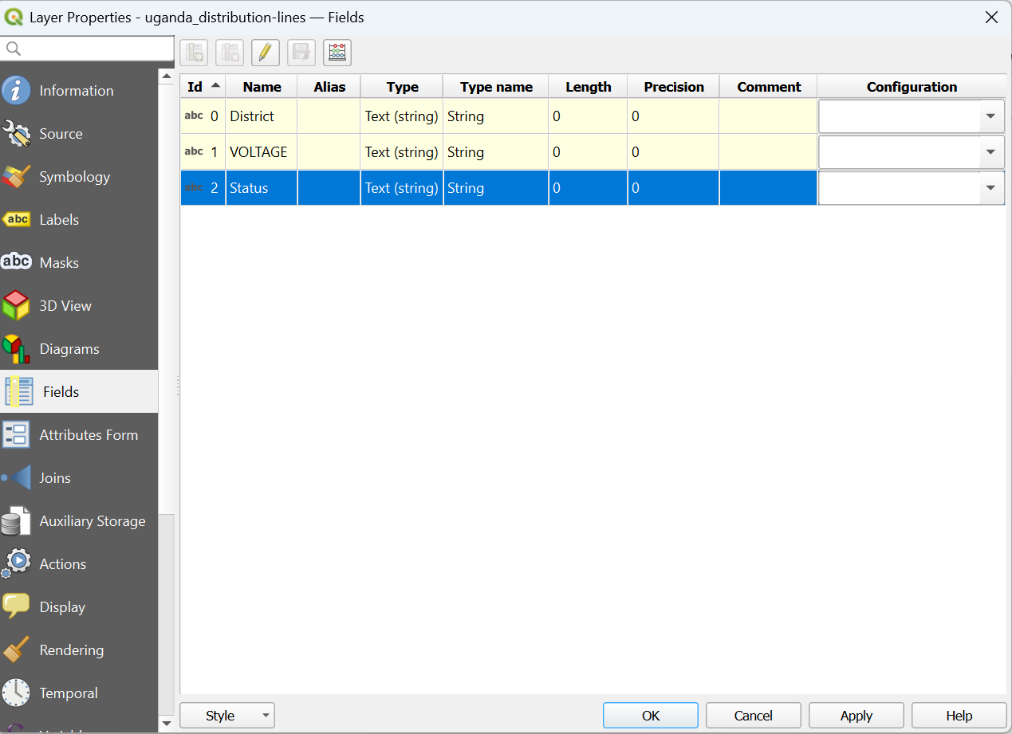
We can reduce the file size by simplifying features (reducing number of vertices). Caution: If the dataset is referenced in degrees, then we will need to reproject first to a meter-denominated CRS before proceeding. As you can see from the middle image above in the CRS section the unit is meters and we may not need to reproject the layer. But this may be required in other cases, and we will show you how to do that by reprojecting the layer. Go to VectoràData Management ToolsàReproject Layer…
Select the correct layer to reproject in the Input layer and the Target CRS (For example: ESRI:102100 – WGS_1984_Web_Marcator_Auxiliary_Sphere). Then click Run.
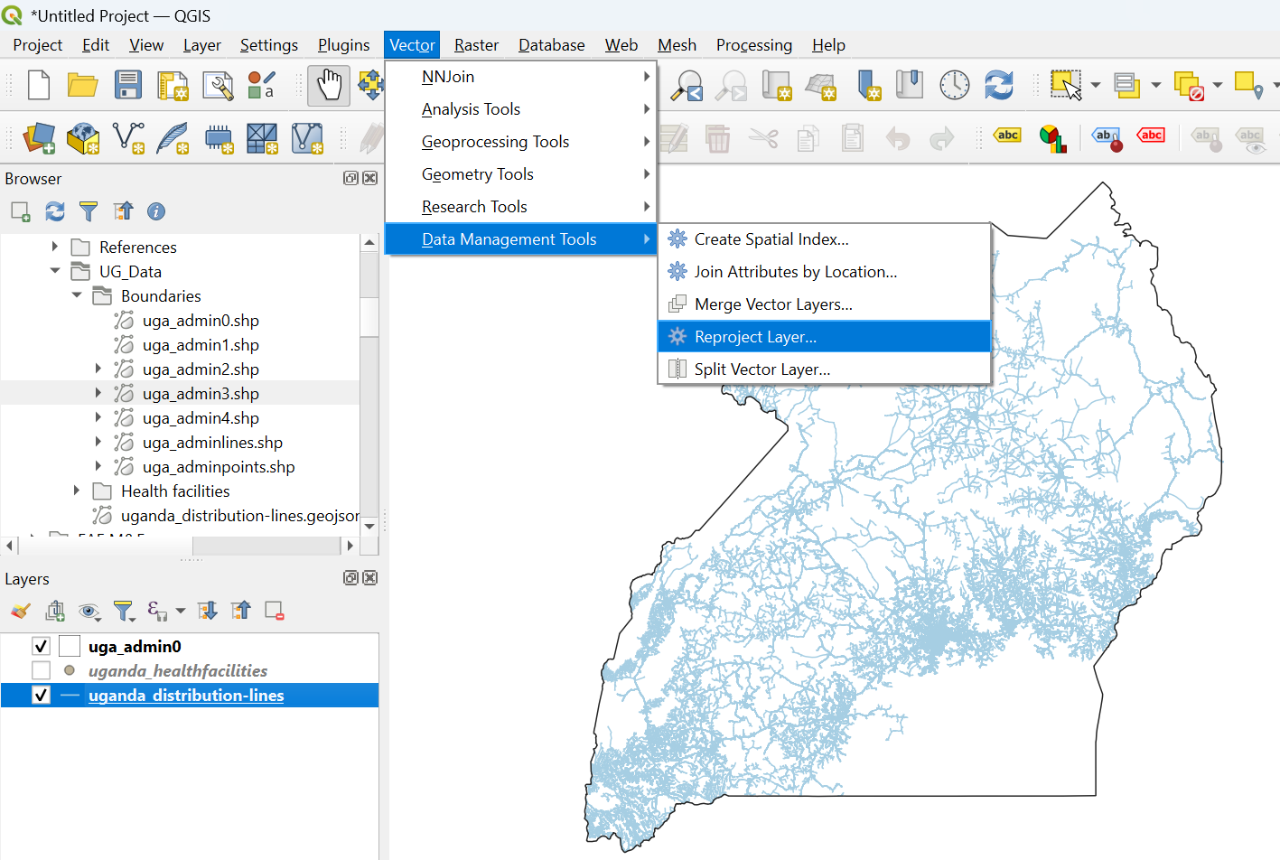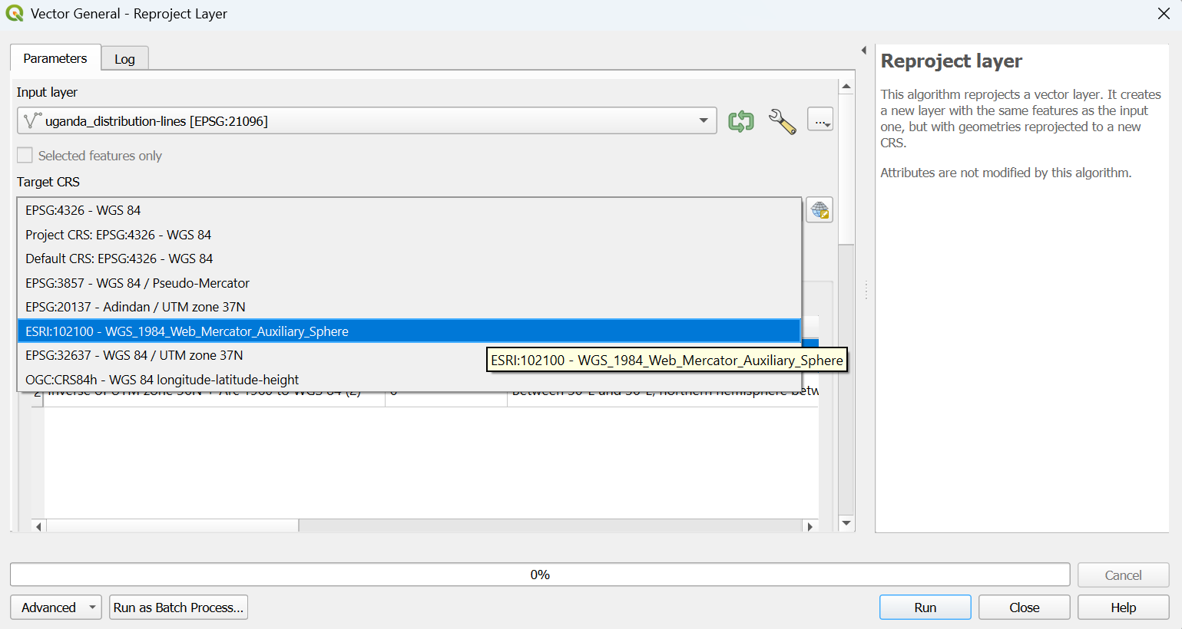
Once you’ve confirmed that your dataset is in a meter-denominated CRS, select the Simplify function. Make sure the Input layer selected is the reproject one or the CRS with units in meters. Then, set the tolerance to a value. Larger tolerance will result in a smaller file. Save the simplified layer and go to the properties to check the change in the file size.
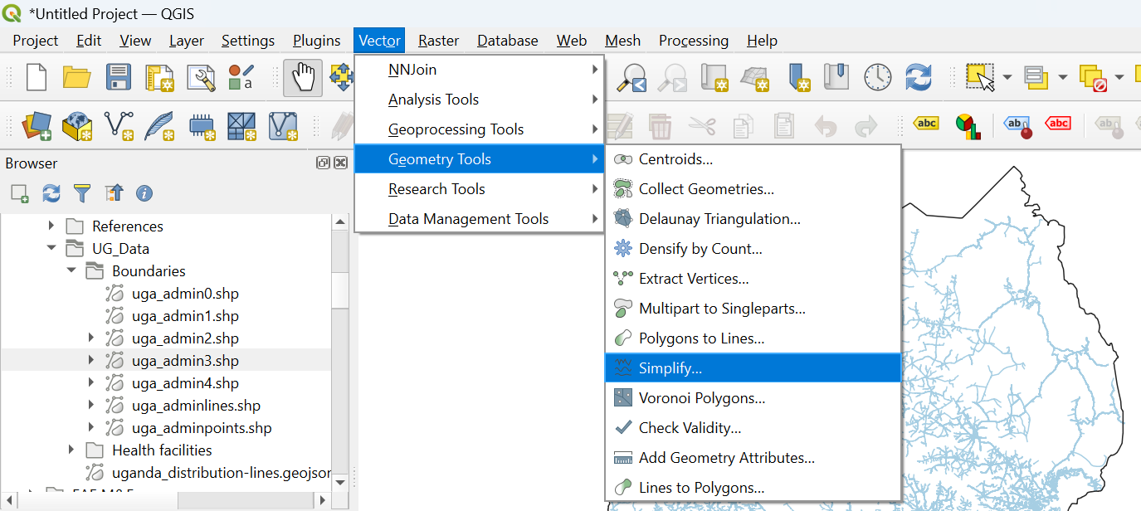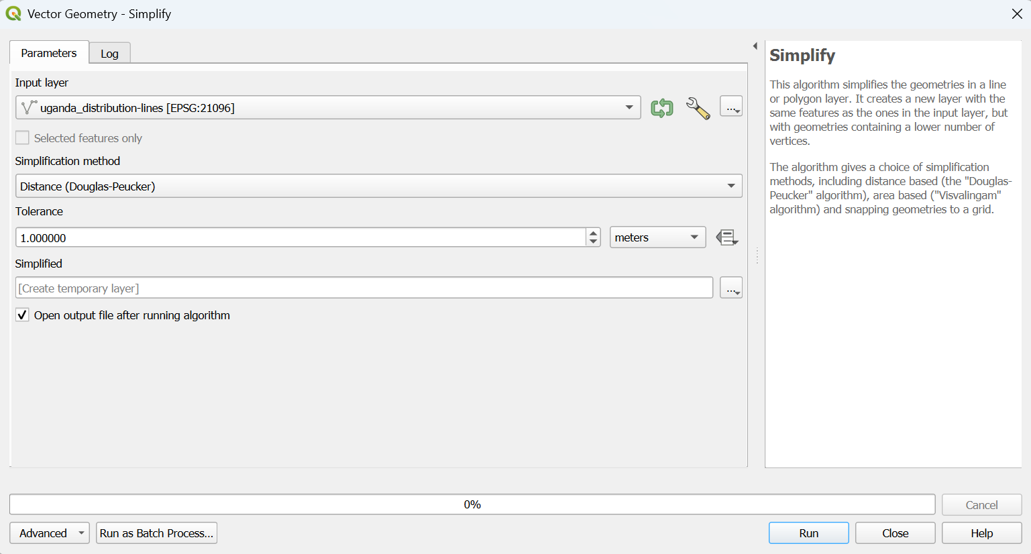
Q2. Which tolerance value in meters did minimize the file size below 15MB?
Q3. What difference do you observe between the original and the simplified lines? (Hint: Overlay both together and zoom in until you see both lines)
Once you are satisfied with the tolerance value and file size of the simplified line, make sure to save the file in GeoJSON format and default CRS of EPSG:4326: WGS84 to be ready for uploading to the Content Management System of EAE.

II. Working with Raster Data
- Gathering data
Download the following datasets from the links provided, extract if they are in zipped folder, and save them in a folder that you can easily recognize on your computer.
- Africa Landforms (africa_landsurfaceforms_90m.zip) https://www.sciencebase.gov/catalog/item/63e4622ed34e9fa19a9c007a (Raster or TIF image)
- Population counts Uganda https://hub.worldpop.org/geodata/summary?id=75839 (Raster or TIF image)
- Relative wealth index Uganda (Uganda_relative_wealth_index.csvCSV(845.1K)) https://data.humdata.org/dataset/relative-wealth-index (CSV file format)
- Opening files in QGIS
This exercise uses QGIS 3.40.X, you can download and install the latest version from https://qgis.org/. For more GIS tutorials, refer https://www.qgistutorials.com/en/
There are many ways to open a file in QGIS
- First, as you have already activated the browser in the previous exercise (if not go to ViewàPanelsàBrowser and select both Browser and Layers to appear in the left panel of your window. Using this method go to the folder where you save the above files and drag and drop or double click on each to open them (for the boundary data open the national boundary or outline of Uganda with file name: uga_admin0).
- Second, you can open a file by LayeràAdd LayeràAdd Raster Layer, which opens another dialogue box to bring the file from the source (folder). See images below
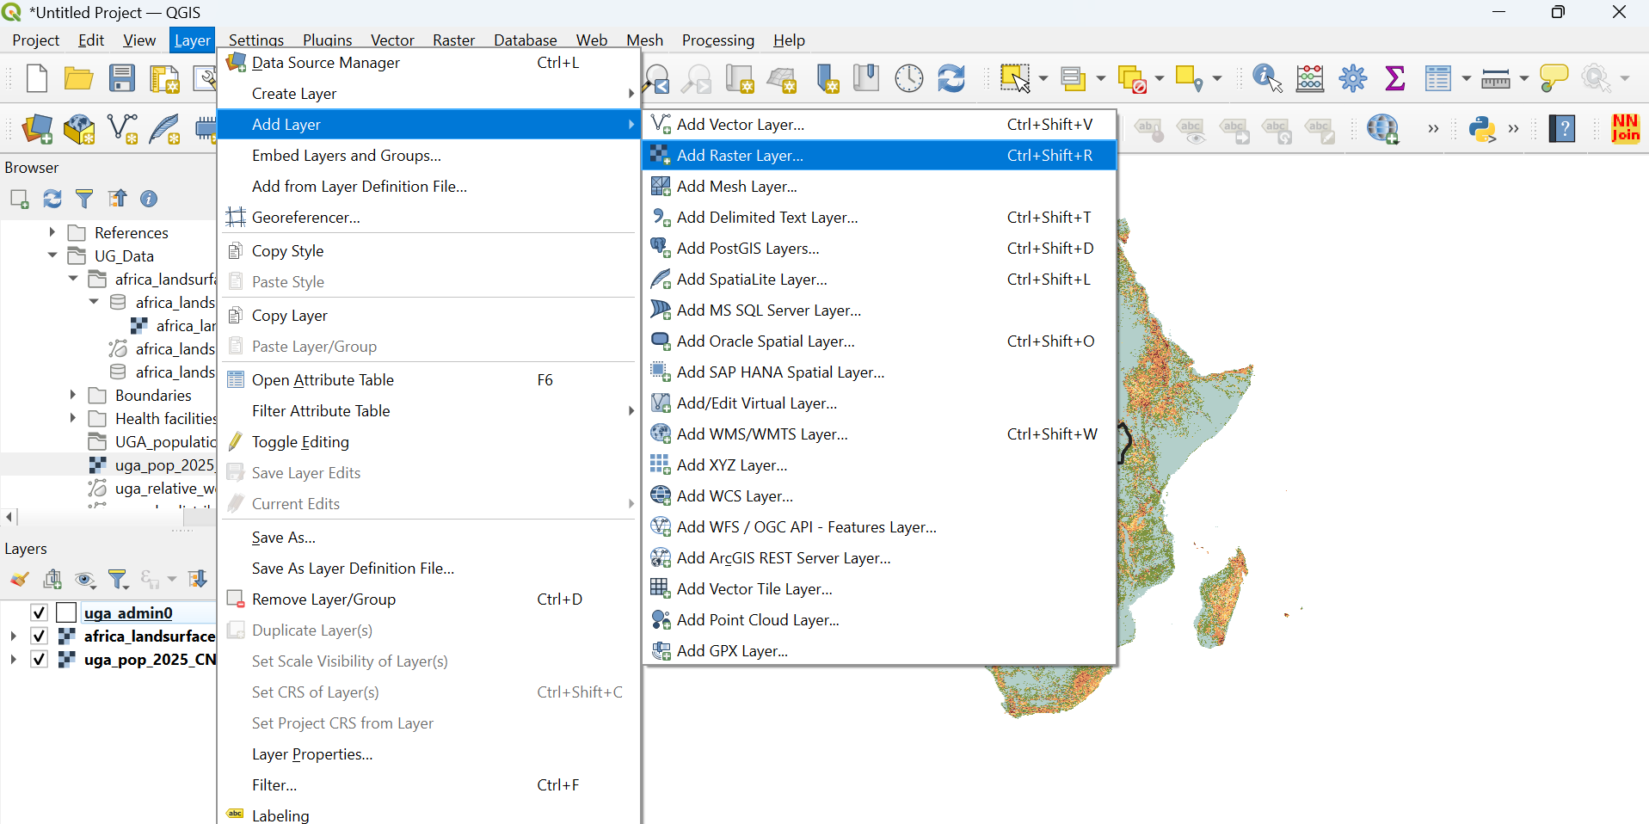
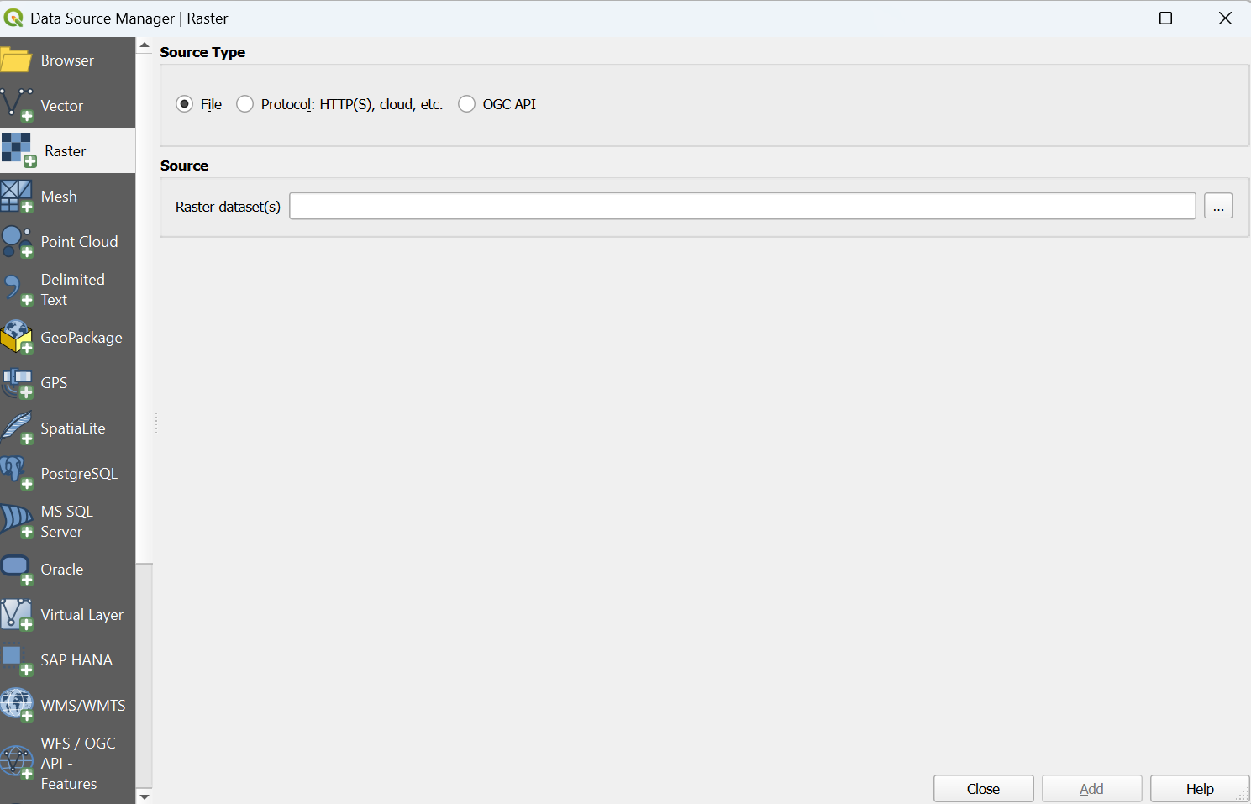
- Clipping images
Raster source data often extends beyond national boundary. They may cover Regional or continent-wide datasets. This results in large file size, especially for high-resolution rasters and Clipping to national boundary only keeps the values we’re interested in.
While Paver, EAE’s automated data processing tool, also clips raster to country boundaries, for large countries we still recommend this as a pre-processing step to streamline data uploads. There may also be satellite imagery in geometric ‘tiles’ that may require merging or creating mosaics before clipping.
To clip a raster file, go to RasteràExtractionàClip Raster by Mask Layer… Then select africa_landsurfaceforms_90m in the Input layer and uga_admin0 in the Mask layer. You can also save the by going to the section Clipped (mask) and then click Run. See image below for the illustration
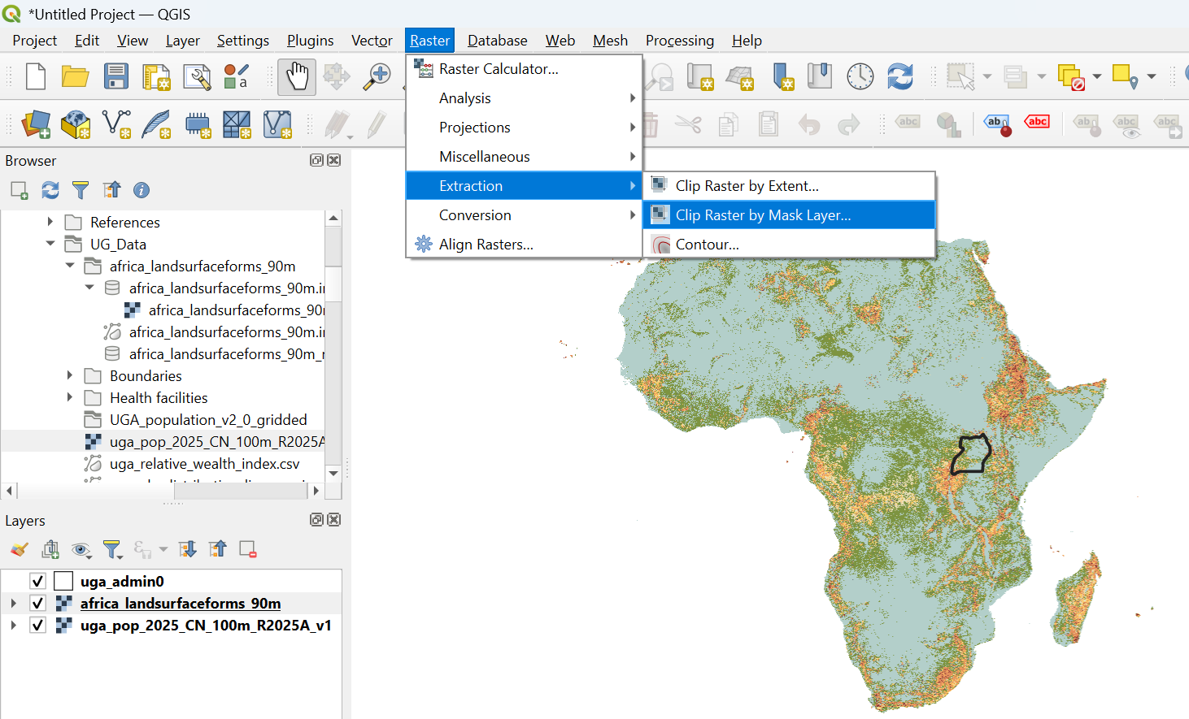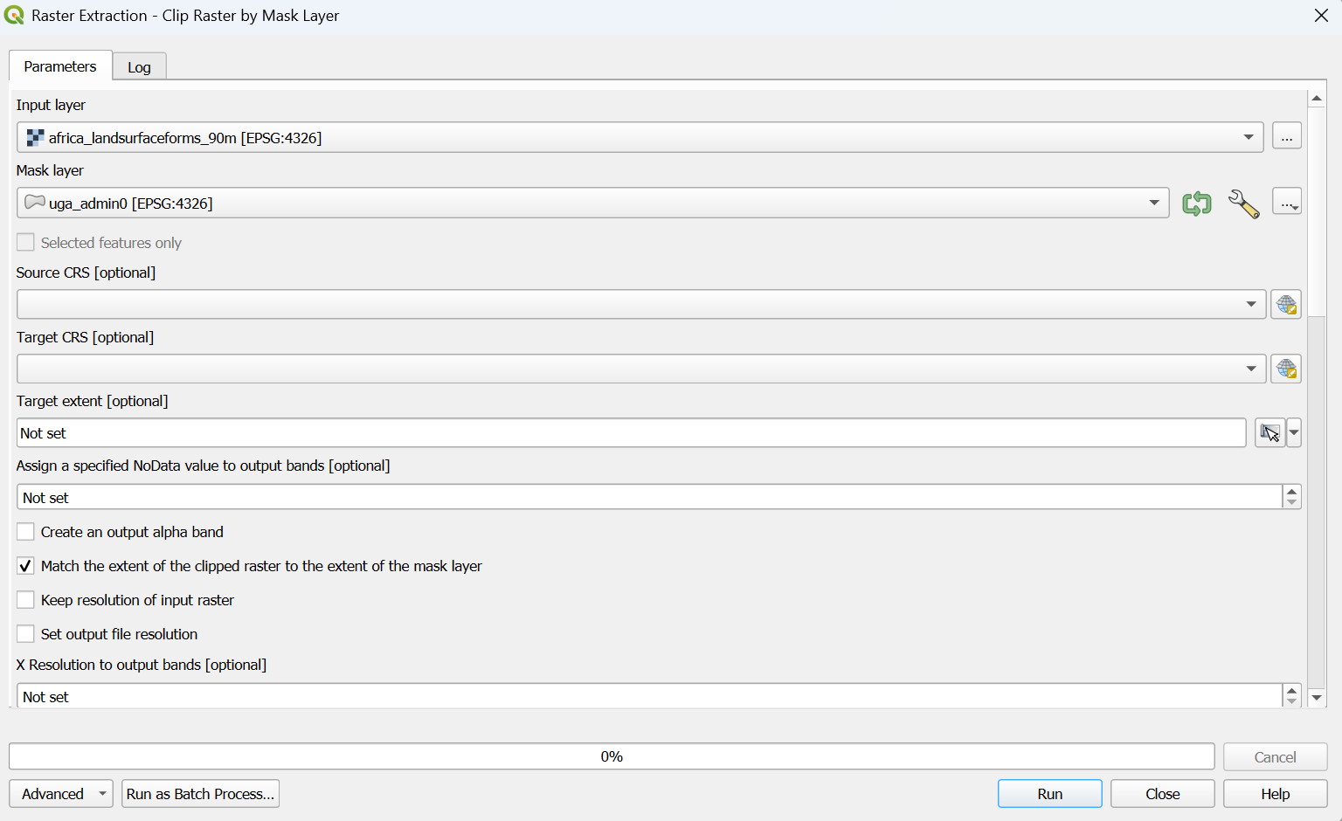
Q4. What is the file size of the landforms covering the whole continent of Africa and the clipped one for Uganda?
Q5. Is the file size of the clipped image for Uganda less than 15MB? If not, what will you do to reduce the file size? (If you are not sure, see the next section on resampling)
- Resampling raster data
Source raster files may come in a higher resolution (finer pixel size) than what is supported in the Energy Access Explorer. Resampling the raster reduces the file size by adjusting the pixel size. You may need to install the GRASS plugin to access r.resamp.stats if you are using older versions of QGIS. To check if this plugin exists, go to Processing and select Toolbox. In the Processing Toolbox Search box type resamp to check its availability.
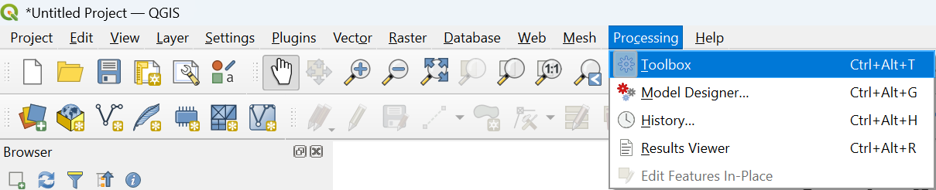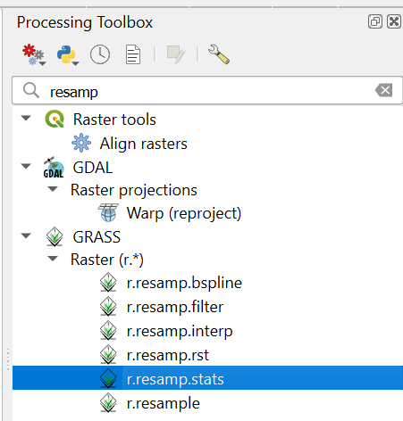
For this exercise, we are going to use the population count data for Uganda that has a file size of 56.88MB, a 100m resolution and a geographic unit (check in Properties).
Follow the following steps
Step One: Reproject Raster
Raster file must be in a meter-denominated Coordinate Reference System (CRS), and we use the Warp (Reproject) function. Go to RasteràProjectionàWarp (Project)… In the second box select the population count data (uga_pop_2025_CN_100m_R2025A_v1) in the Input layer and the ESRI:102100 – WGS_1984_Web_Mercator_Auxiliary_Sphere in the Target CRS. After selecting the input layer and target CRS, click Run.
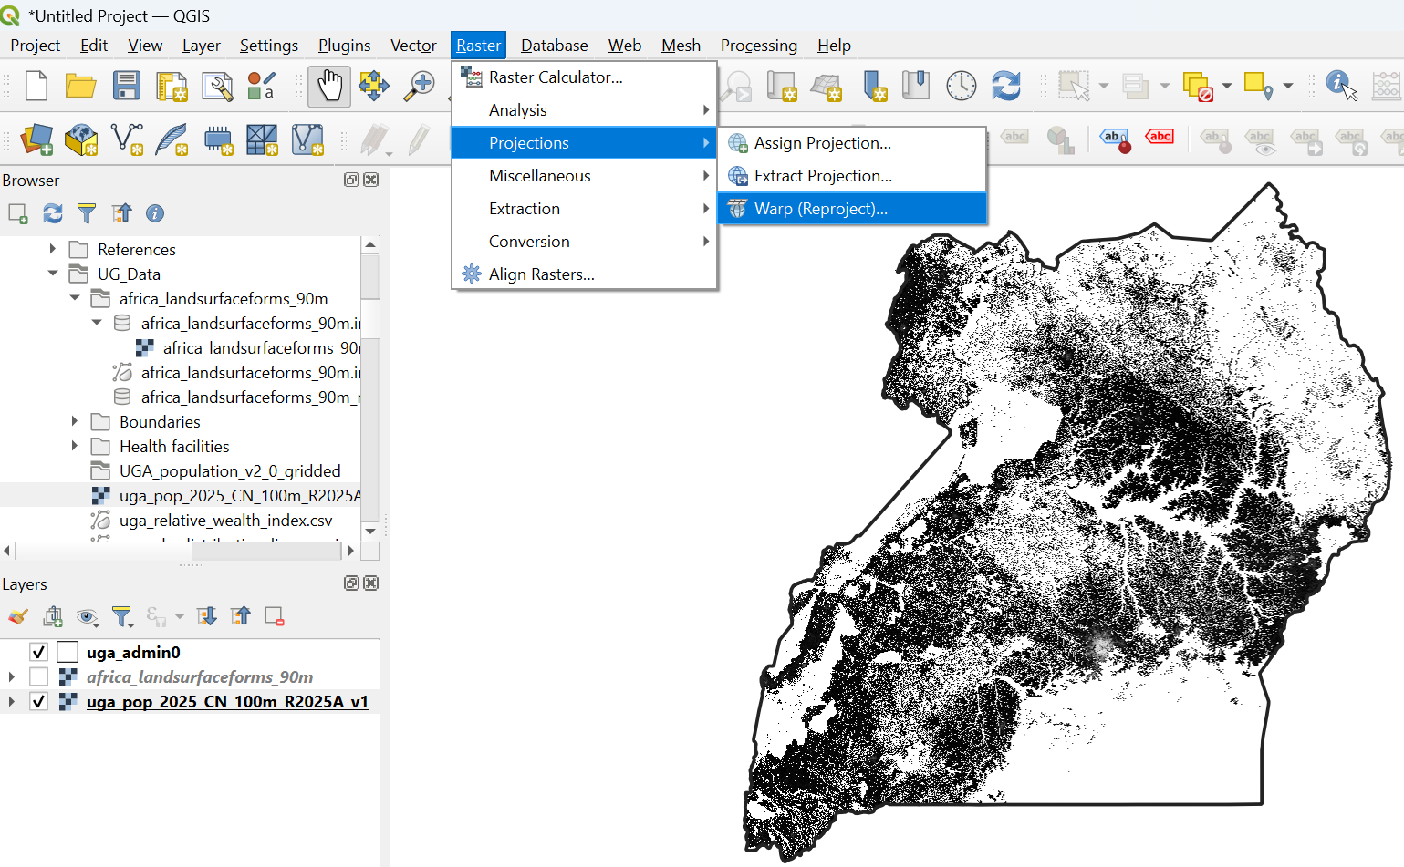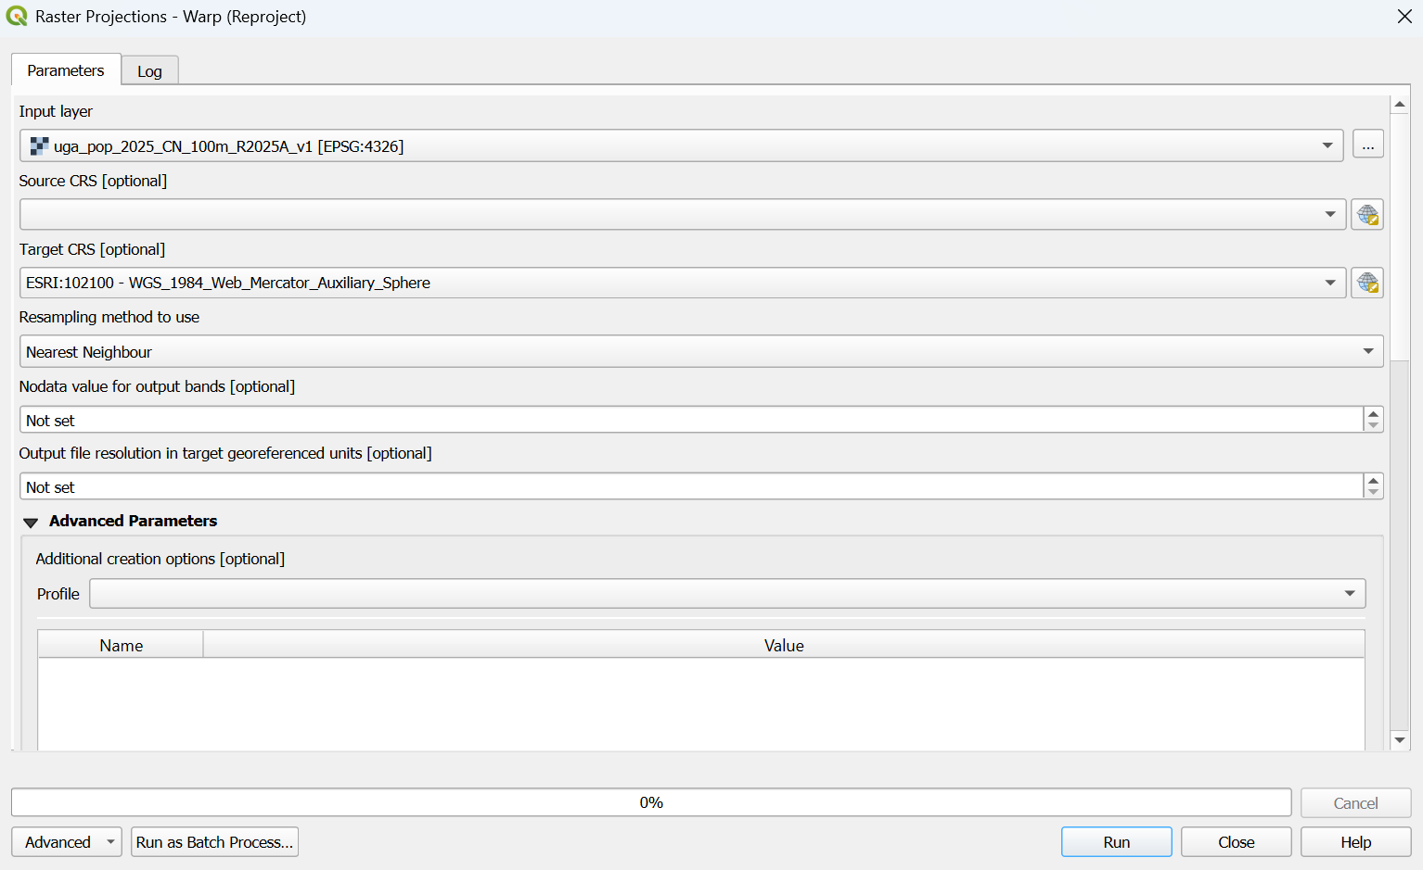
Step Two: Resample Raster
To resample, use the r.resamp.stats from the Processing Toolbox so that we can reduce the resolution to coarser/larger cell size. Select Reprojected as Input raster layer, sum as Aggregation method and 1000 as the GRASS GIS region cellsize and click Run
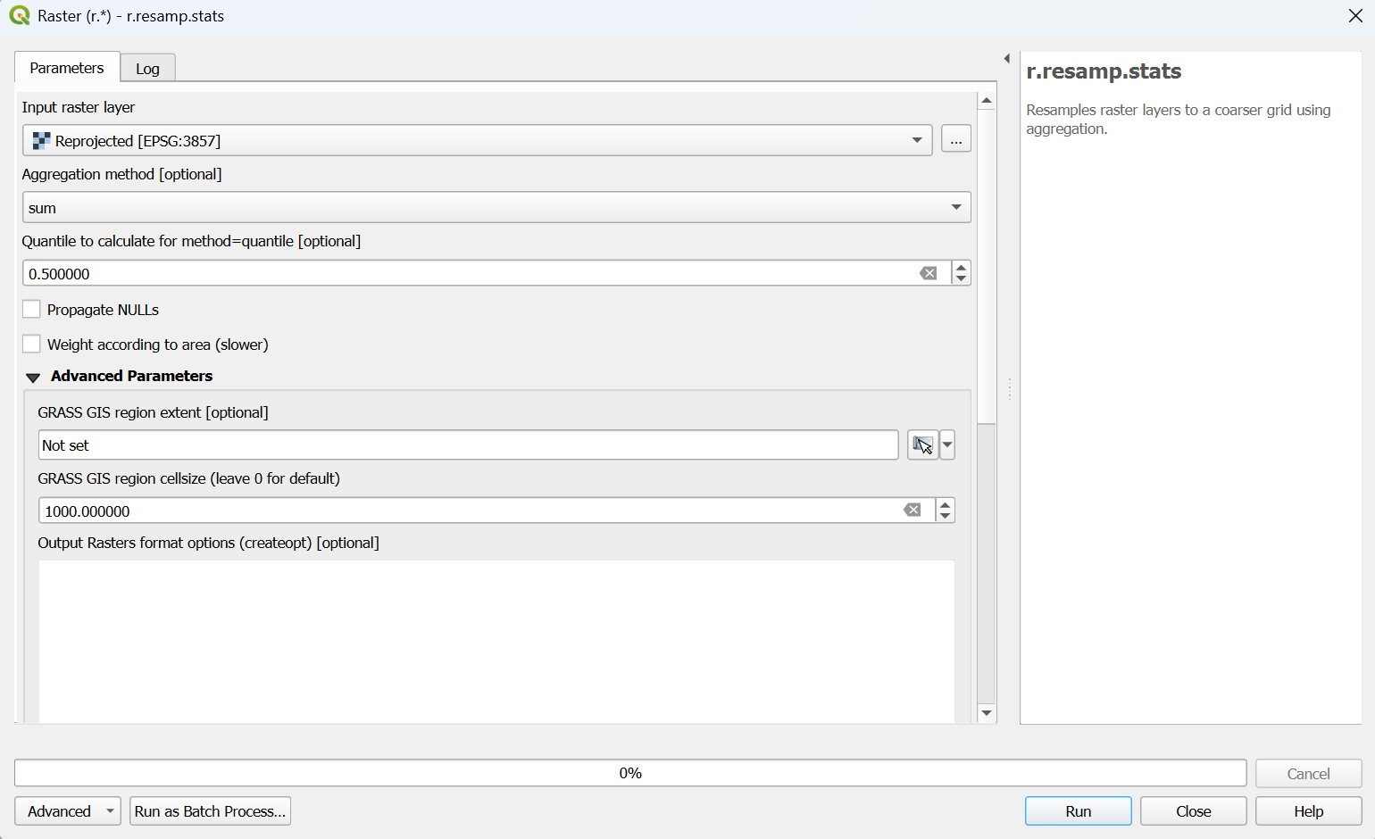

Step Three: Save. geoTIFF
To save the file, right-click on the Resampled aggregatedàExportàSave As.. Select GeoTIFF as the Format, Browse to locate the folder and give the File name. You can also select the Default CRS EPSG:4326 – WGS 84, the click OK
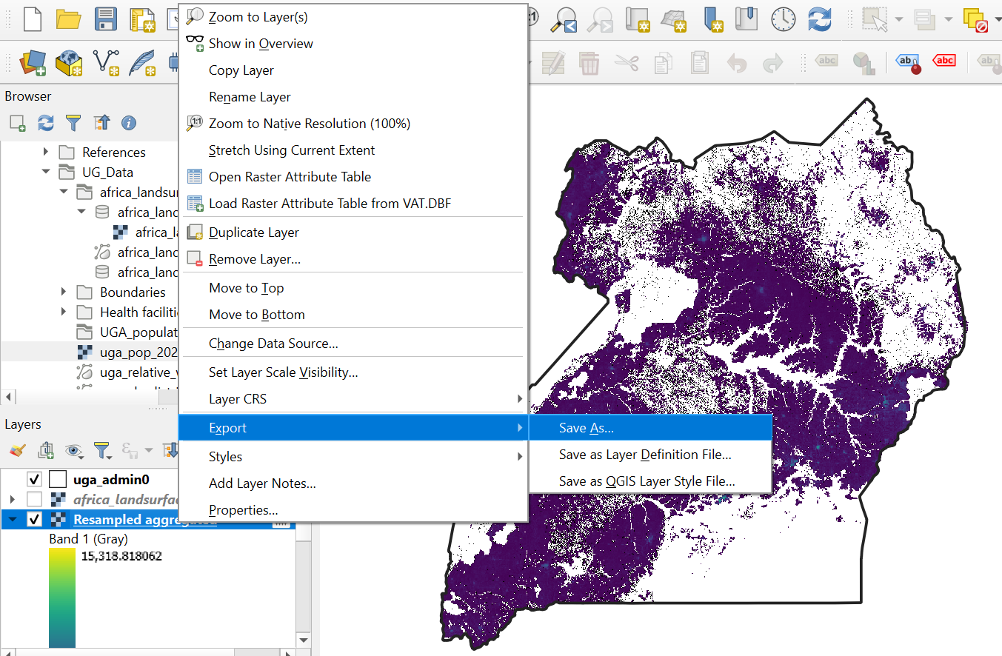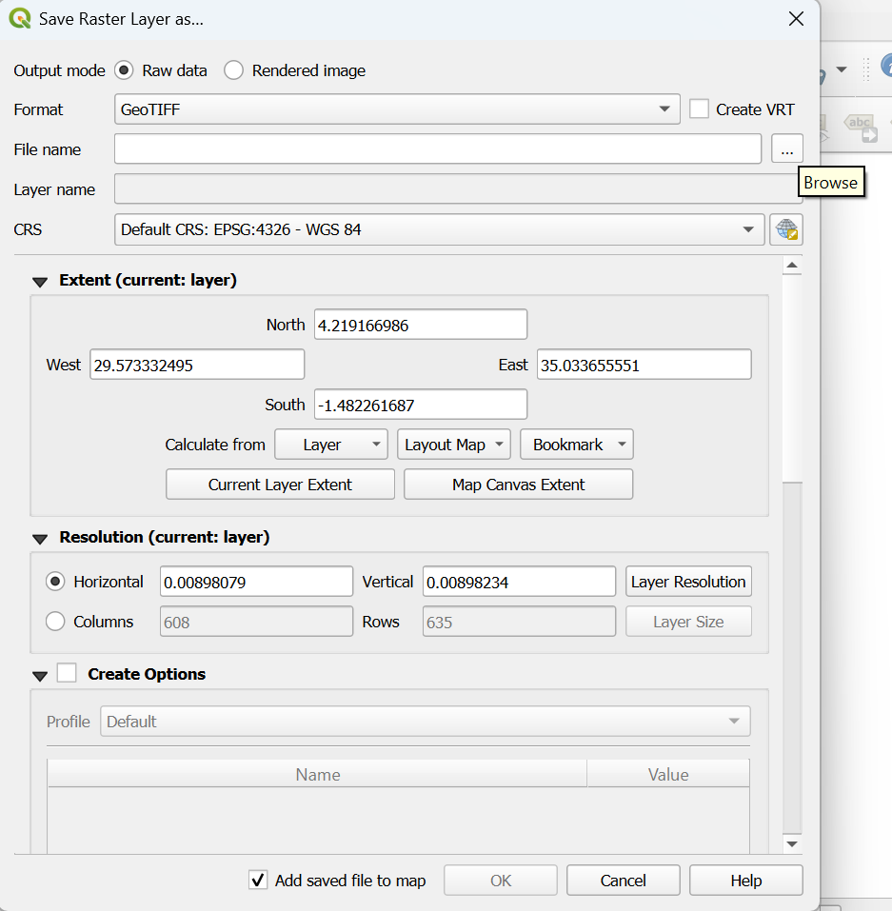
Q6. What is the file size of the resampled Population count data for Uganda?
- Rasterizing vectors
Census and national household surveys are costly and infrequent. Data is also usually aggregated to a subnational unit – lacking the granularity necessary for targeted energy planning. Conventional indicators (e.g. household income) may not represent actual purchasing power, especially in countries with large informal/subsistence sectors.
As a result, data on household wealth can provide useful context for power service providers. Households with wealth above the national median have greater ability to pay market rate tariffs for electricity services. Households below the national median may require financial assistance to meet energy access requirements.
Therefore, we are going to use the Relative Wealth Index data that exists in a CSV format and convert it to a Raster format for showing the utility of socioeconomic data in EAE. The following image shows how the Relative Wealth Index is captured

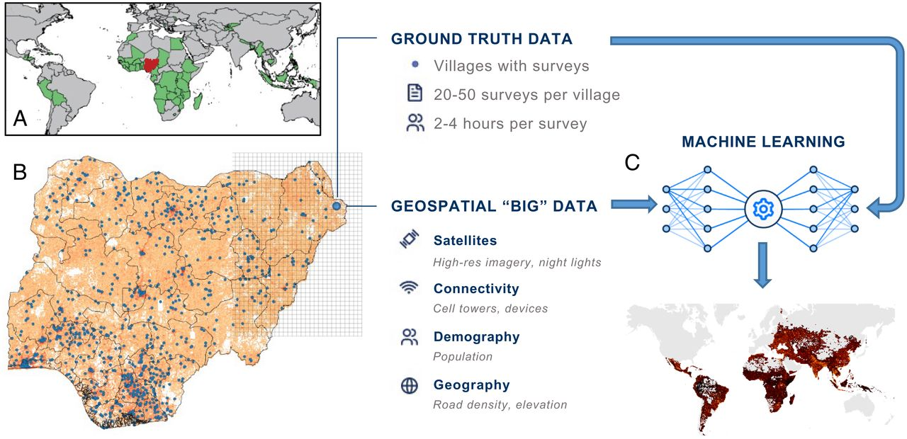
Relative Wealth Index – Novel Approach in Data-Scarce Environments
To convert RWI into EAE readable format, we follow the following steps
Step One: Import .csv Data to QGIS as Points
To import a CSV format data into QGIS, go to LayeràAdd LayeràAdd Delimiter Layer…In the File name select uga_relative_wealth_index.csv. This file has rwi values for more than twenty five thousands points in Uganda.
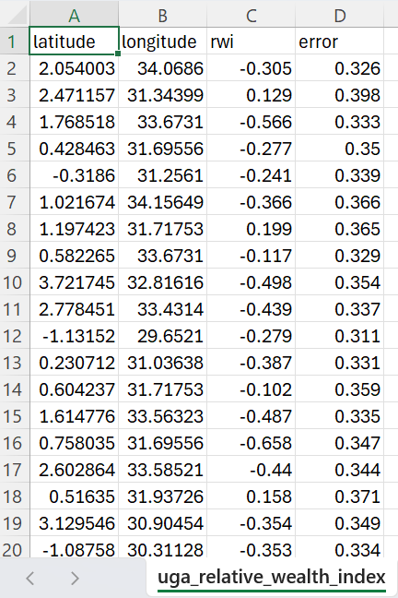
Make sure CSV in File format and Point coordinates in Geometry definition are selected with the correct x-axis (longitude), y-axis (latitude) and Geometry CRS of EPSG:4326 – WGS 84. You can also see the layer settings if the sample data has been correctly captured.
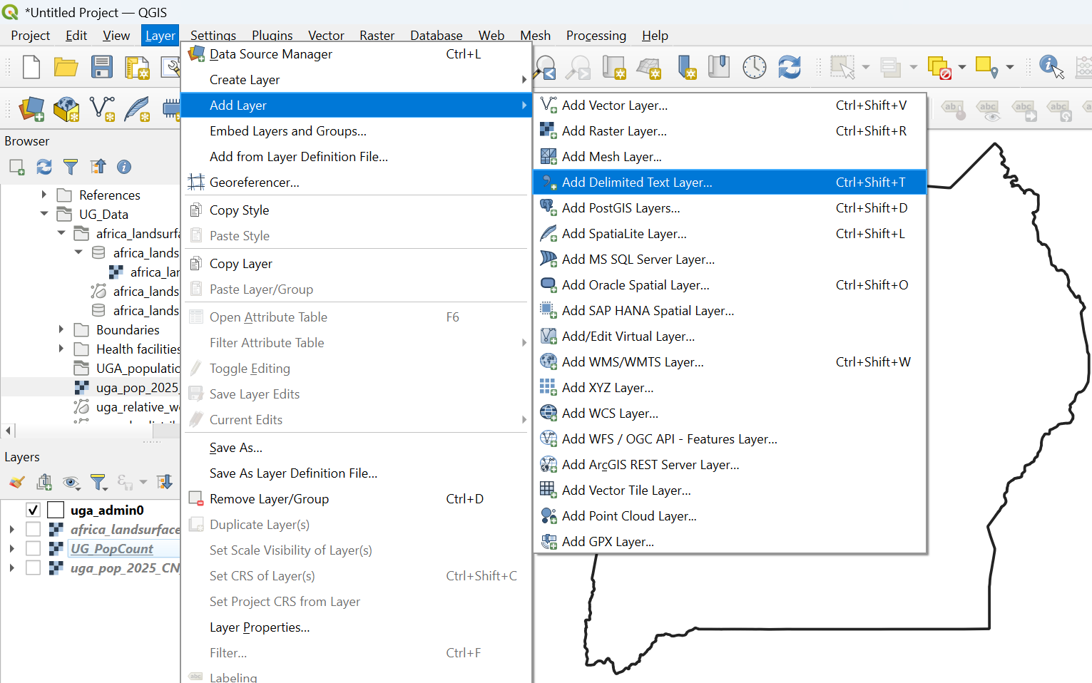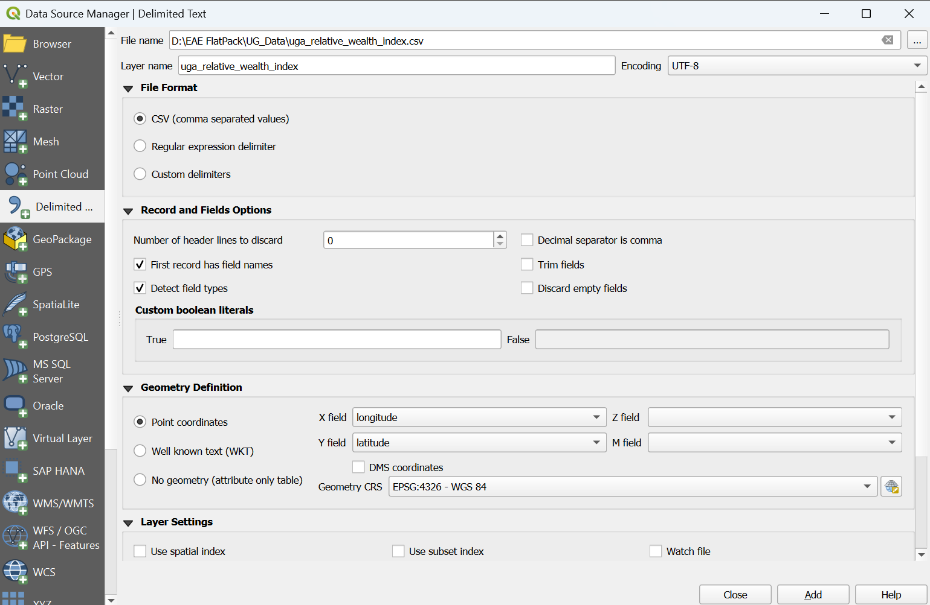
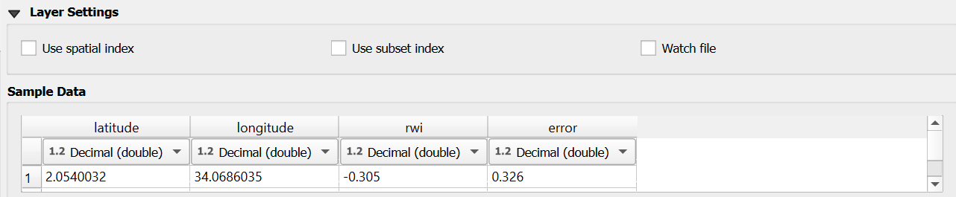
Then, click Add & close. Make sure that the uga_relative_wealth_index displays in point data.
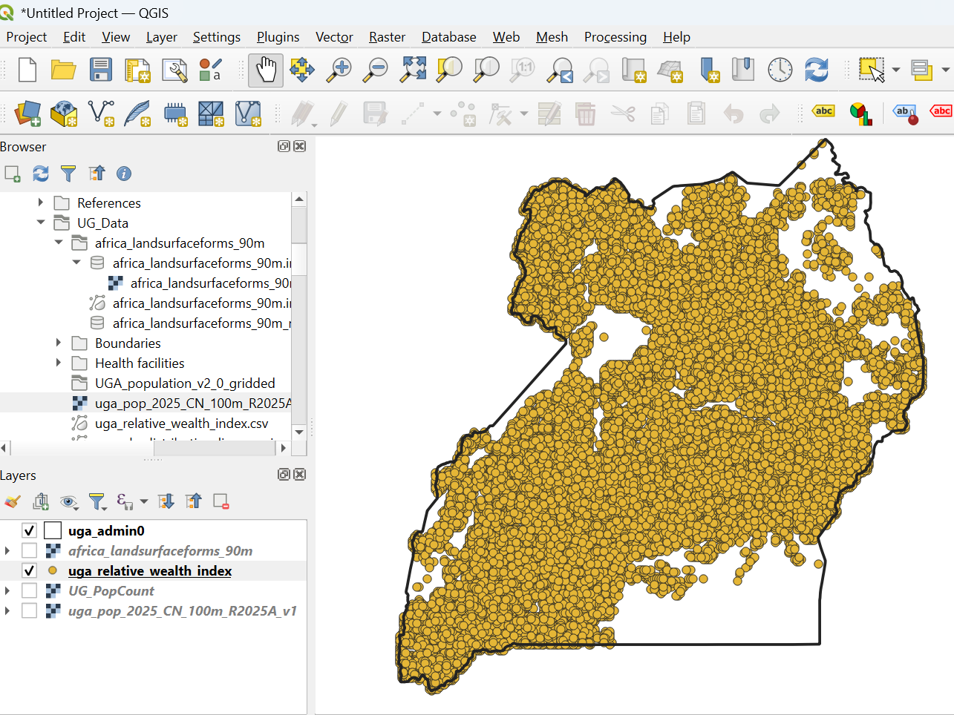
Step Two – Reproject to Meters
As we used the geographic CRS, we need to reproject it to metric units before making any further changes. Go to VectoràData Management ToolsàReproject Layer… Make sure the correct Input layer and Target CRS are selected and click Run.
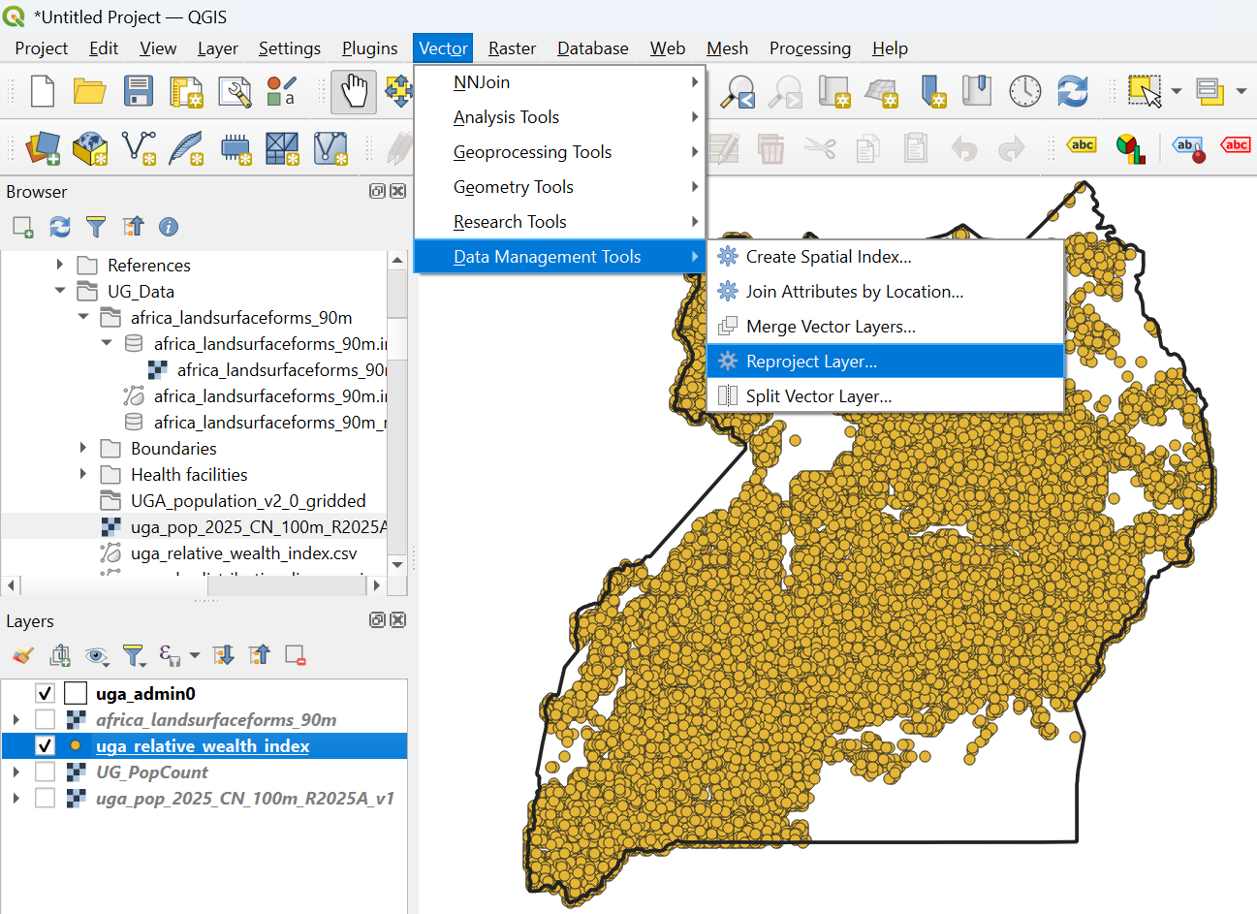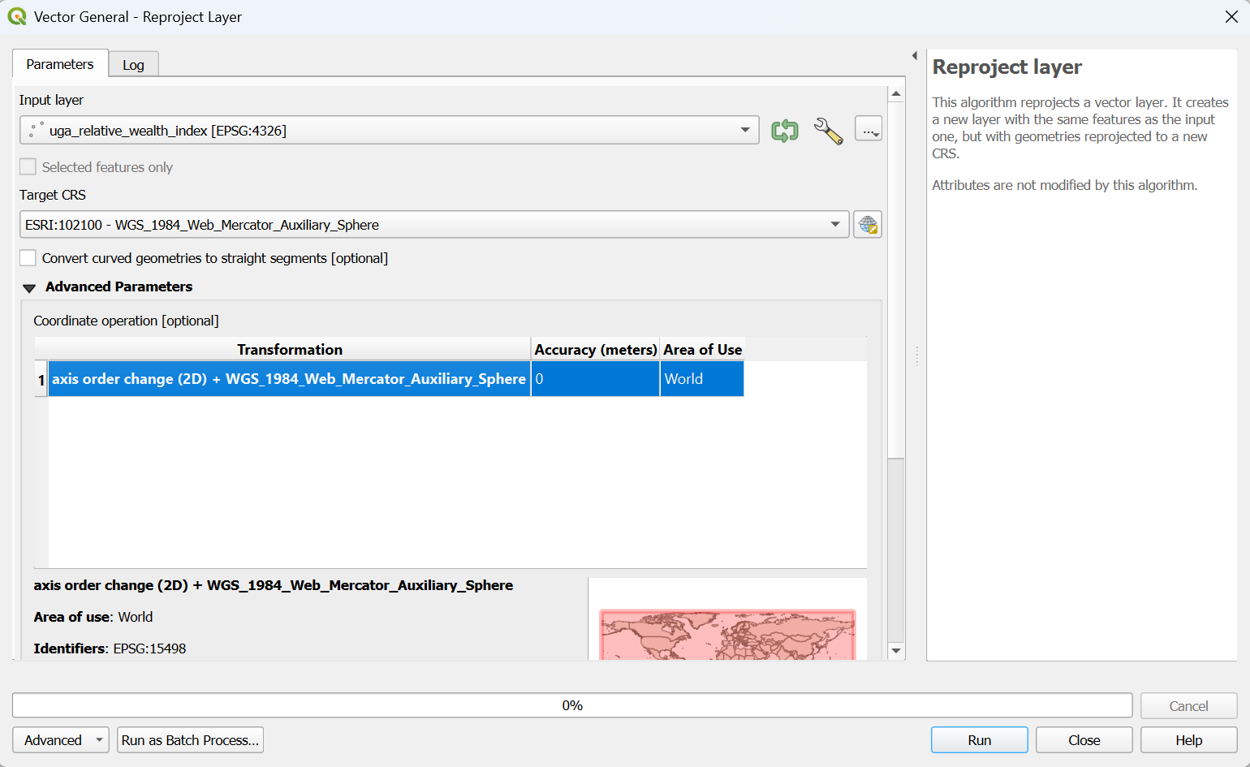
Step Three – Rasterize Points
We use the Rasterize (Vector to Raster) function and you can find it in two ways. Either using RasteràConversionàRasterize (Vector to Raster)…OR searching rasterize in the Processing toolbox
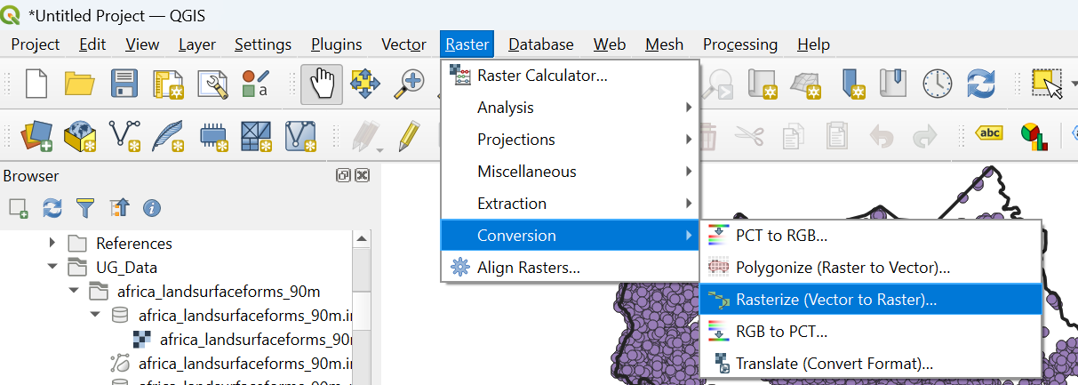 OR 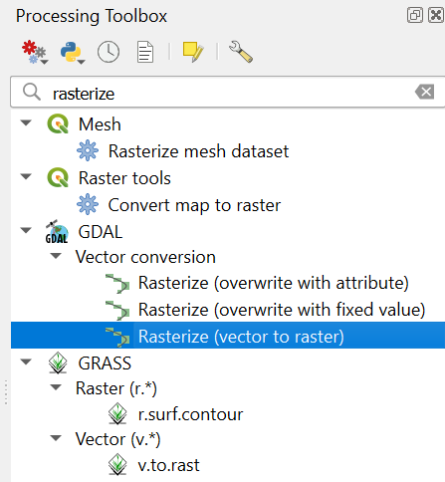
In the box, insert the Reprojected file in the Input layer, rwi as the Field to use for a burn-in value, Georeferenced units as Output raster size units and the horizontal and vertical resolution of 300. Finally, click Run and once the final image is created, right click on the rasterized file and ExportàSave as … to save the file.

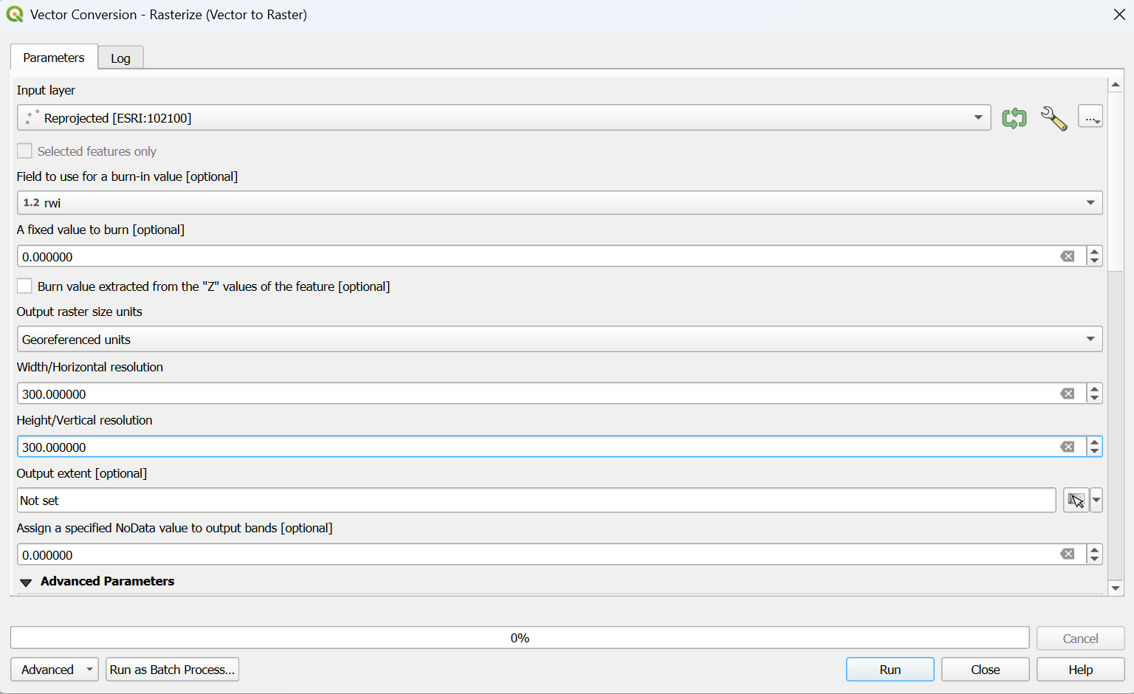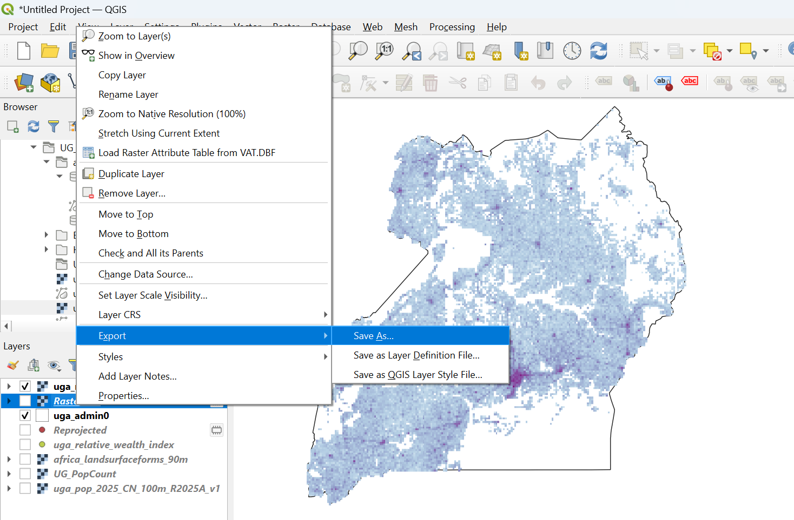

III. Working with Tabular Data
- Gathering data
Download the following datasets from the links provided, extract if they are in zipped folder, and save them in a folder that you can easily recognize on your computer.
- Sub-region boundary Uganda
https://wri-public-data.s3.amazonaws.com/EnergyAccess/UGA/subregion_2022.geojson
- Uganda National Survey Report
https://www.ubos.org/wp-content/uploads/publications/09_2021Uganda-National-Survey-Report-2019-2020.pdf
- Preparing the table
Tabular data refers to data tables arranged in rows and columns. This data type can be used in GIS if it includes georeferenced data columns. Tabular data can be used in GIS platforms if it contains geospatial references in the form of:
    - Coordinates: point data can be georeferenced using longitude-latitude coordinate pairs. Coordinates may be either in decimal degree or degree-minute-second format.
    - Administrative Units: data values can be associated with national or subnational (province, state, or municipality) administrative units.
Common uses for tabular data in GIS include field observations (recorded as coordinates), and census/survey data (at subnational level). In this section, we will see how we can prepare energy related tabular data at subnational level before uploading to EAE
First, load the sub-region boundary data in QGIS. Then, open the attribute table or export the map into CSV format with two columns i.e. FID and F15Regions.
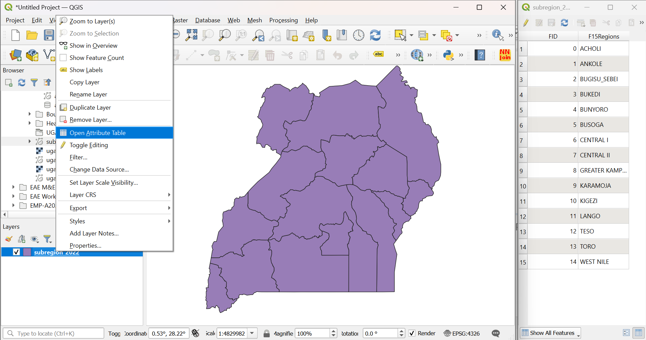
Second, by referring to Table 8.6 in the Uganda National Survey Report, copy or extract the proportion of households using Grid Electricity for lighting for each of the 15 sub-regions.
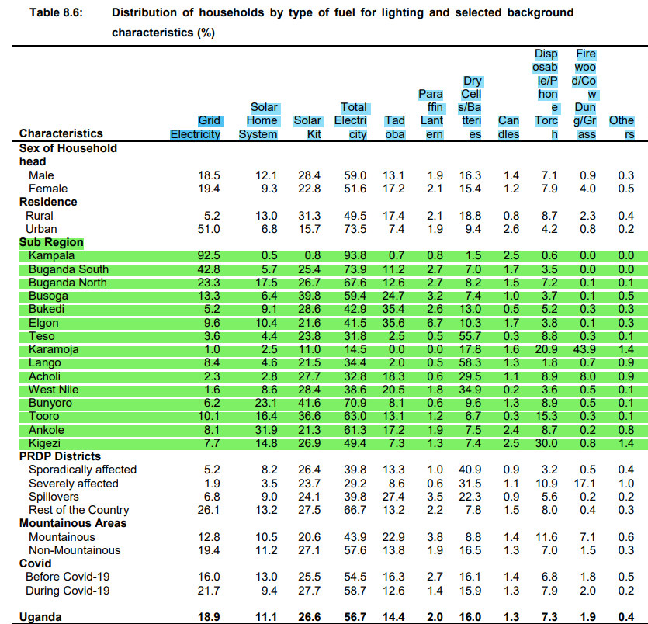
The extracted CSV file for the sub-region and grid electricity by sub-region are represented below. Then, match the FID with Grid Electricity share to extract the resulting table
+ =
Finally, save the file as a .csv in your folder and name it UG_region_lighting_electricity.csv

