Energy Access Explorer
Hands-on 2: Examining EAE Datasets and Method
License:
This work is licensed under the Creative Commons Attribution 4.0 International License (CC BY 4.0). To view a copy of this license, visit https://creativecommons.org/licenses/by/4.0/.
Attribution:
Please cite as: Woldeamanuel, A. A., Khalid, A., Anand, S., Sahar, T., Saklani, A., Sinclair-Lecaros, S., Mentis, D., Ronoh, D., & Stockman, J., 2026. Data Driven, Integrated and Inclusive Energy Planning with Energy Access Explorer. Version 1. Climate Compatible Growth Teaching Kit Website, Climate Compatible Growth.

Learning outcomes
By the end of this exercise, you will be able to:
1) Describe key datasets integrated into EAE
2) Explain the multi-criteria analysis framework used in EAE

Contents
I. EAE layers
- Demand
- Supply
- Census
- Other
II. EAE Prioritization Index
  - Energy Access Potential
  - Demand Index
  - Supply Index
  - Assistance Need Index

I. EAE layers
EAE aggregates geospatial data related to both energy demand and supply. Data on demographics and the social and productive uses of electricity are used to represent current and potential demand, and energy resource availability and infrastructure data are used to visualize current and potential supply. See the figure below for the datasets:
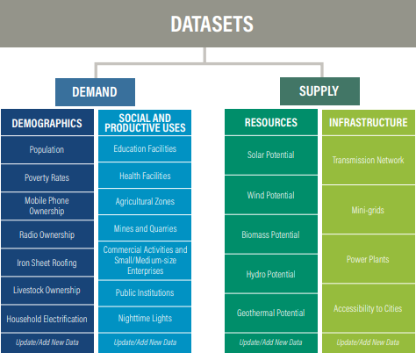
In this section we will explore EAE datasets by choosing geography and area of interest. On a browser, open EAE using the link: https://www.energyaccessexplorer.org/tool/s/
Then select Uganda from the geographies listed.
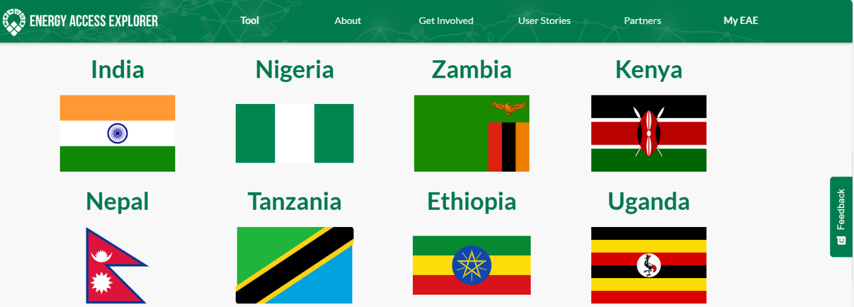
In the pop up ‘Choose your area of interest’ appears
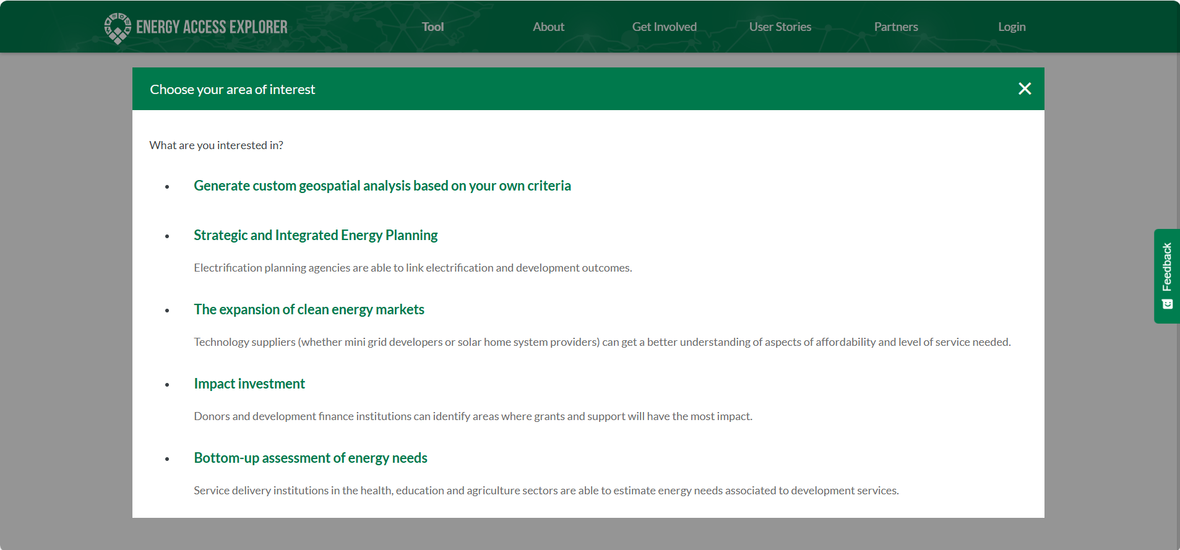
Select ‘Generate custom geospatial analysis based on your own criteria’ to explore the EAE datasets.
After the geography loads, select the Add Layers icon
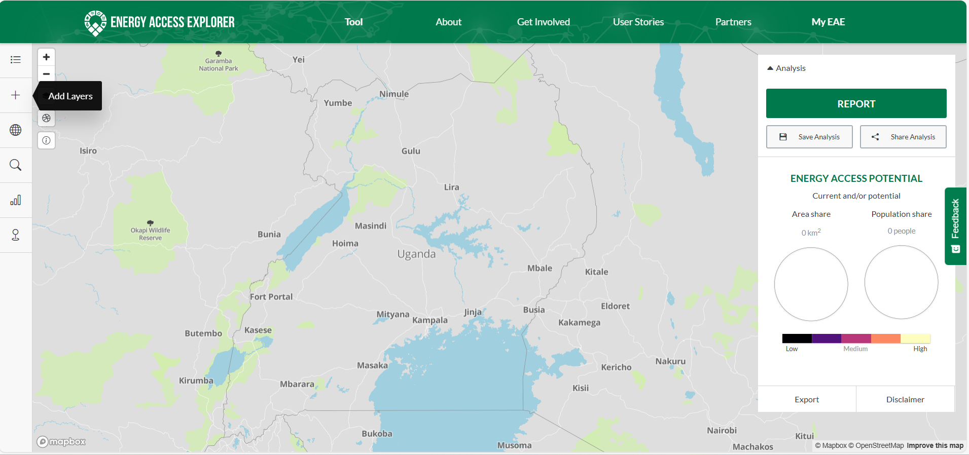
Then, you will see the data categories and datasets in the left panel
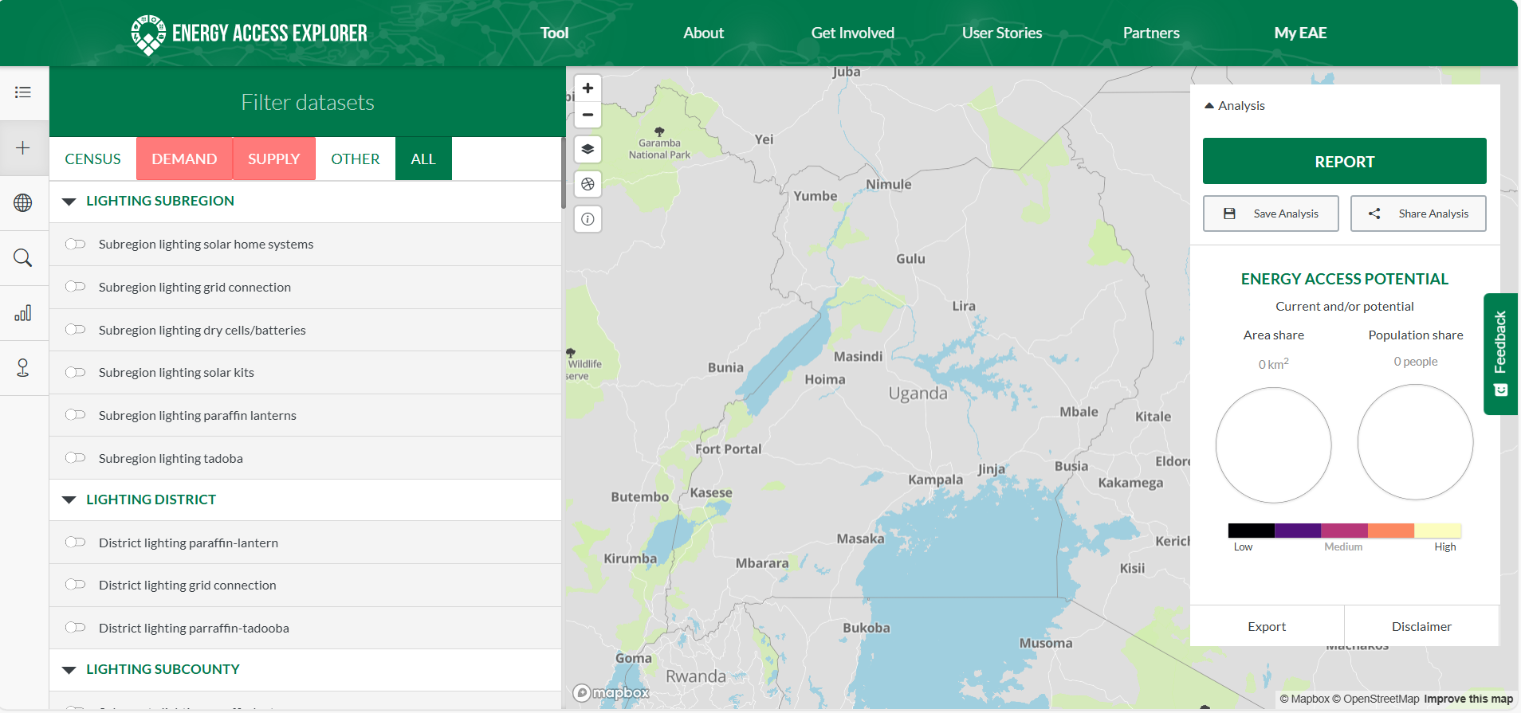

  - Demand
Task 1: From the Demand layer, under Demographics category, select Population density and Relative wealth index. Then, proceed to the Active Layers to study the characteristics of the datasets by expanding all settings.
The resulting image should appear as follows: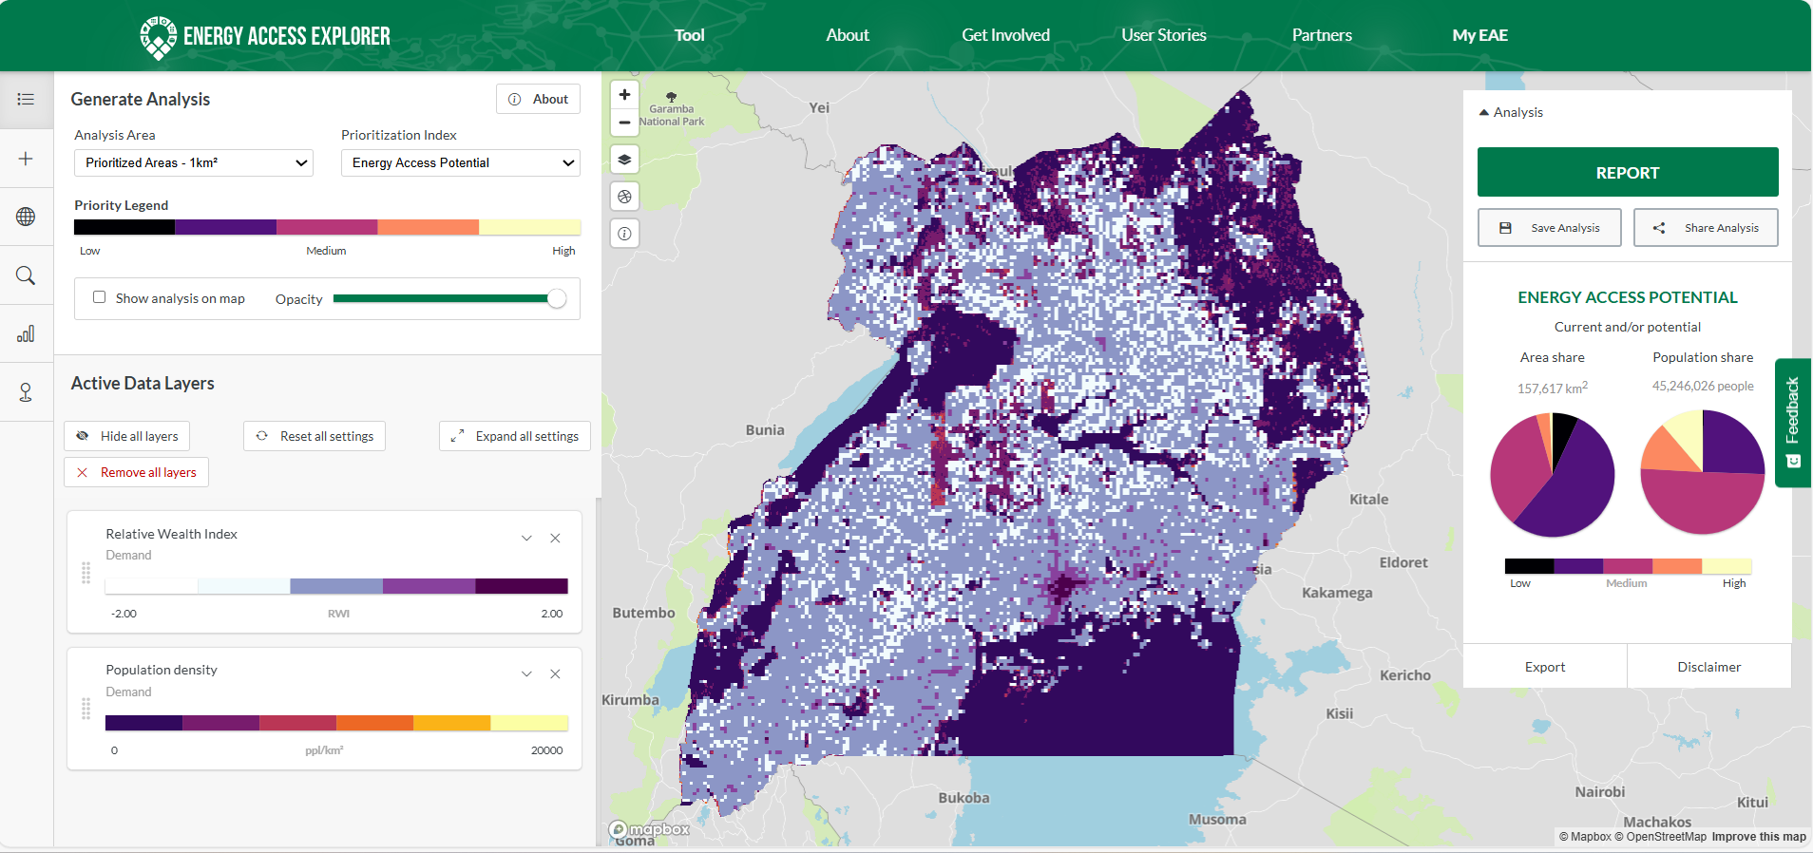
Q1. What does the range of values for RWI indicate and why is the relative wealth index used in EAE? (Hint: About section of the data layer)
Q2. What is the unit of measurement for population density and why this dataset is used in EAE? (Hint: About section of the data layer)
Task 2: First Remove all layers and from the Demand layer, under Productive Uses, select Education and Health Facilities. Then, proceed to the Active Layers to study the characteristics of the datasets by expanding all settings.

The resulting image should appear as follows:
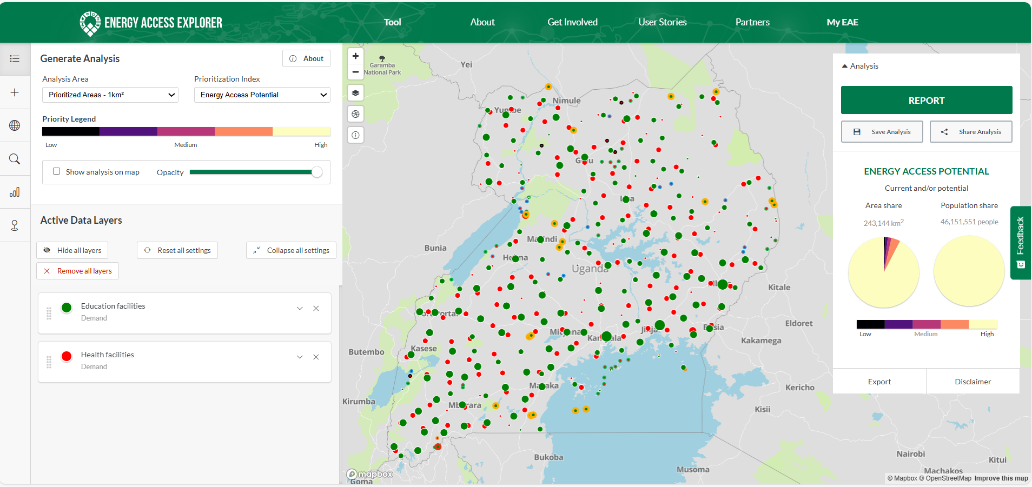
Q3. What differences exist in the classification of education and health facilities datasets?
Q4. How many education and health facilities are represented on the map? (Hint: Table section of the data layer)
  - Supply
Task 3: First Remove all layers and from the Supply layer, under Resources, select Education and Health Facilities. Then, proceed to the Active Layers to study the characteristics of the datasets by expanding all settings.
The resulting image should appear as below:
Q5. Who provided the global solar atlas dataset and when was this dataset updated for different geographies (global, regional, country) (Hint: About section of the data layer)

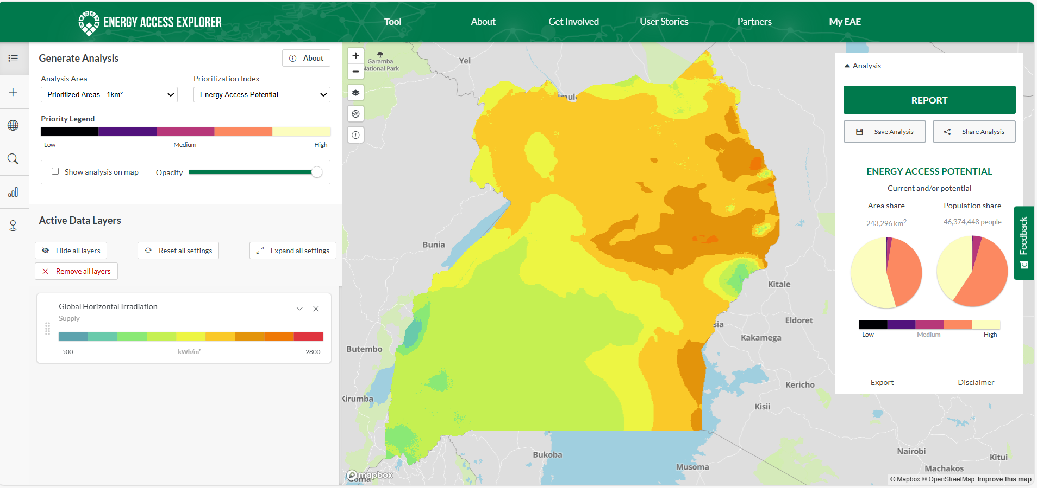
Task 4: First Remove all layers and from the Supply layer, under Infrastructure, select Distribution Lines. Then, proceed to the Active Layers to study the characteristics of the datasets by expanding all settings.
The resulting image should appear as follows:
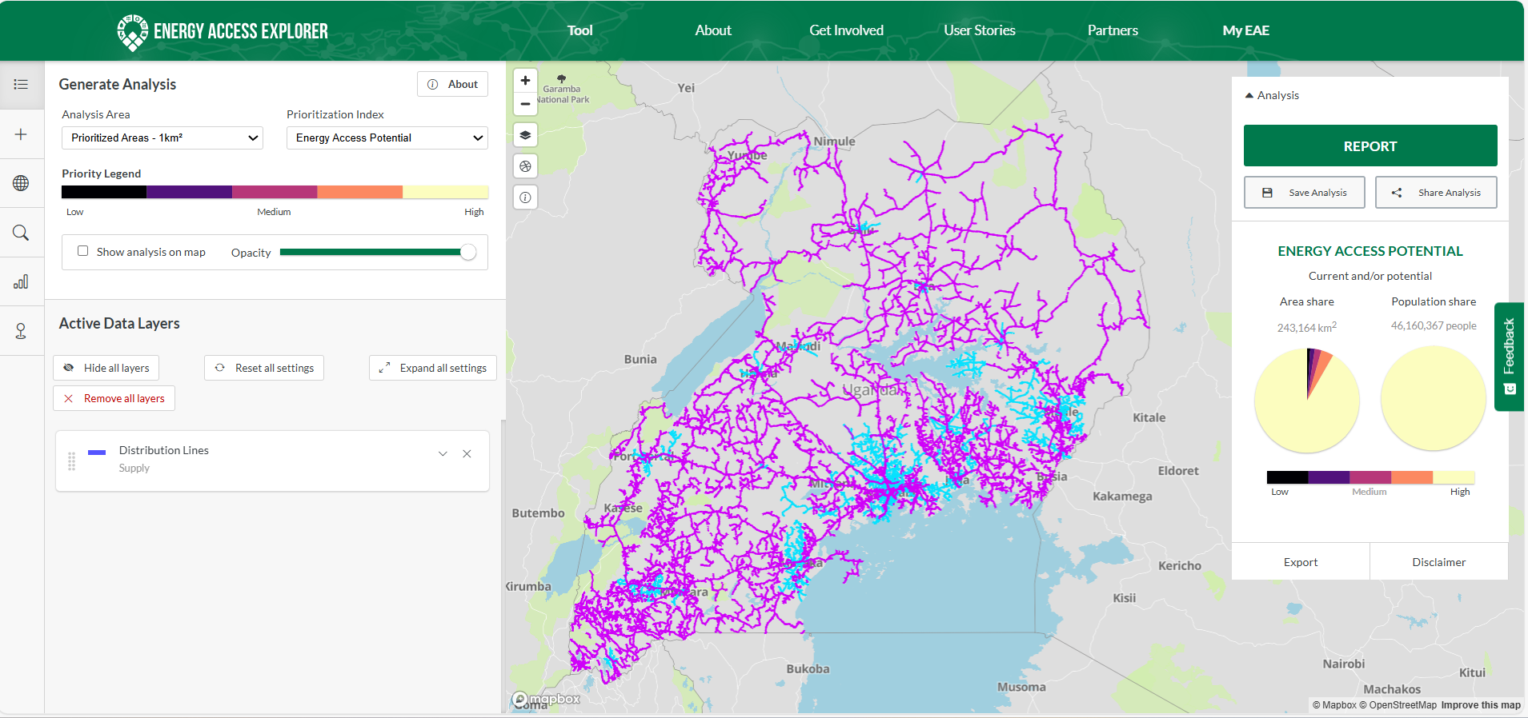
Q6. Which voltage levels do the distribution lines represent and what is their status? (Hint: Table section of the data layer)

  - Census
Census or survey datasets show the proportion of the population at subnational level by lighting and cooking source as well as asset ownership. The map below shows the proportion of the population using firewood for cooking at sub-region level in Uganda.
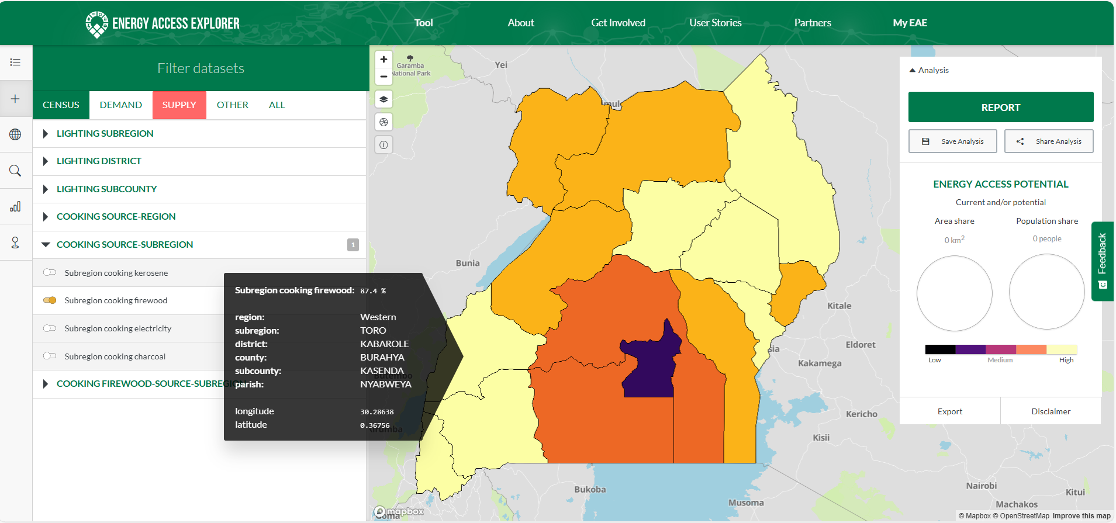
  - Other
The other categories show layers such as environment, finance, admin boundaries, landcover etc. The map below shows distribution of protected areas in Uganda.
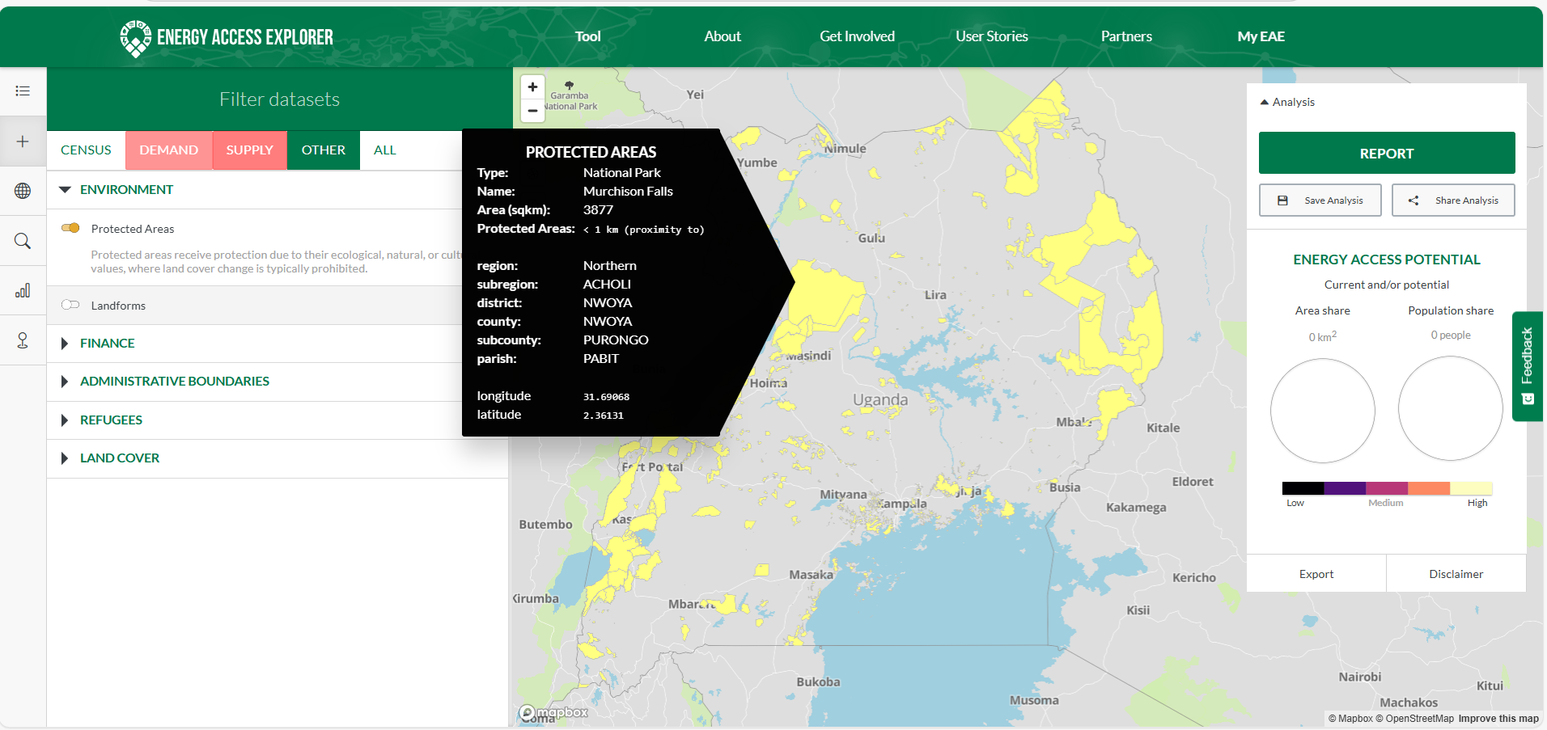

II. EAE Prioritization Index
Energy Access Explorer uses a multi-criteria analysis (MCA) to identify areas of interest to expand energy access. Four types of indices are represented in the EAE prioritization analysis: Energy Access Potential, Demand Index, Supply Index and Assistance Need Index.
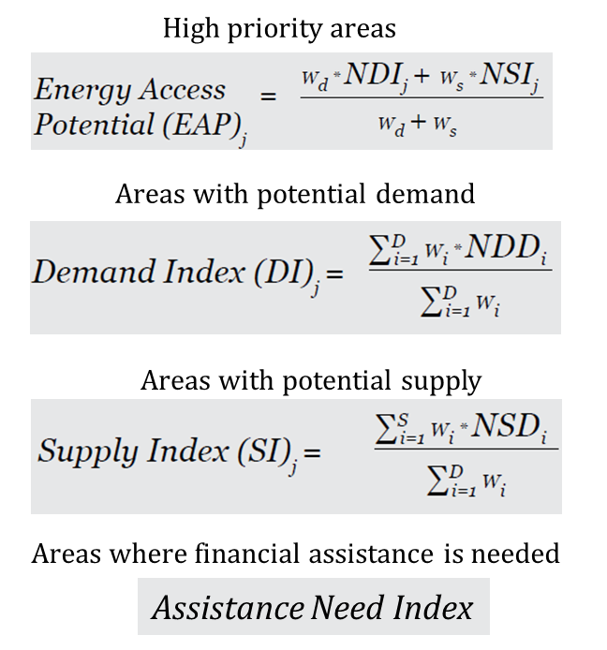
Task 5: Select the demand and supply datasets used in section I without applying any filters to the datasets (The datasets are: Population density, Education and Health Facilities, Global Horizontal Irradiation and Distribution Lines). Only Show the analysis on map (or Hide all layers from the Active Data Layers).
The resulting map should look as follows
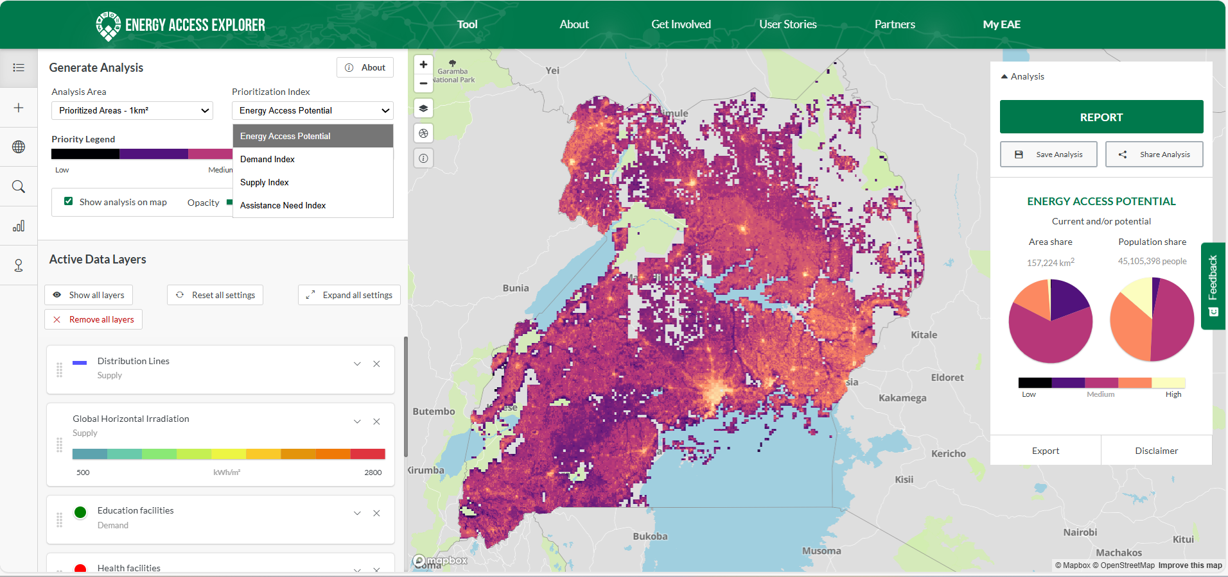
- Energy Access Potential
Q7. How much is the proportion of the population with High Energy Access Potential? (Hint: See the population share in the right panel or report section)
- Demand Index
Q.8. Using the same datasets as above and after changing the prioritization to Demand Index, how much is the proportion of the population with High Demand Index?
- Supply Index
Q9. Using the same datasets as above and after changing the prioritization to Supply Index, how much is the area share with High Supply Index?
- Assistance Need Index
Q10. Using the same datasets as above and in the Assistance Need Index, what is the population share where High financial assistance is needed?

