Energy Access Explorer Front End Exercise
Hands-on 1: Exploring the EAE platform & creating MyEAE user account
License:
This work is licensed under the Creative Commons Attribution 4.0 International License (CC BY 4.0). To view a copy of this license, visit https://creativecommons.org/licenses/by/4.0/.
Attribution:
Please cite as: Woldeamanuel, A. A., Khalid, A., Anand, S., Sahar, T., Saklani, A., Sinclair-Lecaros, S., Mentis, D., Ronoh, D., & Stockman, J., 2026. Data Driven, Integrated and Inclusive Energy Planning with Energy Access Explorer. Version 1. Climate Compatible Growth Teaching Kit Website, Climate Compatible Growth.

Learning outcomes
By the end of this exercise, you will be able to:
1) Understand the key components of the EAE platform
2) Create My EAE user account

Contents
I. EAE Home Page
- Visit home page of the Energy Access Explorer
- Tutorial Videos
- Blogs and Publications
II. Tools or Explore Data
III. About
- What we do
- Primary audience
- Methodology
- Open data and attribution requirements

IV. Get Involved

V. User Stories

VI. Partners

VII. Login/My EAE

I. EAE home page
- Visit the home page of the Energy Access Explorer
On a browser, open Energy Access Explorer using this link: https://www.energyaccessexplorer.org/
Once you enter the link, you should be able to see the page below:
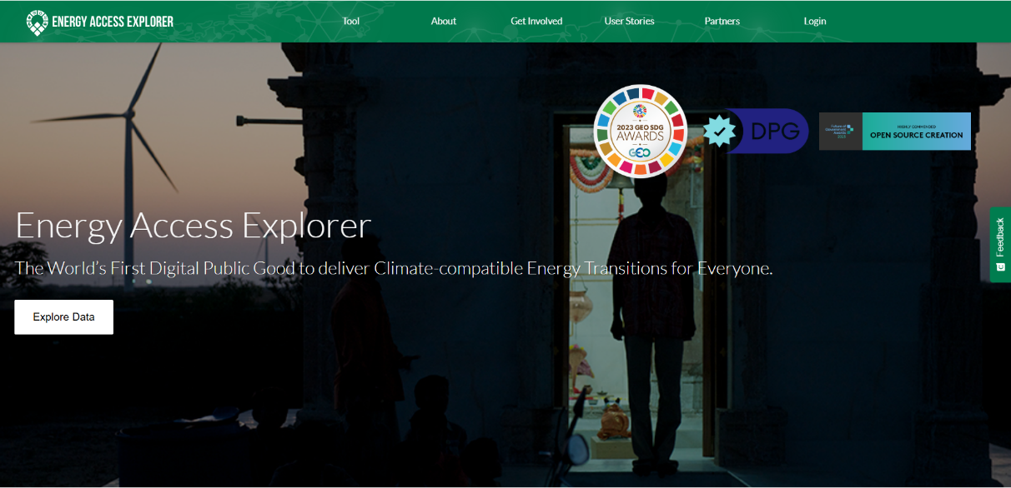
- Tutorial videos
Scrolling further down, you can see the tutorial videos (based on older version of EAE)
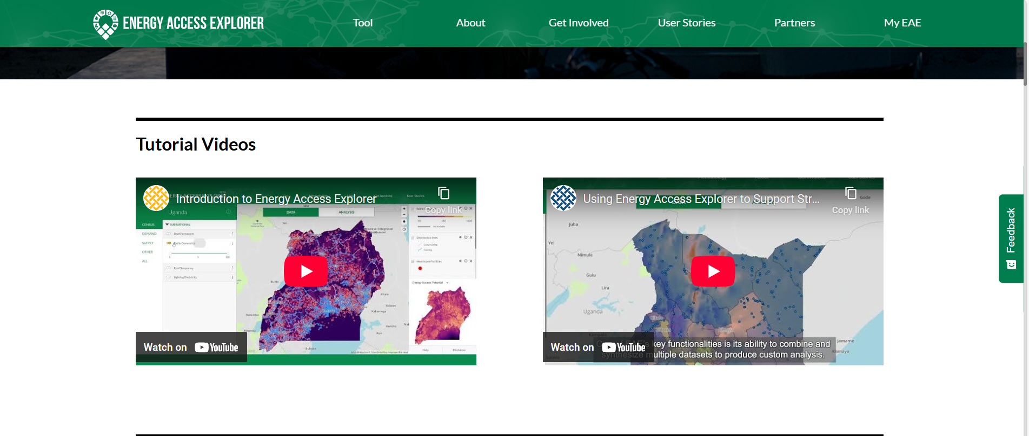

- Blogs and publications
Further down, you will be able to see all the relevant blogs and publications
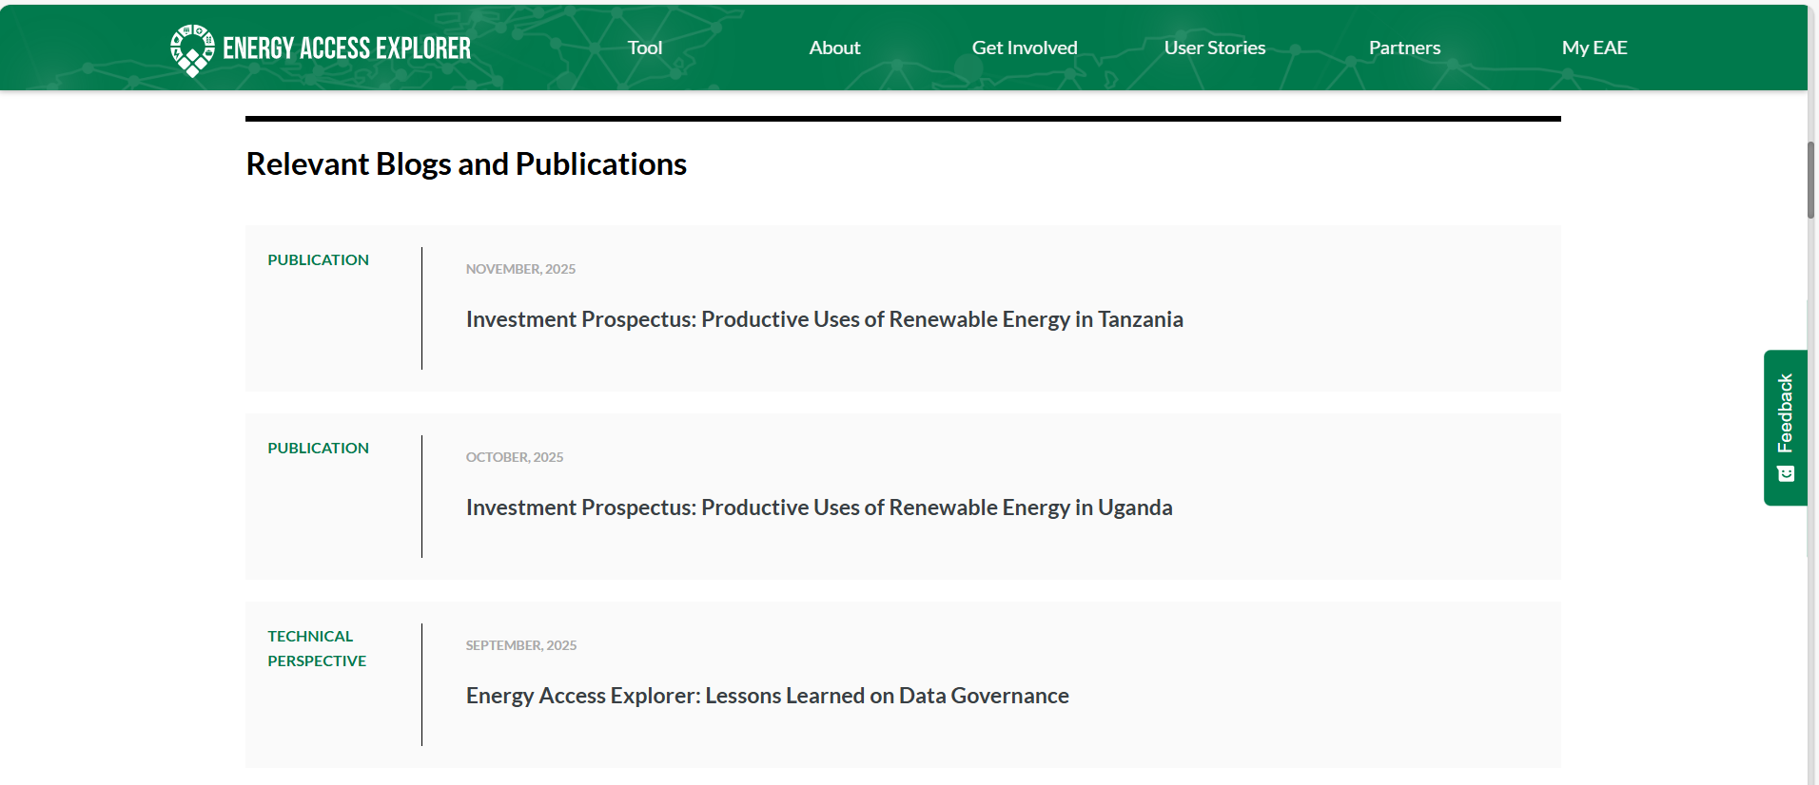

II. Tools or Explore data
Select Tool from the top menu or Explore data to see the EAE geographies listed. https://www.energyaccessexplorer.org/tool/s/
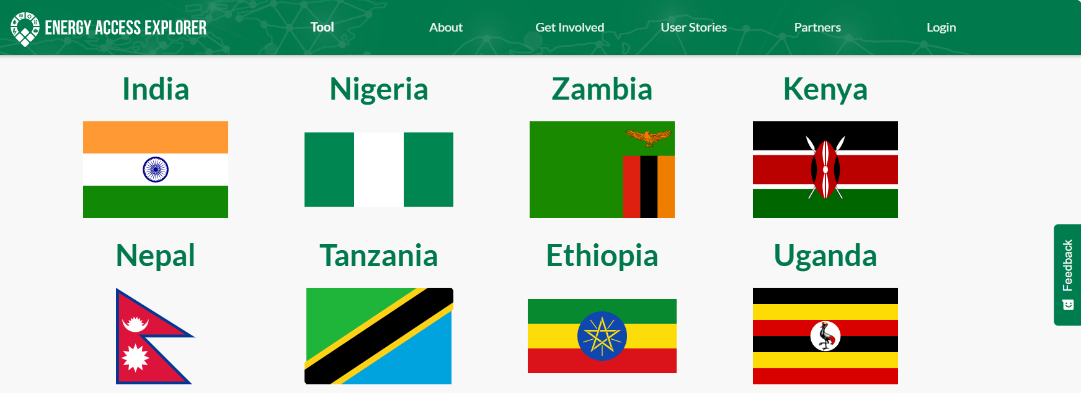

III. About
Select About from the top menu and you will see the following page with information about what we do, primary audience of EAE, methodology and open data commitment of WRI. Under this section, you will also find the EAE brochure and technical note https://www.energyaccessexplorer.org/about/
- What we do
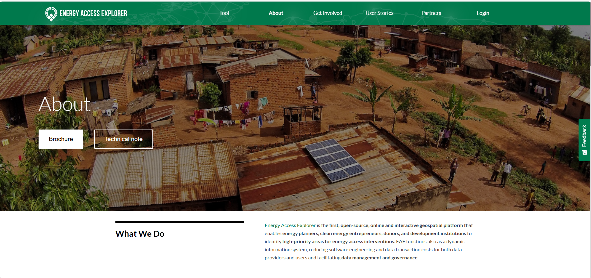
- Primary audience
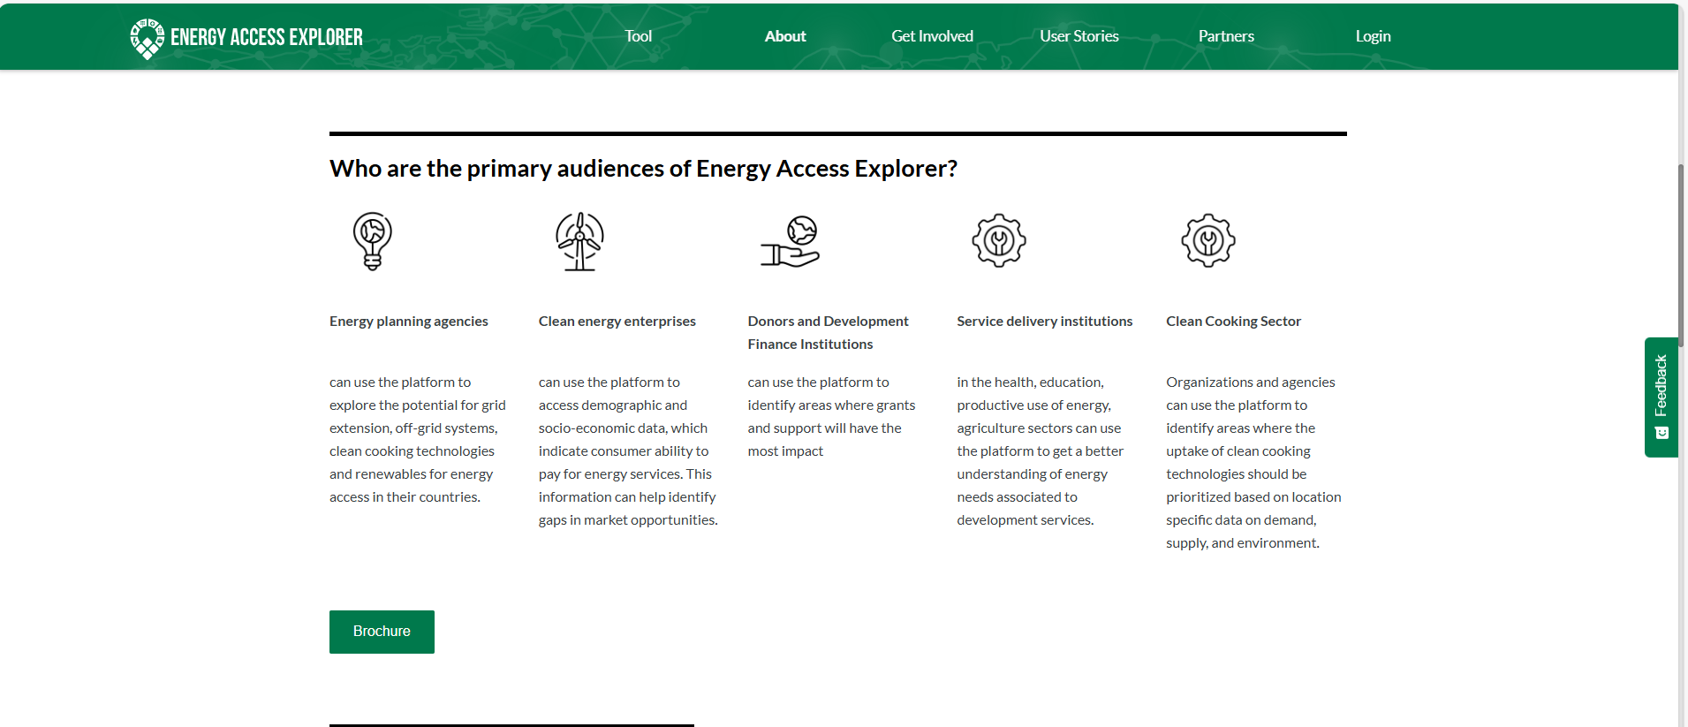

- Methodology
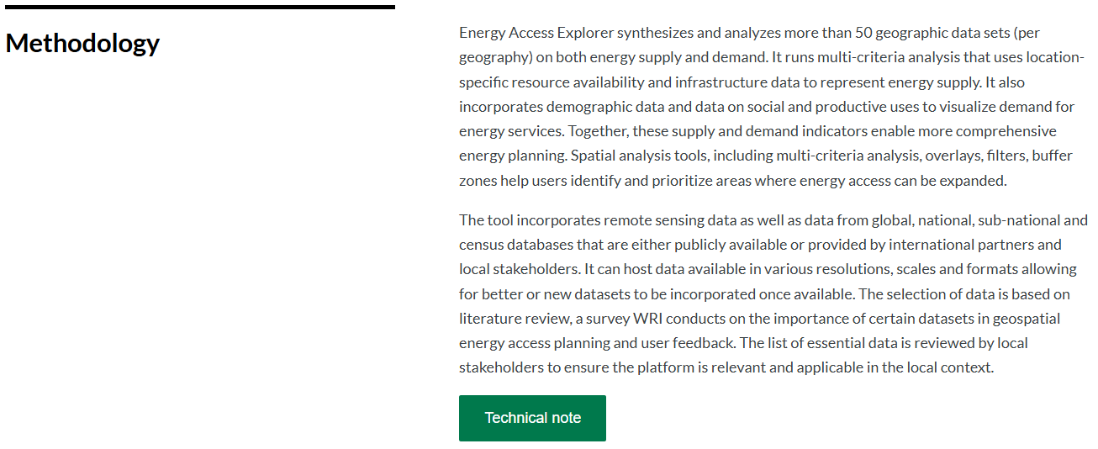
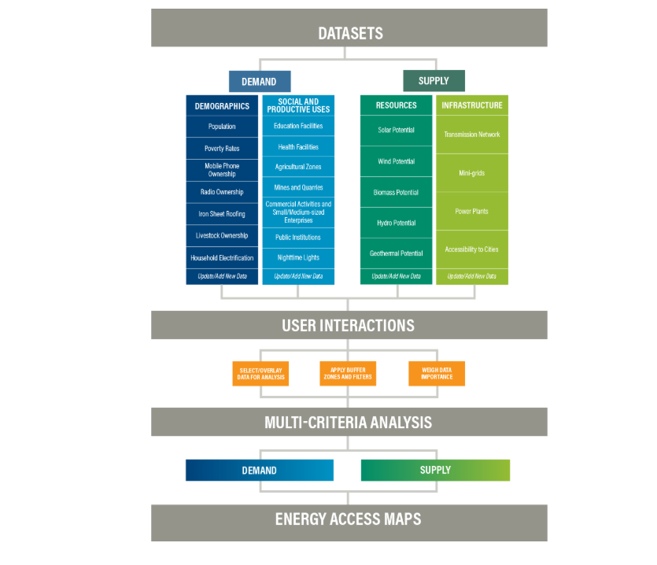

- Open data and attribution requirements
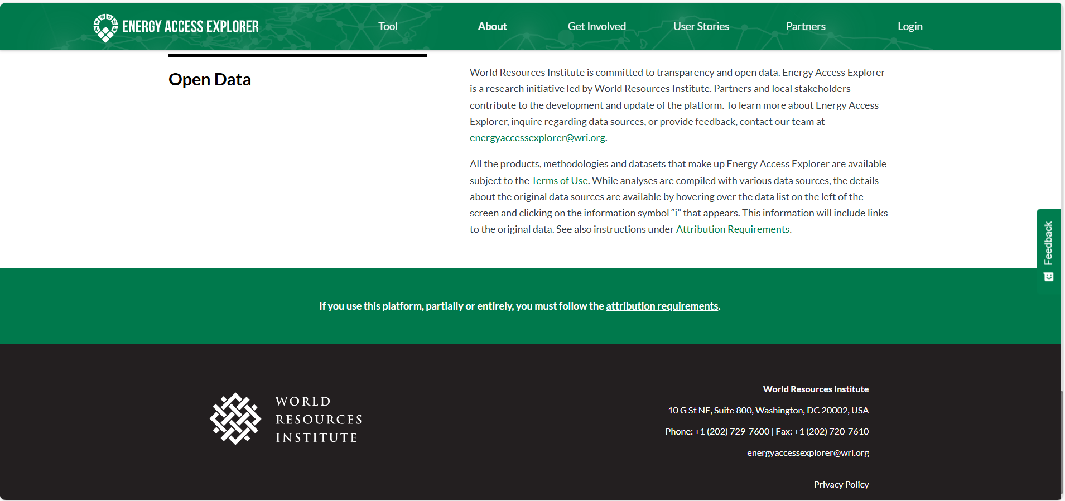

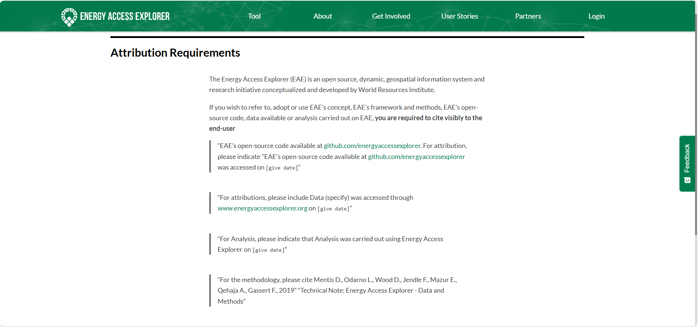

IV. Get Involved
In this section, you can see how you can get involved by contributing data, sharing a story and registering to My EAE https://www.energyaccessexplorer.org/get-involved/. If have also any comments or feedback, you can send an email to energyaccessexplorer@wri.org
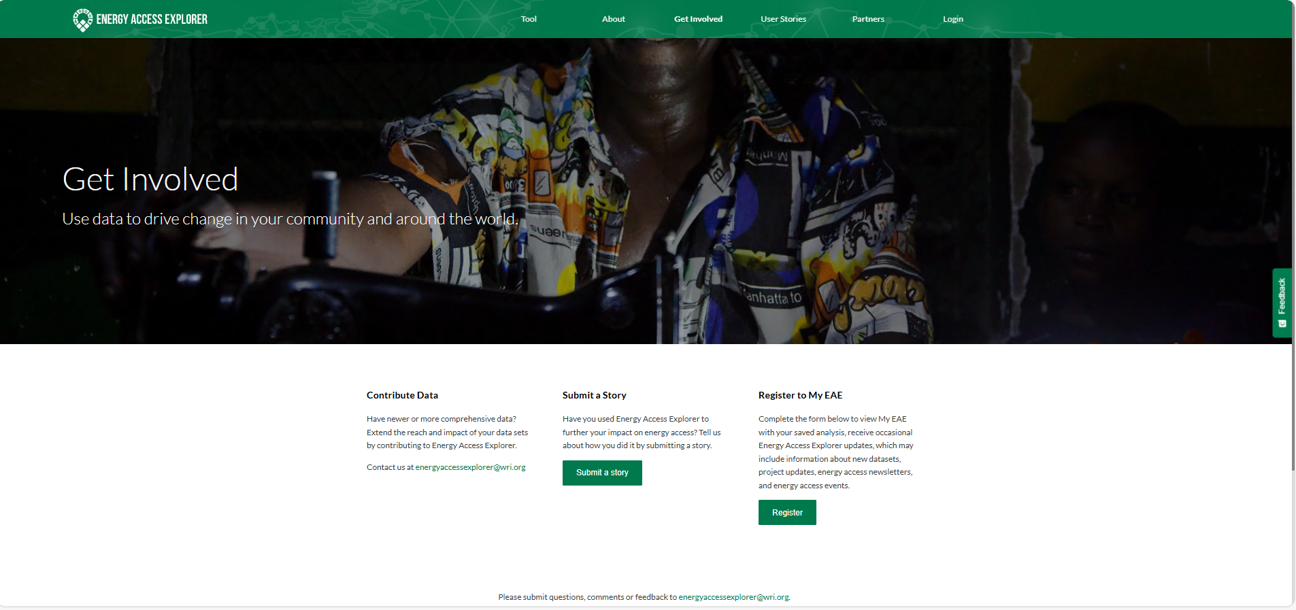

V. User Stories
Here you can see testimonials from different users, and you can also share your story https://www.energyaccessexplorer.org/user-stories/
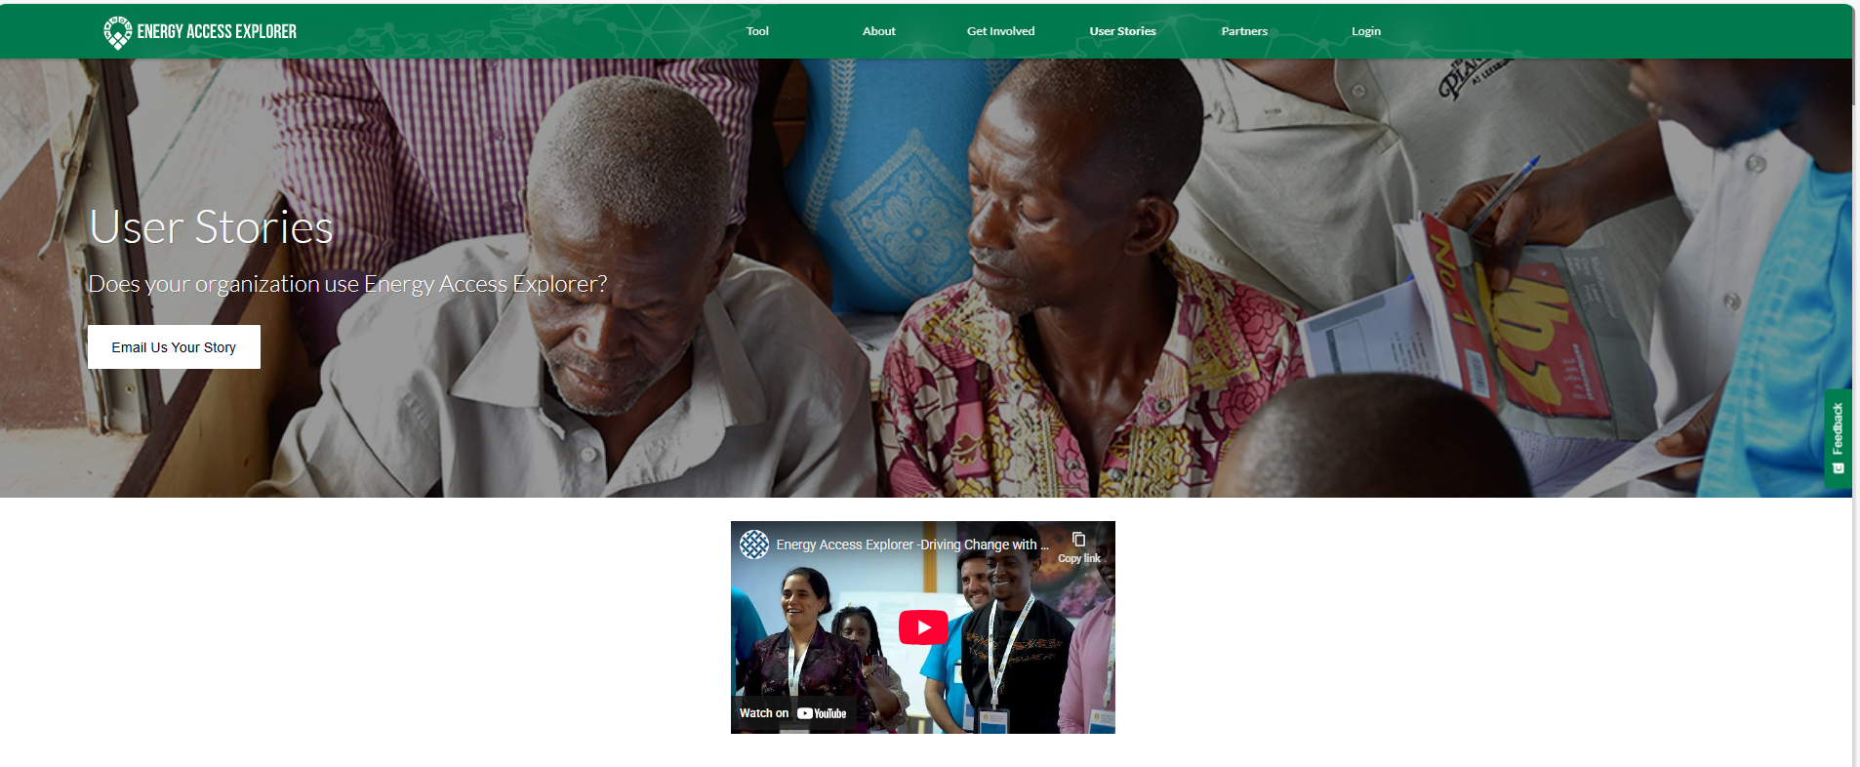

VI. Partners
EAE Close partnership with > 300 stakeholders and >35,000 users. ​The support is estimated to be > 15 MUSD in kind contributions​. See the list partners on the website:
https://www.energyaccessexplorer.org/partners/
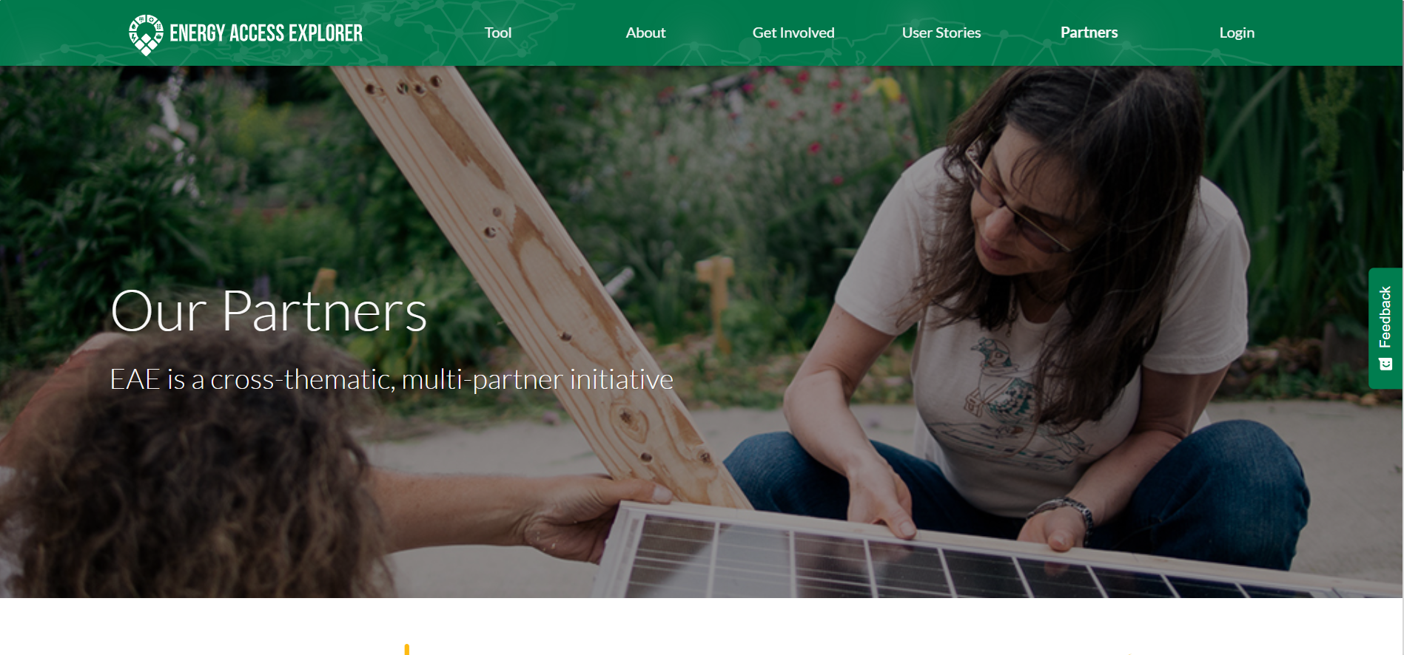

VII. Login/My EAE
To login into My EAE, go to https://www.energyaccessexplorer.org/login/. Use your email and password if you have already registered or click the create one here link to register


Task 1: Register to My EAE and confirm using the link provided by your email
- Go to this link https://www.energyaccessexplorer.org/subscribe/?select=account
- Complete the form below
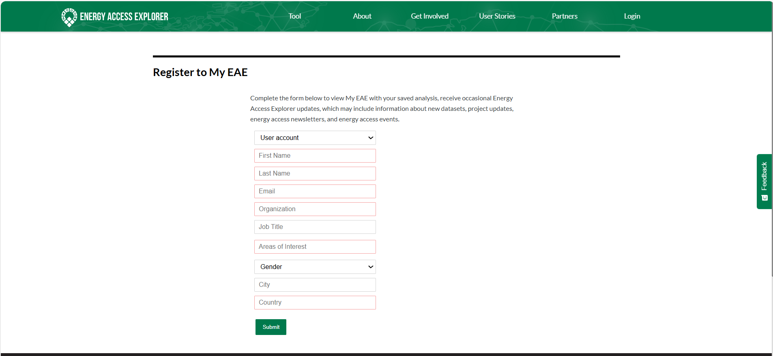
- Once your account is created, you will receive a confirmation email and confirm using the link provided.
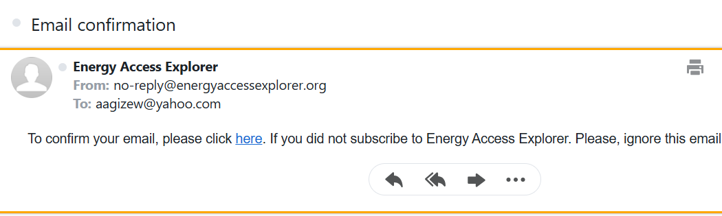
- In case you do not see the confirmation email in your inbox, check your email's spam folder too.
Task 2: Create password and login
- Once your user account has been created and confirmed using the link provided by your email, you will be prompted to create your password
- Then, go to the login page again and insert your email and password to login into the EAE platform
- You can also request a new password if you forgot your previous password
- Note: For back-end trainings, users are required to login using the training environment link https://training.energyaccessexplorer.org/login/
- After login, users can see the frontend of EAE for all Geographies or the geography where the back-end training is provided
- The 'Login' icon at the top right corner also changes into 'My EAE
