MAED: Residential Base Year Reconstruction Workflow
Reconstructing the base year for Cooking end use in MAED
Musah, M., & Kiley, F. (2025). MAED: Residential Base Year Reconstruction Workflow. Reconstructing the base year for cooking end use in MAED. Zenodo. DOI: 10.5281/zenodo.17628941

- Residential Sector Modelling YouTube
Useful Links:

- Residential Sector Modelling Slides

Learning Outcomes

This exercise presents a workflow for reconstructing the base year for the cooking end use within the Residential sector in MAED. By the end of this exercise, you will be able to:
  - Collect and process the necessary inputs for MAED to reconstruct the base year for residential energy demand, focusing on the cooking end use.
    - Required data: Population, number of households, urban–rural distribution, occupancy rates of households, final energy demand (from national energy balance) and efficiencies
  - Validate the base-year results against national energy balance data to ensure model consistency.
Note:
This Hands-On focuses on reconstructing the residential sector as a whole and does not disaggregate residential into urban and rural categories. The methodology, however, can be extended to include such disaggregation when complementary residential survey or census data are available.

Overall Workflow

Figure 1 illustrates the overall workflow for deriving the various input parameters: population, number of dwellings, number of households, specific energy requirements, efficiency, and penetration of energy forms (PEN) when reconstructing the base year for the residential sector in MAED. The rest of this Hands-On (HO) will guide you through the methodology for how to execute this workflow. It uses the example of Ghana, but the process is identical for any country.

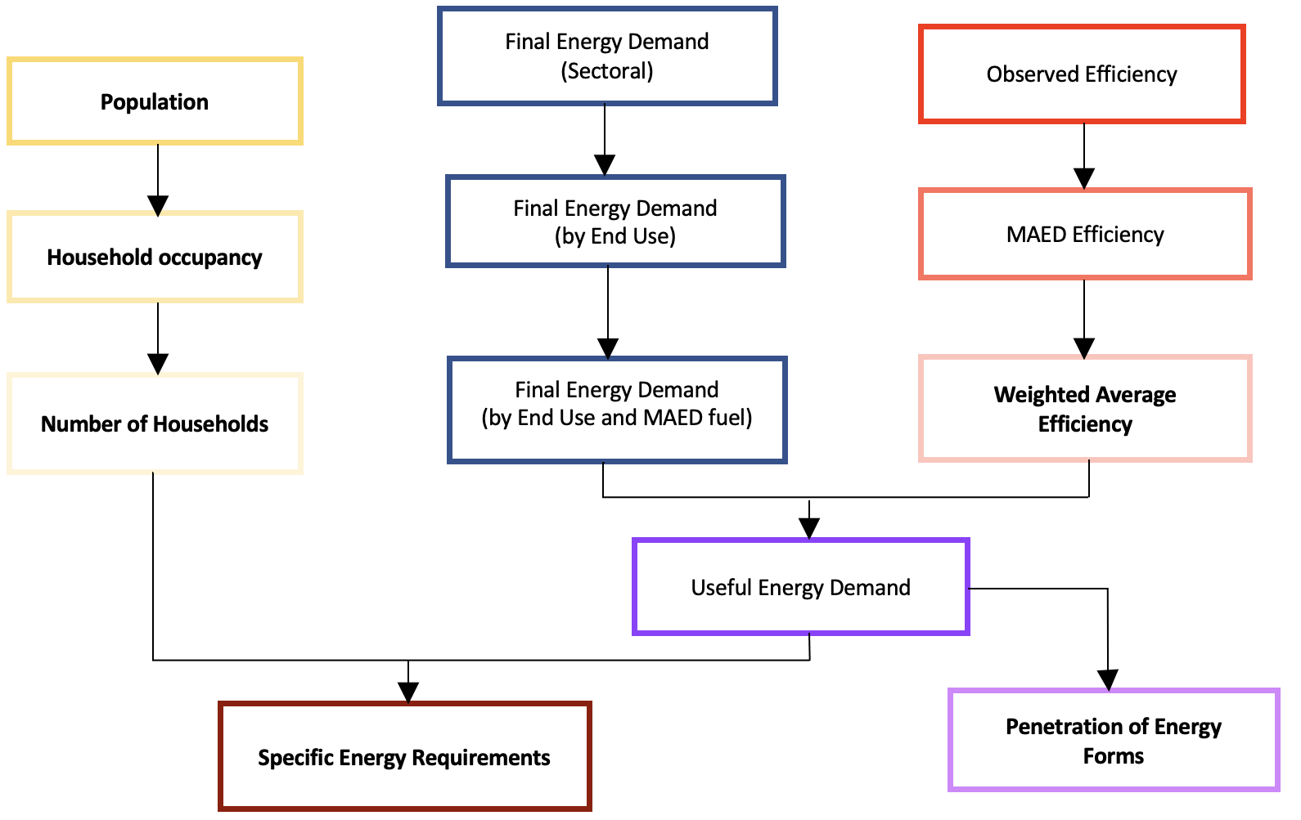

Figure 1: The workflow for reconstructing the base year in the residential sectors. Parameters in bold are direct inputs to MAED. Other parameters are used to derive these direct inputs.

Base Year Selection

The first step is to select a base year. The base year is used as a baseline to project values for your various scenarios (e.g. for a Business-as-Usual you might use the values calculated for the base year for all years in the model period) and is used here to calibrate the model. It is important that the year selected represents a recent and standard year in which all the necessary data is available. This means we want a year in which no major geopolitical events impacted the economy, society, or energy sector. Recent examples of these are COVID, the Russian invasion of Ukraine, etc.

Once the base year has been selected, all relevant data must be collected for that year. For this example, 2023 was selected as it is post-COVID and there were no other events that would result in non-typical energy consumption.

A note on units: for this case study, population is presented in million and energy is presented in GWyr. Consequently, Specific Energy Requirements is given in kWh/dwelling/year. However, population can also be presented in billion and the energy unit can be PJ, Tcal, Mtoe, or GBTU. Depending on which unit and energy unit you use, the units for Specific Energy Requirements may differ from those presented here but the workflow remains the same.

Energy Balance
Depending on the source of your energy balance, it will need to be processed to obtain a Final Energy Demand (FED) for each end use (e.g. Specific Electricity Uses, Air Conditioning, Cooking, Water heating and Space Heating) and for each MAED fuel category (e.g. Traditional Fuels, Modern Biomass, Electricity, Solar Thermal, Fossil Fuels, and Motor Fuels). This Hands-On (HO) exercise will use the national energy balance obtained from the Energy Commission of Ghana to illustrate the workflow for reconstructing the base year.

Generally, it is recommended to use national energy balances published by national agencies (e.g., the Ministry of Energy or Energy Commission) to ensure consistency with domestic statistics. If such data are unavailable, suitable alternatives can be obtained from regional or international databases (e.g. UN, AFREC for Africa, olade-sieLAC for South America and the Caribbean, and the EGEDA for Asia-Pacific Economic Cooperation).

A screenshot of an example national energy balance is shown in Figure 1. The consumption section (the part relevant to MAED) is circled in red and the Residential sector is highlighted in yellow. Table 1 presents the relevant consumption data for the Residential sector.

Table 1: Final Energy Consumption (Demand) taken directly from the energy balance.

Final Consumption, Ktoes | Crude Oil | Natural Gas | LPG | Wood | Charcoal | Solar | Kerosene | Waste | Electricity | Total
Residential | 0 | 0 | 164.5 | 1199.42 | 944.04 | 0 | 2.66 | 0 | 643 | 2953.82

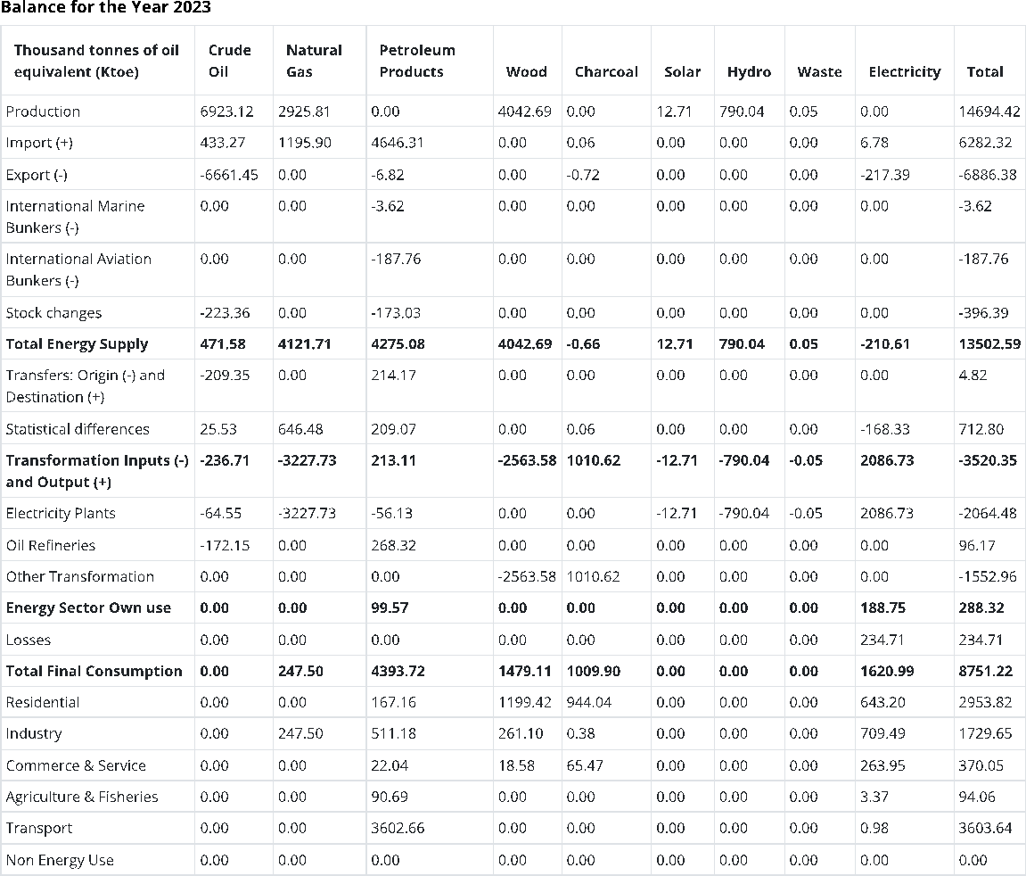
Figure 2: Example energy balance for Ghana. Consumption section enclosed in red box. Residential sector highlighted in yellow.
  - The First step is to split FED into the five end uses: Specific Electricity Uses, Air Conditioning, Cooking, Water heating and Space Heating. The proportions used can be derived from national statistics office, census data, and/or expert judgement.
Only the Cooking end use is presented below as the methodology is identical for the other end use.
Table 2 shows the workflow which uses Equation [1] to obtain Final Consumption by End Use.
𝐹𝑖𝑛𝑎𝑙 𝐶𝑜𝑛𝑠𝑢𝑚𝑝𝑡𝑖𝑜𝑛 𝑏𝑦 𝐸𝑛𝑑 𝑈𝑠𝑒 = 𝐹𝑖𝑛𝑎𝑙 𝐶𝑜𝑛𝑠𝑢𝑚𝑝𝑡𝑖𝑜𝑛 𝑏𝑦 𝑆𝑒𝑐𝑡𝑜𝑟 ×
𝑃𝑟𝑜𝑝𝑜𝑟𝑡𝑖𝑜𝑛𝑎𝑙 𝑆𝑝𝑙𝑖𝑡 𝑏𝑦 𝑒𝑛𝑑 𝑢𝑠𝑒 [1]

Table 2: Tables showing the workflow going from (a) Final Energy Consumption in Residential through
(b) proportional splits for different end uses to (c) Final Energy Consumption in Residential by End Use

(a)
Final Consumption, Ktoes | Crude Oil | Natural Gas | LPG | Wood | Charcoal | Solar | Kerosene | Waste | Electricity | Total
Residential | 0 | 0 | 164.5 | 1199.42 | 944.04 | 0 | 2.66 | 0 | 643 | 2953.82
(b)
Proportional Split, % | Crude Oil | Natural Gas | LPG | Wood | Charcoal | Solar | Kerosene | Waste | Electricity
Space Heating | 0 | 0 | 0 | 0 | 0 | 0 | 0 | 0 | 0
Water Heating | 0 | 0 | 5 | 5 | 5 | 0 | 0 | 0 | 5
Cooking | 0 | 0 | 95 | 95 | 95 | 0 | 45 | 0 | 1
Air Conditioning | 0 | 0 | 0 | 0 | 0 | 0 | 0 | 0 | 6
Appliances | 0 | 0 | 0 | 0 | 0 | 0 | 0 | 0 | 68
Lighting | 0 | 0 | 0 | 0 | 0 | 0 | 55 | 0 | 20
Total | 0 | 0 | 100 | 100 | 100 | 0 | 100 | 0 | 100

(c)
Final Consumption by End Use, Ktoe | Crude Oil | Natural Gas | LPG | Wood | Charcoal | Solar | Kerosene | Waste | Electricity | Total
Cooking | 0 | 0 | 156.275 | 1139.449 | 896.838 |  | 1.197 |  | 6.432 | 2200.191

  - Now, we need to group the fuels as presented in the energy balance into the fuel categories represented in MAED. These are Traditional Fuels, Modern Biomass, Electricity, Solar Thermal, Fossil Fuels, and District heating. For the purposes of this Hands-On exercise, we are going to group ‘LPG and Kerosene’ under Fossil Fuels, ‘Wood and Charcoal’ will be classed as Traditional Fuels while electricity will be classed as electricity.

Table 3: Final Energy Consumption by End Use with fuels grouped into MAED-compatible fuel categories

Final Consumption by MAED End Use, Ktoe | Traditional Fuels | Modern Biomass | Electricity | Solar Thermal | Fossil Fuels | District Heating
Cooking | 2036.287 | 0 | 6.432 | 0 | 157.472 | 0

  - Whenever there are substitutable energy forms (electricity, fossil fuels, traditional fuels, modern biomass, solar systems) that can meet a given end use (e.g., cooking, water heating, or space heating), the Final Energy Demand (FED) must be converted into Useful Energy Demand (UED). To do so, we need to find Real Efficiencies (i.e. efficiencies observed in reality), then we transform these to derive MAED Efficiencies and finally we derive Weighted Average Efficiencies (WAE) due to fuel groupings.

- Real Efficiencies: the efficiencies represented here are supposed to represent those observed in reality and will come from literature and/or government statistic agencies/Ministry of Energy. The efficiencies represented in this table are used for illustrative purposes and should not be used when developing a case study.
N.B. By default, in MAED, FED for Appliances and Lighting is equal to UED. This is because it is a non-substitutional energy form (no competition between other energy forms for a specific end use).

Table 4: Real Efficiencies as derived from literature.

Real Efficiency, % | Crude Oil | Natural Gas | LPG | Wood | Charcoal | Solar | Kerosene | Waste | Electricity
Cooking | 40 | 60 | 67 | 13 | 22 | 70 | 25 | 40 | 90

- MAED Efficiencies: we then adjust the Real Efficiencies to account for the assumption built into MAED that Electricity for Thermal Uses is 100% efficient. Equation [2] is used to get from Table 4 to Table 5.

𝑀𝐴𝐸𝐷 𝐸𝑓𝑓𝑖𝑐𝑖𝑒𝑛𝑐𝑦𝑥
= 𝑅𝑒𝑎𝑙 𝐸𝑓𝑓𝑖𝑐𝑖𝑒𝑛𝑐𝑦𝑥 , 𝑤ℎ𝑒𝑟𝑒 𝑥 = 𝑎 𝑠𝑝𝑒𝑐𝑖𝑓𝑖𝑐 𝑓𝑢𝑒𝑙 [2]
𝑅𝑒𝑎𝑙 𝐸𝑓𝑓𝑖𝑐𝑖𝑒𝑛𝑐𝑦𝑒𝑙𝑒𝑐𝑡𝑒𝑒𝑖𝑐𝑖𝑡𝑦

Table 5: MAED adjusted efficiencies

MAED Efficiency, % | Crude Oil | Natural Gas | LPG | Wood | Charcoal | Solar | Kerosene | Waste | Electricity
Cooking | 44 | 67 | 74 | 14 | 24 | 78 | 28 | 44 | 90

- Weighted Average Efficiencies (WAE): we now need to account for the fact that we have grouped some fuels as represented in the Energy Balance into fuel categories that are represented in MAED (step 2). Equation [3] illustrates how to do this for two fuels x and y while Equation [4] presents a more generalised formula for any number of fuels.

𝑊𝑊𝐴𝐸 = (𝐸𝑓𝑓𝑖𝑐𝑖𝑒𝑛𝑐𝑦𝑥×𝐹𝐸𝐷𝑥)+(𝐸𝑓𝑓𝑖𝑐𝑖𝑒𝑛𝑐𝑦𝑦×𝐹𝐸𝐷𝑦)
(𝐹𝐸𝐷𝑥+𝐹𝐸𝐷𝑦)
[3]

𝑊𝑊𝐴𝐸 = 𝐹𝐸𝐷𝑥(𝐸𝑓𝑓𝑖𝑐𝑖𝑒𝑛𝑐𝑦𝑥) , 𝑤ℎ𝑒𝑟𝑒 𝑥 = 𝑎 𝑠𝑝𝑒𝑐𝑖𝑓𝑖𝑐 𝑓𝑢𝑒𝑙 [4]

𝑛
∑
𝑥=1
𝐹𝐸𝐷𝑥

Table 6: Weighted Average Efficiency for MAED grouped fuels in Thermal Uses

WAE, % | Traditional Fuels | Modern Biomass | Electricity | Solar Thermal | Fossil Fuels | District Heating
Cooking | 19 | 0 | 100 | 0 | 74 | 0

  - The next step is to derive Useful Energy Demand (UED) for cooking end Uses from the FED (Table 3) and WAE (Table 6). See Equation [5].

𝑈𝐸𝐷 = 𝐹𝐸𝐷𝑥 × 𝑊𝑊𝐴𝐸𝑥 , 𝑤ℎ𝑒𝑟𝑒 𝑥 = 𝑠𝑝𝑒𝑐𝑖𝑓𝑖𝑐 𝑓𝑢𝑒𝑙 [5]
Table 7:Useful Energy Demand for cooking end uses Ktoe

UED, Ktoe | Traditional Fuels | Modern Biomass | Electricity | Solar Thermal | Fossil Fuels | District Heating | Total
Cooking | 383.81 | 0 | 6.43 | 0 | 116.67 | 0 | 506.9167

  - We now have our UED for cooking in the base year. Now, we want to calculate the Penetration of Energy Forms (PEN) in the base year from the total of these UEDs. See Equation [6]. We also want to convert the units into kWh (Table 9) to account for the units used in calculating Specific Energy Requirement

𝑃𝐸𝑁𝑥,𝑖
= 100 ( 𝑈𝐸𝐷𝑥,𝑖 ) , 𝑥 = 𝑓𝑢𝑒𝑙, 𝑖 = 𝑒𝑛𝑑 𝑢𝑠𝑒 [6]
∑𝑛 𝑈𝐸𝐷𝑖
𝑥

Table 9: Useful Energy Demand for cookingl end uses in kWh

UED, kWh | Traditional Fuels | Modern Biomass | Electricity | Solar Thermal | Fossil Fuels | District Heating | Total
Cooking | 4,463,758,500 | 0 | 74,804,160 | 0 | 1,356,878,561 | 0 | 5,895,441,221

Table 10: Penetration of Energy Forms for the different fuel categories as derived from the Useful Energy Demand

Pen, % | Traditional Fuels | Modern Biomass | Electricity | Solar Thermal | Fossil Fuels | District Heating | Total
Cooking | 76 | 0 | 1 | 0 | 23 | 0 | 100

Demographic Data

To derive the specific energy requirements for cooking end uses in the residential sector, we need to determine the number of households in the base year. For the purposes of this Hands-On (HO), we will use demographic data derived from the 2021 Population and Housing Census of Ghana, published by the Ghana Statistical Service (GSS). It is essential that the base year for population data aligns with the base year selected for the energy balance, ensuring consistency across all model inputs.

  - First, we compile the relevant demographic parameters from the national census. In this case, we are interested in the total population and the average number of persons per household in Ghana.
  - From here we divide the total population by the average number of persons per household to obtain total Number of households in Ghana.

Note:
When disaggregating the residential sector into urban and rural households, the average number of persons per household should be obtained separately for each category. Consequently, the number of households must also be calculated independently for urban and rural household.

Table 11: Demographic data taken directly from source.

Parameter | 2023
Population | 33,790,000
Person/households | 3.80
Number of households | 8,892,105
N.B. Additional data are required for other end uses in the residential sector, such as cooling, which requires information on the percentage of dwellings with air conditioning; space heating, which requires data on the total heated household area (m²); water heating, which requires information on the share of dwellings with hot water facilities; and for appliances and lighting, which requires data on the percentage of electrified dwellings.

Specific Energy Requirement

We now have the required data to calculate the Specific Energy Requirement for cooking end use in Residential sector.

I. Specific Energy Requirement for cooking end use is calculated by dividing total useful energy demand for cooking end use (Table 9) by the total number of households (Table 11). See Equation [7].

𝐶𝑂𝑂𝐾𝐷𝑊𝑊𝑈,𝑅
= 𝑈𝐸𝐷𝑈,𝑅 , 𝑤ℎ𝑒𝑟𝑒 𝑈, 𝑅 = 𝑈𝑟𝑏𝑎𝑛 𝑎𝑛𝑑 𝑅𝑢𝑟𝑎𝑙 [7]
𝐶𝐾𝑈,𝑅

Table 12: Specific Energy Requirements for cooking end use.

End Use | Cooking
Specific Energy Requirements [kWh/dwelling/year] | 663.00

Model Input and Results Validation

We are now ready to input the calculated data into the model and validate our results.
  - First, we need to input the values from Tables 6, 10, 11 and 12. The following parameters need to be defined for the base year to enable the successful calculation of results:
N.B. In MAED, the Residential sector is typically disaggregated into Urban and Rural sub-sectors. However, when representing the entire residential sector without disaggregation, the relevant parameters such as specific cooking energy requirements, efficiencies, and penetration of energy forms (PEN) can be entered under a single column (either Urban or Rural).
For the purposes of this exercise, all data were entered under the Urban column to represent the total residential sector.

- Population (million units) from Table 11:
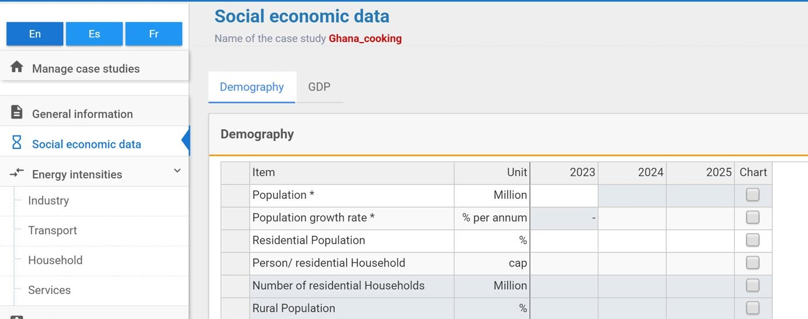

- Person/households from Table 11:
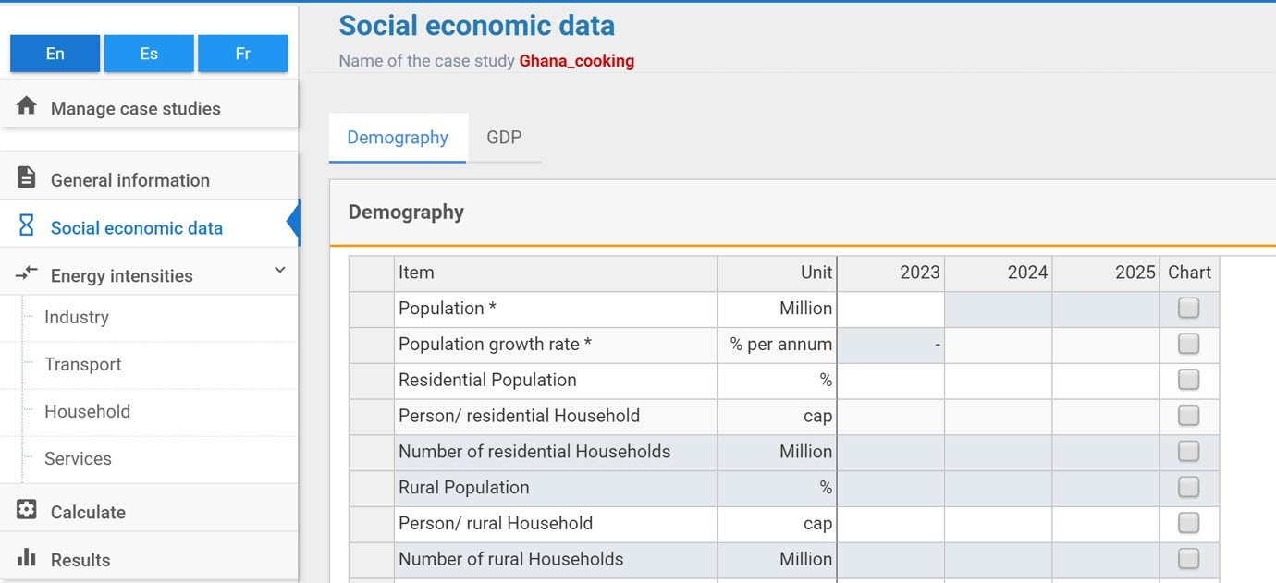

- Specific Energy Requirements from Table 12:
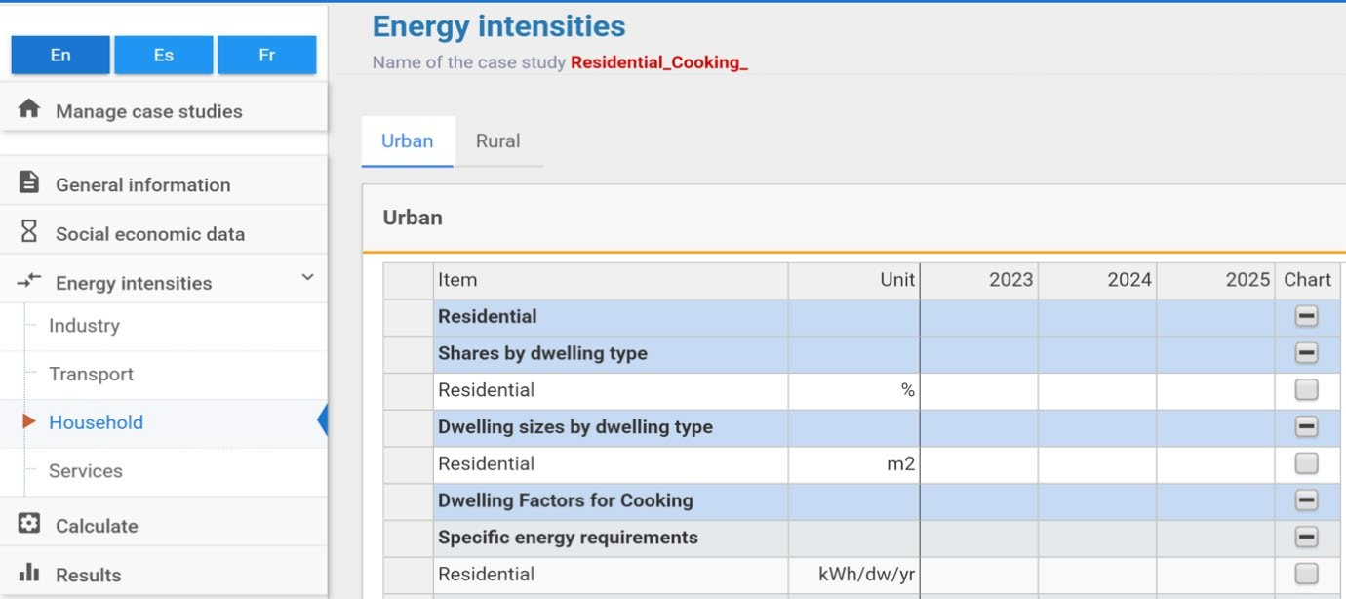

- Penetration of energy forms for cooking Uses (%) from Table 10:

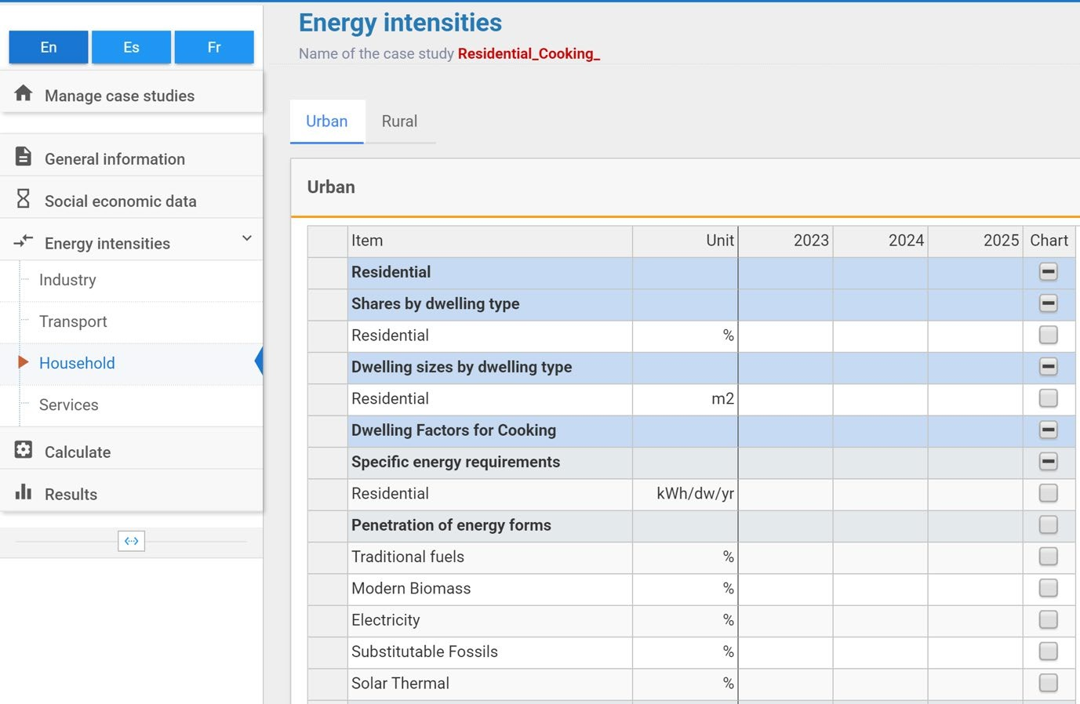
- Efficiencies for cooking Uses (%) from Table 6:
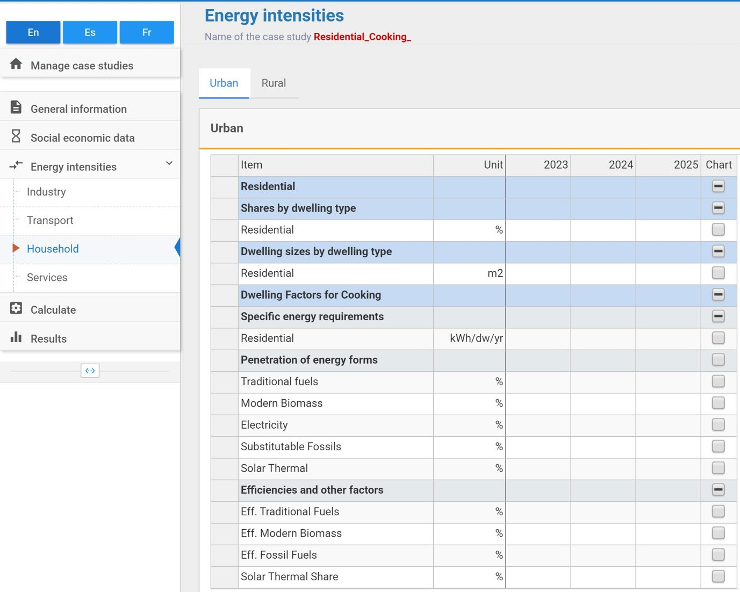

b. We then calculate the results and visualise the Final Energy Demand results in the User Interface. We compare these results to the known values obtained from the Energy Balance. If they are roughly equal (<1% difference), then we have reconstructed the base year successfully. If they are not equal (>1% difference), then we have made an error in our calculations and we need to revisit them. A common error is not using the correct units, so pay attention to this.

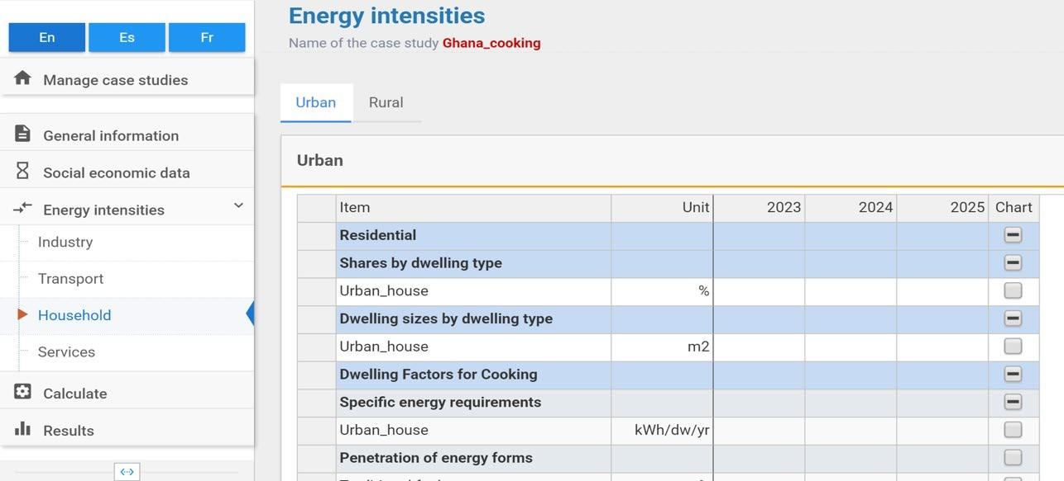

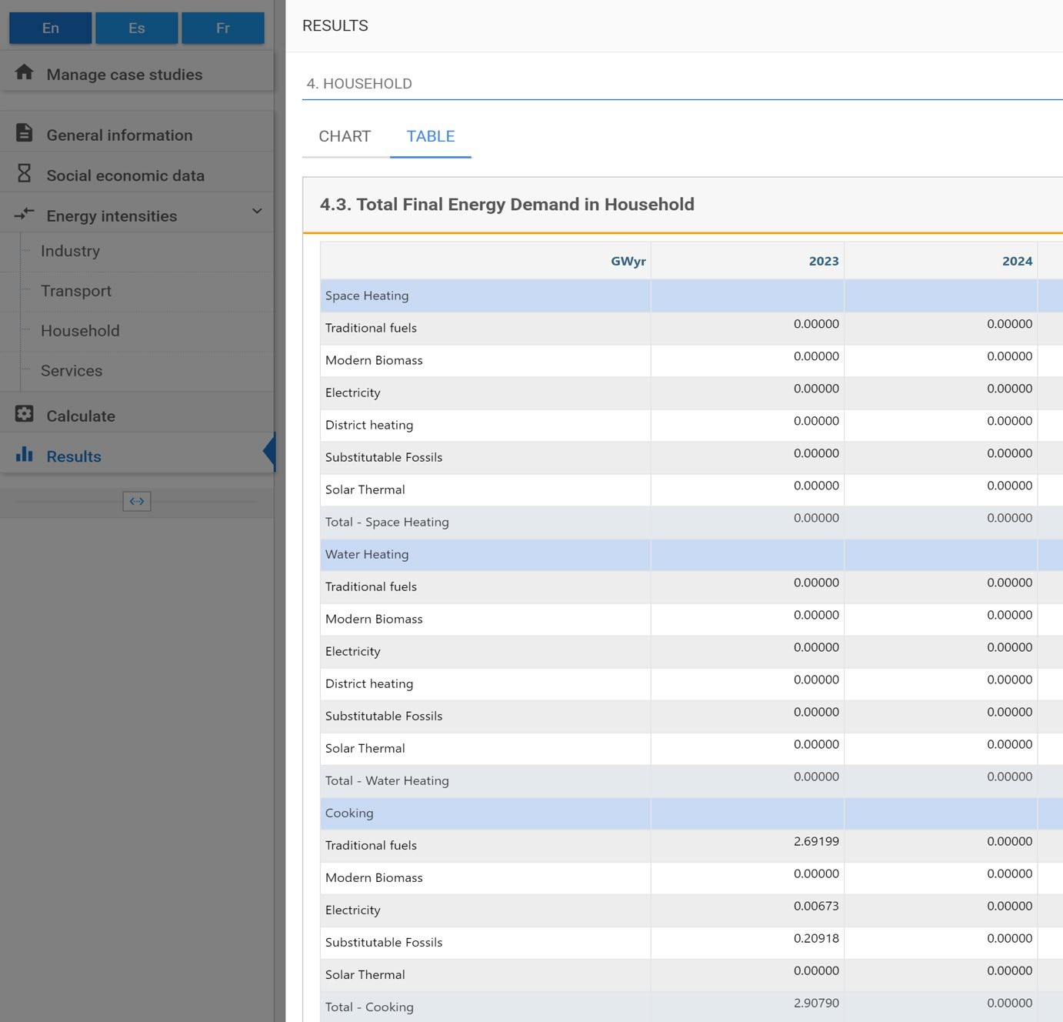
To validate the result obtained from the model, we compare the model output of 2.90790 GWyr with the corresponding value from the energy balance, 2,200.191 ktoe. Before the comparison, both figures must be expressed in the same units. The first step is to convert the energy balance value from ktoe to GWh, using the standard conversion factor 1 ktoe = 11.63 GWh. The result is then divided by 8,760 hours (the number of hours in a year) to obtain the equivalent average annual value 2.9210 GWyr.
We observe a difference of only 0.013%. This confirms that the base year has been successfully reconstructed.

Reflective Questions for Model Enhancement

- How could you split this case to include Urban and Rural households? What differnces would you expect?
- What additional data sources would be required to support this level of detail?
- How could you simulate a national clean-cooking transition scenario?

